

Faculty of Computing and Information Technology (FOCS)

Academic Year 2020/2021

**BACS3183**

**Advanced Database Management**

|  |  |  |
| --- | --- | --- |
| Programme | : | RDS3 |
| Tutorial Group | : | G2 |
| Date Submitted to Tutor | : | 01-09-2021 |

**Team Members:**

|  |  |  |  |
| --- | --- | --- | --- |
| **No** | **Student Name** | **Student ID** | **Signature** |
| 1. | Tan Yi Hong | 20WMR08890 |  |
| 2. | Tan Teoh Xin Ee | 20WMR08887 |  |
| 3. | Tan Wei Siong | 20WMR08888 |  |
| 4. | Nigel Lee Jian Hsee | 20WMR08882 |  |

**Declaration**

We confirm that we have read and shall comply with all the terms and conditions of TAR University College’s plagiarism policy.

We declare that this assignment is free from all forms of plagiarism and for all intents and purposes is my own properly derived work.

|  |  |  |  |  |  |
| --- | --- | --- | --- | --- | --- |
| Signature | : |  |  |  |  |
| Name | : | Tan Yi Hong | Tan Teoh Xin Ee | Tan Wei Siong | Nigel Lee Jian Hsee |
| Date | : | 01-09-2021 | 01-09-2021 | 01-09-2021 | 01-09-2021 |

**Table of Content**

**Chapter 1 Background of the System 4**

**Chapter 2 Entity-Relationship Modeling 5**

**2.1 ERD 5**

**2.2 Assumptions and Business Rules 5**

**Chapter 3 Data Definition 8**

**Chapter 4 Queries, Procedures, Triggers and Reports 12**

**4.1 (Tan Yi Hong) 12**

**4.1.1 Query 1: Top pet type that received treatment in each branch (Strategic) 12**

**4.1.2 Query 2: Appointment made on times of a day in each branch for last year (Tactical) 13**

**4.1.3 Query 3: Year 2020 first half sales vs second half sales in each branch (Operational) 15**

**4.1.4 Procedure 1: Add Appointment Record 16**

**4.1.5 Procedure 2: Delete Appointment Record 18**

**4.1.6 Trigger 1: Validate the proper date time on insertion of appointment 18**

**4.1.7 Trigger 2: Monitor the deletion of appointment record 19**

**4.1.8 Report 1: Summary report of Specific veterinarian with all of his/her transactions done in a year 20**

**4.1.9 Report 2: Detail report of Customer list in specific state with appointment made in a year 25**

**4.1.10 Report 3: On demand report of Customer list who do transaction for less than three times in a year 30**

**4.2 (Tan Teoh Xin Ee) 32**

**4.2.1 Query 1: Top Medicine Used in each branch (Strategic) 32**

**4.2.2 Query 2: Top Veterinarian in each branch (Tactical) 33**

**4.2.3 Query 3: Late Supplier List (Operational) 34**

**4.2.4 Procedure 1: Add Medical Supply 35**

**4.2.5 Procedure 2: Delete Medical Supply 37**

**4.2.6 Trigger 1: Add Stock Quantity (Add after purchasing stock) 37**

**4.2.7 Trigger 2: Minus Stock Quantity (Minus after adding transaction detail) 38**

**4.2.8 Report 1: Detail report of Veterinarian Performance 38**

**4.2.9 Report 2: Summary report of Supplier Profile 40**

**4.2.10 Report 3: On demand report of Inventory value 43**

**4.3 (Tan Wei Siong) 45**

**4.3.1 Query 1: Top and Least Treatment Last Year for Each Branch (Strategic) 45**

**4.3.2 Query 2: Selected Pet Type Age Group and Respective Visit Quantity(Tactical) 46**

**4.3.3 Query 3: Gross Profit and Net Profit Previous Year(Operational) 48**

**4.3.4 Procedure 1: Pet Registration 49**

**4.3.5 Procedure 2: Display Owner Information 52**

**4.3.6 Trigger 1: Check Owner Age 53**

**4.3.7 Trigger 2: Check Appointment Date Time 54**

**4.3.8 Report 1: Summary Report of Treatment Revenue in Selected Year 56**

**4.3.9 Report 2: Detail Report of Medic Performance 63**

**4.3.10 Report 3: On-demand Report of the Pet Treatment Detail 70**

**4.4 (Nigel Lee Jian Hsee) 75**

**4.2.1 Query 1: Top Three Pets Customer’s Postcode for each Branch based on total**

**transaction amount (Strategic) 75**

**4.4.2 Query 2: Rank top treatment, to medicine sales and total revenue of a**

**branch 77**

**4.4.3 Query 3: View Customer Transaction History by entering Customer ID 80**

**4.4.4 Procedure 1: Create Transaction 84**

**4.4.5 Procedure 2: Add Transaction Detail 89**

**4.4.6 Procedure 3: Edit Transaction Detail 94**

**4.4.7 Trigger 1: Validate Payment Date Time 100**

**4.4.8 Trigger 2: Update medicine quantity and transaction total amount after**

**editing transaction detail 102**

**4.4.9 Trigger 3: Update the stock and transaction total amount after deleting**

**transaction detail 103**

**4.4.10 Trigger 4: Update total amount after inserting new transaction detail 103**

**4.4.11 Report 1: Summary report of Veterinarian Performance in a month 104**

**4.4.12 Report 2: On demand report of days that performed poorly for a specific**

**with a date range 110**

**4.4.13 Report 3: Detail report of each Branch’s Performance in a specific year 121**

**Chapter 5 Extra Effort Highlights 131**

**5.1 (Tan Yi Hong) 131**

**5.1.1 Views 131**

**5.1.2 User Defined Exception 133**

**5.1.3 Sequences 134**

**5.1.4 Triggers 134**

**5.2 (Tan Teoh Xin Ee) 135**

**5.2.1 Views 135**

**5.2.2 User Defined Exception 136**

**5.2.3 Sequence 136**

**5.2.4 Trigger 137**

**5.3 (Tan Wei Siong) 138**

**5.3.1 User Defined Exceptions 138**

**5.3.2 Sequence 138**

**5.3.3 Procedure 138**

**5.3.4 Trigger 139**

**5.4 (Nigel Lee Jian Hsee) 140**

**5.4.1 Views 140**

**5.4.2 User Defined Exceptions 141**

**5.4.3 Trigger 144**

**Chapter 1 Background of the System**

The 4 Golden Duck Wellness Veterinary Clinic is a pet clinic operating from the year 2019 with a database of 4 main functions. 4 Golden Duck Wellness Veterinary Clinic has 3 three branches which are located in Kuala Lumpur, Penang, and Kedah.

**Payment & Transaction**

This function is to record every detail of a pet owner’s transaction in the Wellness Veterinary Clinic. It can be used to track and monitor transactions of each pet owner. By recording all transactions, various reports can be generated to gain business insights. This function is able to calculate the total amount of a transaction. The transaction will include all the quantities of a medicine bought by the pet owner and treatment for their pets.

**Appointment/Booking**

The purpose of this function is to let customers make appointments for the treatment of their pets. This function can record all appointments made to make sure the service of treatment does not clash with each other and arrange the time of appointment schedule. Staff will be handling appointments and able to see the record in the tables to serve the customers accordingly.

**Pet Registration**

The purpose of this function is to have an easy way to register and record the pet information into the system. By recording the pet detail, it allows the staff to check whether the owner has registered before or not. If not yet registered, the system will require the staff to register the pet owner first before adding the pet.

**Medical Stock Management**

This function is mainly to manage the stock in the Wellness Veterinary Clinic such as the medicine. It can help us to keep track of the transaction of medicine from the supplier and and the transaction of medicine from the customer. This function is able to calculate the total amount of transactions for the medicine that we use to order from the supplier.

**Chapter 2 Entity-Relationship Modeling**

**2.1 ERD**

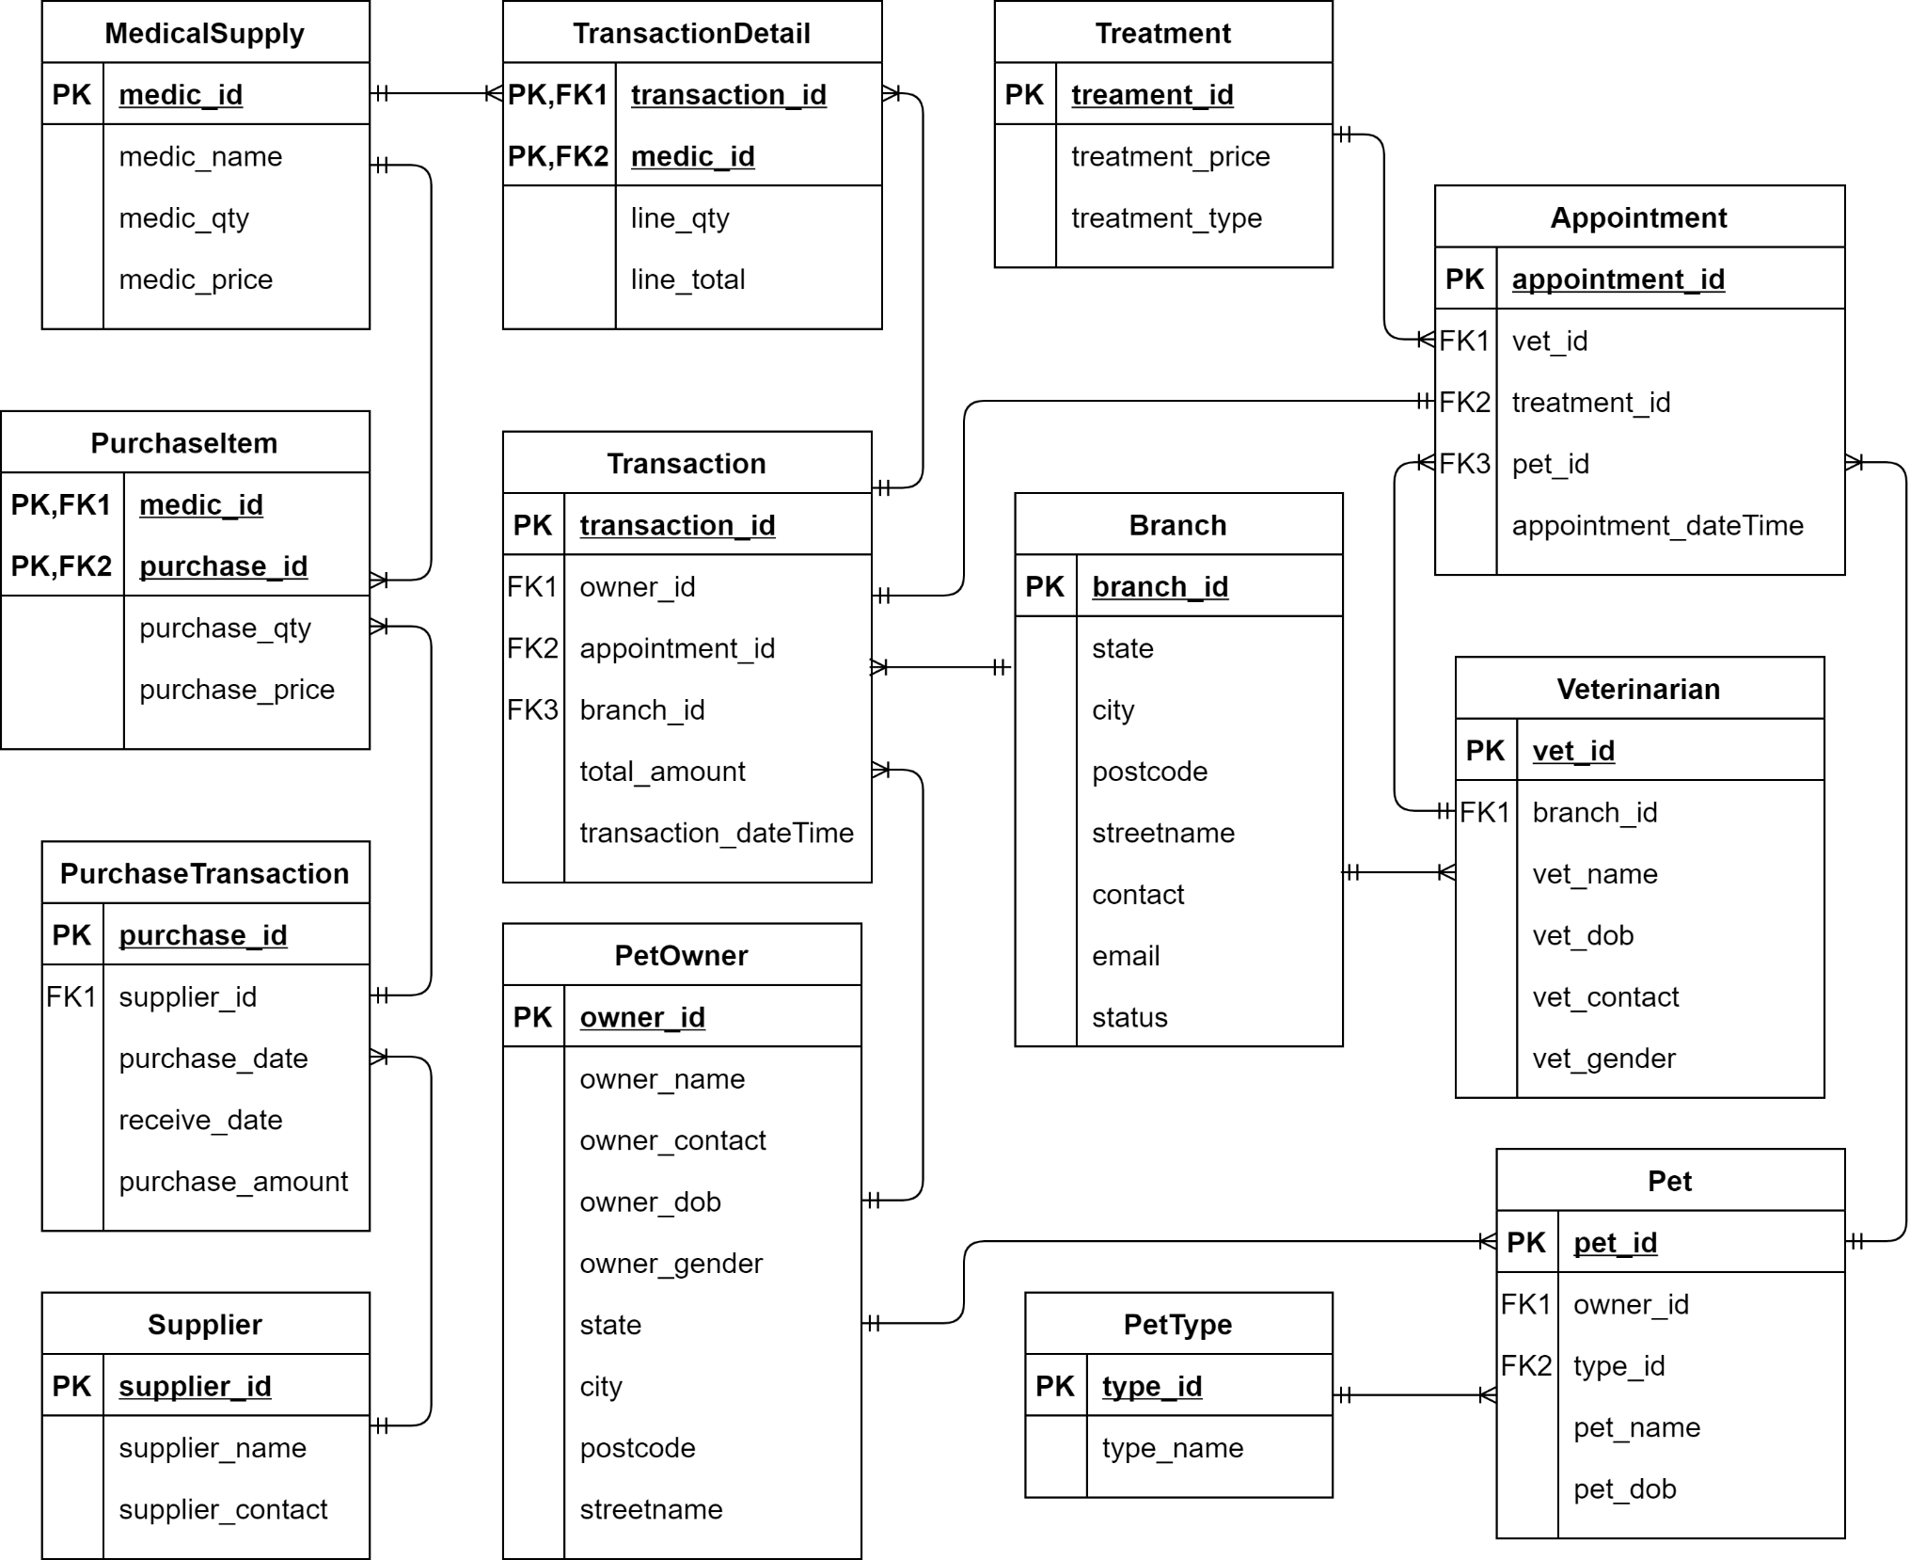

**2.2 Assumptions and Business Rules**

**Branch**

1. All branches of pet clinics have the same operation time which is 10am-6pm.
2. One branch can have many veterinarians, but each veterinarian can only work in one branch.(One-to-many)
3. One branch can have manytransactions, but each transaction can only have one branch.(One-to-many)

**Treatment**

1. One treatment can have many appointments, but one appointment can only have one treatment. (One-to-Many)

**Pet**

1. One pet can have many appointments, but each appointment can only have one pet.(One-to-Many)
2. Each pet can only be recorded under one pet owner, while one pet owner can have multiple pets.(Many-to-One)

**PetOwner**

1. Each pet owner can have one or many pets, while one pet can only have one pet owner. (One-to-Many)
2. Each pet owner can have one or more transactions, while each transaction can only have one pet owner recorded. (One-to-Many)

**Veterinarian**

1. One veterinarian can handle many appointments, but each appointment can only be handled by one veterinarian.(One-to-many)
2. One veterinarian can only in one branch, but one branch can have many veterinarians.(Many-to-One)

**PurchaseTransaction**

1. One PurchaseTransaction can have many PurchaseItem, but one PurchaseItem can only have one PurchaseTransaction. (One-to-Many)
2. One PurchaseTransaction can only have one Supplier, but one Supplier can have many PurchaseTransaction.

**PurchaseItem**

1. One PurchaseItem can only have one PurchaseTransaction, but one PurchaseTransaction can have many PurchaseItem. (One-to-One)

Formula

transacPurAmt = price * quantity

**Supplier**

1. One supplier can have many PurchaseTransaction, but one PurchaseTransaction can only have one supplier. (One-to-Many)

**Medical Supply**

1. One medical supply can be included in many transaction details, but a transaction detail can have only one or none medical supply. (Zero/One-to-Many)
2. Price of the medical supply must be more than its purchase price.

**Transaction Detail**

1. One transaction detail can have one medical supply, a medical supply can be included in many transaction details.(One-to-Many)
2. One transaction detail can only be included in a transaction , a transaction can be included in many transaction details.(One-to-Many)
3. One transaction must include either one medical supply or treatment.
4. Transaction amount cannot be zero.
5. Transaction details cannot be edited after 7 days from the transaction data.

Formula

line_total = medic_price * line_qty

**Transaction**

1. Each single transaction can have many transaction details, but one transaction detail can only be included in one transaction. (One-to-Many)
2. One transaction can have only one pet owner, but a pet owner can have many transactions. (One-to-Many)
3. Each transaction can only have one appointment. (One-to-One)

Formula

total_line_total += line_total

total_amount = total_line_total + treatment_price (Sum up all the line total and treatment price )

**Appointment**

1. One appointment only can have one pet, but one pet can have many appointments. (One-to-Many)
2. Appointment can only be made in business hours(10.00am to 5.00pm).
3. One appointment only can have one veterinarian, but one veterinarian can have many appointments. (One-to-Many).
4. One appointment only can have one treatment, but one treatment can be included in many appointments. (One-to-Many).
5. Each appointment can only be included in the transaction.
6. The appointment can only be made if the selected veterinarian is available on the selected period.

**Chapter 3 Data Definition**

Create table statements with appropriate constraints:

**3.1 Branch table**

CREATE TABLE Branch(

branch_id CHAR(5) NOT NULL,

state VARCHAR2(30) NOT NULL,

city VARCHAR2(30) NOT NULL,

postcode NUMBER(5) NOT NULL,

streetName VARCHAR2(50) NOT NULL,

contact VARCHAR2(11) NOT NULL,

email VARCHAR2(30) NOT NULL,

status VARCHAR2(10) NOT NULL,

PRIMARY KEY (branch_id),

CONSTRAINT chk_status CHECK(status IN ('Active','Not Active'))

);

**3.2 Veterinarian table**

CREATE TABLE Veterinarian(

vet_id CHAR(5) NOT NULL,

branch_id CHAR(5) NOT NULL,

vet_name VARCHAR2(30) NOT NULL,

vet_dob DATE NOT NULL,

vet_contact VARCHAR2(11) NOT NULL,

vet_gender CHAR(1) NOT NULL,

PRIMARY KEY (vet_id),

FOREIGN KEY (branch_id) REFERENCES Branch (branch_id),

CONSTRAINT chk_vet_gender CHECK(vet_gender IN ('M','F')),

CONSTRAINT chk_vet_contact CHECK(REGEXP_LIKE(vet_contact,'^[0-9]+$'))

);

**3.3 Pet Owner table**

CREATE TABLE PetOwner(

owner_id CHAR(5) NOT NULL,

owner_name VARCHAR2(30) NOT NULL,

owner_contact VARCHAR2(11) NOT NULL,

owner_dob DATE NOT NULL,

owner_gender CHAR(1) NOT NULL,

state VARCHAR2(30) NOT NULL,

city VARCHAR2(30) NOT NULL,

postcode VARCHAR2(5) NOT NULL,

streetName VARCHAR2(50) NOT NULL,

PRIMARY KEY (owner_id),

CONSTRAINT chk_owner_gender CHECK(owner_gender IN ('M','F')),

CONSTRAINT chk_owner_name CHECK(REGEXP_LIKE(owner_name,'^[a-z A-z]+$')),

CONSTRAINT chk_owner_contact CHECK(REGEXP_LIKE(owner_contact,'^[0-9]+$'))

);

**3.4 Pet Type table**

CREATE TABLE PetType(

type_id CHAR(5) NOT NULL,

type_name VARCHAR2(30) NOT NULL,

PRIMARY KEY (type_id),

CONSTRAINT chk_type_name CHECK(REGEXP_LIKE(type_name,'^[a-z A-z]+$'))

);

**3.5 Pet table**

CREATE TABLE Pet(

pet_id CHAR(5) NOT NULL,

owner_id CHAR(5) NOT NULL,

pet_name VARCHAR2(30) NOT NULL,

pet_dob DATE NOT NULL,

type_id CHAR(5) NOT NULL,

PRIMARY KEY (pet_id),

FOREIGN KEY (owner_id) REFERENCES PetOwner (owner_id),

FOREIGN KEY (type_id) REFERENCES PetType (type_id),

CONSTRAINT chk_pet_name CHECK(REGEXP_LIKE(pet_name,'^[a-z A-z]+$'))

);

**3.6 Treatment table**

CREATE TABLE Treatment(

treatment_id CHAR(5) NOT NULL,

treatment_price NUMBER(7,2) NOT NULL,

treatment_type VARCHAR2(50) NOT NULL,

PRIMARY KEY (treatment_id),

CONSTRAINT chk_treatment_price CHECK(treatment_price > 0)

);

**3.7 Appointment table**

CREATE TABLE Appointment(

appointment_id CHAR(10) NOT NULL,

vet_id CHAR(5) NOT NULL,

treatment_id CHAR(5) NOT NULL,

pet_id CHAR(5) NOT NULL,

appointment_dateTime DATE NOT NULL,

PRIMARY KEY (appointment_id),

FOREIGN KEY (vet_id) REFERENCES Veterinarian (vet_id),

FOREIGN KEY (treatment_id) REFERENCES Treatment (treatment_id),

FOREIGN KEY (pet_id) REFERENCES Pet (pet_id)

);

**3.8 Transaction table**

CREATE TABLE Transaction(

transaction_id CHAR(11) NOT NULL,

owner_id CHAR(5) NOT NULL,

appointment_id CHAR(10) NOT NULL,

branch_id CHAR(5) NOT NULL,

total_amount NUMBER(7,2) NOT NULL,

transaction_dateTime DATE NOT NULL,

PRIMARY KEY (transaction_id),

FOREIGN KEY (owner_id) REFERENCES PetOwner (owner_id),

FOREIGN KEY (appointment_id) REFERENCES Appointment (appointment_id),

FOREIGN KEY (branch_id) REFERENCES Branch (branch_id),

CONSTRAINT chk_total_amount CHECK(total_amount > 0)

);

**3.9 Medical Supply table**

CREATE TABLE MedicalSupply(

medic_id CHAR(5) NOT NULL,

medic_name VARCHAR2(30) NOT NULL,

medic_qty NUMBER(5) NOT NULL,

medic_price NUMBER(7,2) NOT NULL,

PRIMARY KEY(medic_id),

CONSTRAINT chk_qty CHECK(medic_qty>=0),

CONSTRAINT chk_price CHECK(medic_price>0)

);

**3.10 Transaction Detail table**

CREATE TABLE TransactionDetail(

transaction_id CHAR(11) NOT NULL,

medic_id CHAR(5) NOT NULL,

line_qty NUMBER(3) NOT NULL,

line_total Number(7,2) NOT NULL,

PRIMARY KEY (transaction_id, medic_id),

FOREIGN KEY (transaction_id) REFERENCES Transaction (transaction_id),

FOREIGN KEY (medic_id) REFERENCES MedicalSupply (medic_id),

CONSTRAINT chk_line_total CHECK(line_total > 0),

CONSTRAINT chk_line_qty CHECK(line_qty > 0)

);

**3.11 Supplier table**

CREATE TABLE Supplier(

supplier_id CHAR(5) NOT NULL,

supplier_name VARCHAR2(50) NOT NULL,

supplier_contact VARCHAR2(11) NOT NULL,

PRIMARY KEY (supplier_id),

CONSTRAINT chk_sup_name CHECK(REGEXP_LIKE(supplier_name,'^[a-z A-z]+$')),

CONSTRAINT chk_sup_contact CHECK(REGEXP_LIKE(supplier_contact,'^[0-9]+$'))

);

**3.12 Purchase Transaction table**

CREATE TABLE PurchaseTransaction(

purchase_id CHAR(5) NOT NULL,

supplier_id CHAR(5) NOT NULL,

purchase_date DATE NOT NULL,

receive_date DATE NOT NULL,

purchase_amount NUMBER(7,2) NOT NULL,

PRIMARY KEY (purchase_id),

FOREIGN KEY (supplier_id) REFERENCES Supplier (supplier_id),

CONSTRAINT chk_pur_amount CHECK(purchase_amount>= 0)

);

**3.13 Purchase Item table**

CREATE TABLE PurchaseItem(

medic_id CHAR(5) NOT NULL,

purchase_id CHAR(5) NOT NULL,

purchase_qty NUMBER(3) NOT NULL,

purchase_price NUMBER(7,2) NOT NULL,

PRIMARY KEY (medic_id, purchase_id),

FOREIGN KEY (medic_id) REFERENCES MedicalSupply (medic_id),

FOREIGN KEY (purchase_id) REFERENCES PurchaseTransaction (purchase_id),

CONSTRAINT chk_pqty CHECK(purchase_qty>0),

CONSTRAINT chk_pprice CHECK(purchase_price>0)

);

**Chapter 4 Queries, Procedures, Triggers and Reports**

**4.1 (Tan Yi Hong)**

**4.1.1 Query 1: Top pet type that received treatment in each branch (Strategic)**

**Purpose: The purpose of this query is to let the clinic know the top pet type that received treatment in each branch so that the organization can focus more on the service on which type of pets in each branch to provide better service to their customer for all branches.**

clear break

clear compute

set linesize 80

set pagesize 100

break on state on branch_id skip 1

COMPUTE SUM LABEL TOTAL OF nooftreatment percentage transactionamount on branch_id

TTITLE ON

TTITLE CENTER 'Top Pet Type that received treatment in each branch' SKIP 1-

CENTER ========================================================= SKIP 2

COLUMN branch_id FORMAT a10

COLUMN branch_id HEADING 'Branch ID'

COLUMN state FORMAT a15

COLUMN type_name FORMAT a10

COLUMN type_name HEADING 'Pet Type'

COLUMN nooftreatment HEADING 'Treatment|Received'

COLUMN transactionamount FORMAT 9999999.99

COLUMN transactionamount HEADING 'Total|Transaction|Made'

COLUMN Percentage FORMAT 999.99

COLUMN Percentage HEADING 'Percent|Over|Total'

CREATE OR REPLACE VIEW topPetTreatment AS

SELECT t.branch_id, pt.type_name, COUNT(t.appointment_id) AS NoOfTreatment, SUM(t.total_amount) AS TransactionAmount

FROM appointment a, veterinarian v, pet p, petType pt, transaction t

WHERE t.appointment_id=a.appointment_id AND a.vet_id=v.vet_id AND a.pet_id=p.pet_id

AND p.type_id=pt.type_id AND t.appointment_id=a.appointment_id

GROUP BY t.branch_id, pt.type_name

ORDER BY t.branch_id, SUM(t.total_amount) DESC;

SELECT a.branch_id, b.state, a.type_name, a.nooftreatment, (a.NoOfTreatment/COUNT(t.appointment_id))*100 AS Percentage, a.transactionAmount, RANK() OVER(PARTITION BY a.branch_id ORDER BY a.transactionAmount DESC) Ranks

FROM topPetTreatment a, transaction t, branch b

WHERE a.branch_id=t.branch_id AND a.branch_id=b.branch_id

GROUP BY a.branch_id, b.state, a.type_name, a.nooftreatment, a.transactionAmount

ORDER BY a.branch_id, a.transactionamount DESC;

**Sample Output:**

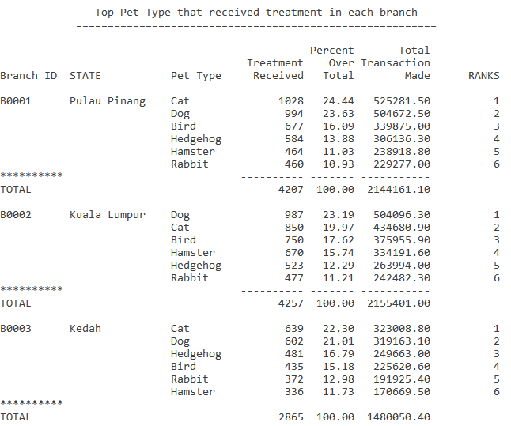

**4.1.2 Query 2: Appointment made on times of a day in each branch for last year (Tactical)**

**Purpose: The purpose of this query is to list out all appointments made during the times of a day in each branch and to know the peak business time to let the organization adjust the shifts between the veterinarian to suitable shifts whether increasing or decreasing the time shifts between them.**

clear break

clear compute

set linesize 71

set pagesize 100

BREAK ON REPORT

COMPUTE SUM LABEL TOTAL AVG LABEL AVERAGE OF MORNING AFTERNOON EVENING totalappointment ON REPORT

COLUMN morning FORMAT 999999999

COLUMN afternoon FORMAT 999999999

COLUMN evening FORMAT 999999999

TTITLE ON

TTITLE CENTER 'Appointment made on times of a day in each branch for last year' SKIP 1-

CENTER =================================================================== SKIP 2

COLUMN branch_id FORMAT a10

COLUMN branch_id HEADING 'Branch ID'

COLUMN state FORMAT a15

COLUMN totalappointment FORMAT 999999999

COLUMN totalappointment HEADING 'Total|Appointment'

CREATE OR REPLACE VIEW morningApp AS

SELECT t.branch_id, COUNT(t.transaction_id) AS MORNING

FROM appointment a, transaction t

WHERE t.appointment_id = a.appointment_id AND

EXTRACT(HOUR FROM CAST(a.appointment_datetime AS TIMESTAMP)) BETWEEN 10 AND 12

AND EXTRACT(YEAR FROM a.appointment_datetime) = EXTRACT(YEAR FROM SYSDATE)-1

GROUP BY t.branch_id

ORDER BY t.branch_id;

CREATE OR REPLACE VIEW afternoonApp AS

SELECT t.branch_id, COUNT(t.transaction_id) AS AFTERNOON

FROM appointment a, transaction t

WHERE t.appointment_id = a.appointment_id AND

EXTRACT(HOUR FROM CAST(a.appointment_datetime AS TIMESTAMP)) BETWEEN 13 AND 15

AND EXTRACT(YEAR FROM a.appointment_datetime) = EXTRACT(YEAR FROM SYSDATE)-1

GROUP BY t.branch_id

ORDER BY t.branch_id;

CREATE OR REPLACE VIEW eveningApp AS

SELECT t.branch_id, COUNT(t.transaction_id) AS EVENING

FROM appointment a, transaction t

WHERE t.appointment_id = a.appointment_id AND

EXTRACT(HOUR FROM CAST(a.appointment_datetime AS TIMESTAMP)) BETWEEN 16 AND 18

AND EXTRACT(YEAR FROM a.appointment_datetime) = EXTRACT(YEAR FROM SYSDATE)-1

GROUP BY t.branch_id

ORDER BY t.branch_id;

SELECT a.branch_id, d.state, a.morning, b.afternoon, c.evening, (a.morning + b.afternoon + c.evening) AS TotalAppointment

FROM morningApp a, afternoonApp b, eveningApp c, branch d

WHERE a.branch_id=b.branch_id AND a.branch_id=c.branch_id AND a.branch_id=d.branch_id

GROUP BY a.branch_id, d.state, a.morning, b.afternoon, c.evening

ORDER BY a.branch_id;

**Sample Output:**

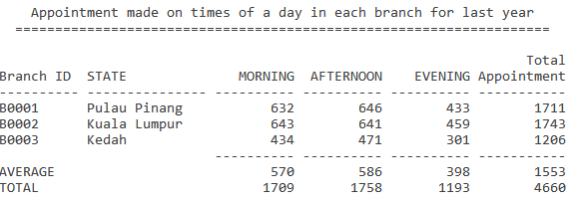

**4.1.3 Query 3: Year 2020 first half sales vs second half sales in each branch (Operational)**

**Purpose: The purpose of this query is to calculate and compare the sales of first half and second half in the year 2020 for each branch. It can show the operational sales of the clinic and compare the sales difference or percent difference to better understand the trends of their sales growth.**

clear break

clear compute

BREAK ON REPORT

COMPUTE SUM LABEL TOTAL AVG LABEL AVERAGE OF SALES2020_1STHALF SALES2020_2NDHALF SALESDIFF ON REPORT

set linesize 95

set pagesize 100

TTITLE ON

TTITLE CENTER 'Year 2020 first half sales vs second half sales' SKIP 1-

CENTER ================================================== SKIP 2

COLUMN branch_id FORMAT a10

COLUMN branch_id HEADING 'Branch ID'

COLUMN state FORMAT a15

COLUMN SALES2020_1STHALF FORMAT 9999999.99

COLUMN SALES2020_1STHALF HEADING 'First Half Sales'

COLUMN SALES2020_2NDHALF FORMAT 9999999.99

COLUMN SALES2020_2NDHALF HEADING 'Second Half Sales'

COLUMN SALESDIFF FORMAT 9999999.99

COLUMN SALESDIFF HEADING 'Sales Different'

COLUMN SALESDIFF_PERCENTAGE FORMAT 999.99

COLUMN SALESDIFF_PERCENTAGE HEADING 'Percent Different'

CREATE OR REPLACE VIEW Sales2020_1stHalf AS

SELECT branch_id, SUM(total_amount) AS Sales2020_1stHalf

FROM transaction

WHERE EXTRACT(YEAR FROM transaction_dateTime) = 2020 AND EXTRACT(MONTH FROM transaction_dateTime) <= 6

GROUP BY branch_id

ORDER BY branch_id, SUM(total_amount) DESC;

CREATE OR REPLACE VIEW Sales2020_2ndHalf AS

SELECT branch_id, SUM(total_amount) AS Sales2020_2ndHalf

FROM transaction

WHERE EXTRACT(YEAR FROM transaction_dateTime) = 2020 AND EXTRACT(MONTH FROM transaction_dateTime) > 6

GROUP BY branch_id

ORDER BY branch_id, SUM(total_amount) DESC;

SELECT a.branch_id, c.state, a.Sales2020_1stHalf, b.Sales2020_2ndHalf, Sales2020_2ndHalf-Sales2020_1stHalf AS SalesDiff, (Sales2020_2ndHalf/Sales2020_1stHalf)*100 AS SalesDiff_Percentage

FROM branch c, Sales2020_1stHalf a, Sales2020_2ndHalf b

WHERE a.branch_id=c.branch_id AND b.branch_id=c.branch_id

GROUP BY a.branch_id, c.state, a.Sales2020_1stHalf, b.Sales2020_2ndHalf

ORDER BY branch_id;

**Sample Output:**

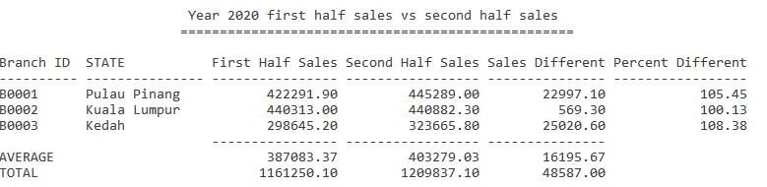

**4.1.4 Procedure 1: Add Appointment record**

**Purpose: The purpose of this stored procedure is to add a new appointment record into the database when customers want to make new appointments.**

CREATE OR REPLACE PROCEDURE PRC_ADD_APPOINTMENT(IN_vetID in CHAR, IN_treatmentID in CHAR, IN_petID in CHAR, IN_dateTime in DATE) AS

v_insertID CHAR(10);

v_branchID CHAR(5);

counter_t NUMBER;

counter_p NUMBER;

e_invalid_treatment EXCEPTION;

PRAGMA EXCEPTION_INIT(e_invalid_treatment, -20050);

e_invalid_pet EXCEPTION;

PRAGMA EXCEPTION_INIT(e_invalid_pet, -20051);

BEGIN

counter_t := 0;

counter_p := 0;

SELECT branch_id INTO v_branchID

FROM veterinarian

WHERE vet_id = IN_vetID;

SELECT COUNT(*) INTO counter_t

FROM treatment

WHERE treatment_id = IN_treatmentID;

IF counter_t = 0 THEN

RAISE_APPLICATION_ERROR(-20050, 'Invalid Treatment ID.');

END IF;

SELECT COUNT(*) INTO counter_p

FROM pet

WHERE pet_id = IN_petID;

IF counter_p = 0 THEN

RAISE_APPLICATION_ERROR(-20051, 'Invalid Pet ID.');

END IF;

IF v_branchID = 'B0001' THEN

v_insertID := TO_CHAR('PP'||app_seq_PG.NEXTVAL);

ELSIF v_branchID = 'B0002' THEN

v_insertID := TO_CHAR('KL'||app_seq_KL.NEXTVAL);

ELSIF v_branchID = 'B0003' THEN

v_insertID := TO_CHAR('KD'||app_seq_KD.NEXTVAL);

END IF;

insert into appointment values(v_insertID,IN_vetID,IN_treatmentID,IN_petID,IN_dateTime);

DBMS_OUTPUT.PUT_LINE (CHR(10));

DBMS_OUTPUT.PUT_LINE ('Appointment add SUCCESSFUL as follows: ');

DBMS_OUTPUT.PUT_LINE ('Appointment ID: '||v_insertID||'|Veterinarian ID: '||IN_vetID||'|Treatment ID: '||IN_treatmentID||'|Pet ID: '||IN_petID||'|Appointment Date Time: '||IN_dateTime);

EXCEPTION

WHEN NO_DATA_FOUND THEN

DBMS_OUTPUT.PUT_LINE ('No Veterinarian found');

WHEN e_invalid_treatment THEN

DBMS_OUTPUT.PUT_LINE('No such Treatment ID');

DBMS_OUTPUT.PUT_LINE(SQLERRM);

WHEN e_invalid_pet THEN

DBMS_OUTPUT.PUT_LINE('No such Pet ID');

DBMS_OUTPUT.PUT_LINE(SQLERRM);

END;

/

**Sample Output:**

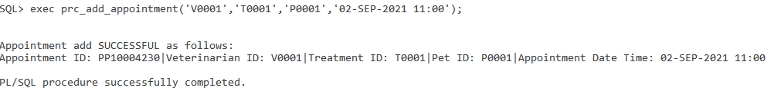

**4.1.5 Procedure 2: Delete Appointment record**

**Purpose: The purpose of this stored procedure is to delete an existing record from the appointment table when a customer has cancelled the appointment made. It will only require the appointment ID to delete the record.**

CREATE OR REPLACE PROCEDURE PRC_DEL_APPOINTMENT(IN_appointmentID in CHAR) AS

BEGIN

DELETE FROM appointment

WHERE appointment_id = IN_appointmentID;

DBMS_OUTPUT.PUT_LINE (IN_appointmentID||' Deleted successfully.');

EXCEPTION

WHEN NO_DATA_FOUND THEN

DBMS_OUTPUT.PUT_LINE ('No Appointment found');

END;

/

**Sample Output:**

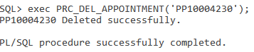

**4.1.6 Trigger 1: Validate the proper date time on insertion of appointment**

**Purpose: The purpose of this trigger is to validate the newly inserted appointment to match in a proper date and time which can make an appointment.**

CREATE OR REPLACE TRIGGER trg_appointmentDateTime

BEFORE INSERT OR UPDATE ON Appointment

FOR EACH ROW

BEGIN

IF :new.appointment_datetime<SYSDATE THEN

RAISE_APPLICATION_ERROR(-20052, 'Cannot insert the date time before now.' );

ELSIF EXTRACT(HOUR FROM CAST(:new.appointment_datetime AS TIMESTAMP)) < 10 THEN

RAISE_APPLICATION_ERROR(-20053, 'Date time must be after business hour.' );

ELSIF EXTRACT(HOUR FROM CAST(:new.appointment_datetime AS TIMESTAMP)) > 17 THEN

RAISE_APPLICATION_ERROR(-20054, 'Date time must be before business hour.' );

END IF;

END;

/

**Sample Output:**

**When the appointment insert is before now:**

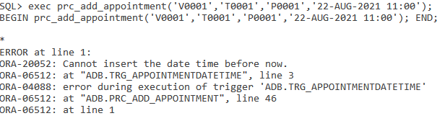

**When the appointment insert is before the business hour:**

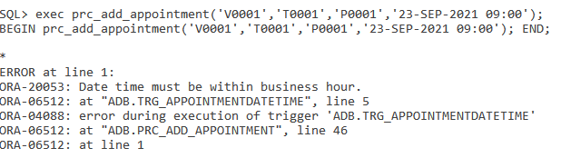

**When the appointment insert is after the business hour:**

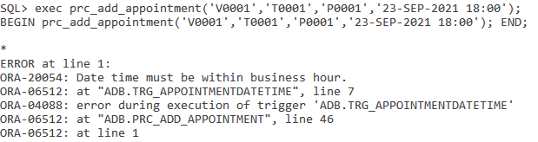

**4.1.7 Trigger 2: Monitor the deletion of appointment record**

**Purpose: The purpose of this trigger is to check whether the appointment that user wants to delete is recorded in the transaction or not, and it will be unable to delete when the record is in the transaction already.**

CREATE OR REPLACE TRIGGER trg_delAppointment

BEFORE DELETE ON Appointment

FOR EACH ROW

DECLARE

counter NUMBER;

BEGIN

counter := 0;

SELECT COUNT(*) INTO counter

FROM transaction

WHERE appointment_id = :old.appointment_id;

IF counter = 1 THEN

DBMS_OUTPUT.PUT_LINE(:old.appointment_id||' has been recorded in the Transaction and cannot be deleted');

RAISE_APPLICATION_ERROR(-20055,'Appointment delete unsuccessful');

END IF;

END;

/

**Sample Output:**

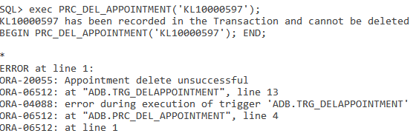

**4.1.8 Report 1: Summary report of Specific veterinarian with all of his/her transactions done in a year**

**Purpose: The purpose of this report is to summarize a specific veterinarian with all of his/her transactions done in a selected year with the form of a detailed report. It can let organizations know the contribution of the transaction amount they made or to trace the total amount of transactions done by that veterinarian.**

CREATE OR REPLACE PROCEDURE prc_vet_summary(IN_vetID in CHAR, IN_year in NUMBER) AS

v_vetName VARCHAR2(50);

v_branchID CHAR(5);

v_state VARCHAR2(50);

v_totalAmount NUMBER;

counter NUMBER;

record_count NUMBER;

e_norecord EXCEPTION;

PRAGMA EXCEPTION_INIT(e_norecord,-20060);

CURSOR vet_trans IS

SELECT t.transaction_id, t.appointment_id, tr.treatment_type, t.transaction_dateTime, t.total_amount

FROM transaction t, appointment a, treatment tr

WHERE t.appointment_id=a.appointment_id AND a.treatment_id=tr.treatment_id AND a.vet_id=IN_vetID AND EXTRACT(YEAR FROM t.transaction_dateTime) = IN_year

ORDER BY transaction_dateTime DESC;

BEGIN

v_totalAmount := 0;

counter := 0;

record_count := 0;

SELECT COUNT(*) INTO record_count

FROM transaction t, appointment a

WHERE t.appointment_id=a.appointment_id AND EXTRACT(YEAR FROM t.transaction_dateTime) = IN_year AND a.vet_id=IN_vetID;

IF record_count = 0 THEN

RAISE_APPLICATION_ERROR(-20060,'No record found');

END IF;

SELECT v.vet_name, v.branch_id, b.state INTO v_vetName, v_branchID, v_state

FROM veterinarian v, branch b

WHERE v.branch_id=b.branch_id AND vet_id=IN_vetID;

DBMS_OUTPUT.PUT_LINE (chr(10));

DBMS_OUTPUT.PUT_LINE ('Summary report of all transaction made by Veterinarian '||IN_vetID);

DBMS_OUTPUT.PUT_LINE('Report generated on : ' || TO_CHAR(CURRENT_DATE, 'DD-MM-YYYY HH:MI:SS') || ' by ' || USER);

DBMS_OUTPUT.PUT_LINE (chr(10));

DBMS_OUTPUT.PUT_LINE ('Veterinarian Name : '||v_vetName);

DBMS_OUTPUT.PUT_LINE ('Branch ID : '||v_branchID);

DBMS_OUTPUT.PUT_LINE ('State : '||v_state);

DBMS_OUTPUT.PUT_LINE(LPAD('-', 120, '-'));

DBMS_OUTPUT.PUT_LINE(RPAD('Transaction ID', 23, ' ') || RPAD('Appointment ID', 23, ' ') || RPAD('Treatment Type', 30, ' ')|| RPAD('Transaction Date Time', 32, ' ') || RPAD('Total Amount', 20, ' '));

DBMS_OUTPUT.PUT_LINE(LPAD('-', 120, '-'));

FOR trans IN vet_trans LOOP

DBMS_OUTPUT.PUT_LINE(RPAD(trans.transaction_id,23,' ')||RPAD(trans.appointment_id,23,' ')|| RPAD(trans.treatment_type, 30, ' ')||RPAD(trans.transaction_dateTime, 32, ' ') ||'RM '|| RPAD(TRIM(TO_CHAR(trans.total_amount,'999G999D99')), 17, ' '));

v_totalAmount := v_totalAmount + trans.total_amount;

counter := counter + 1;

END LOOP;

DBMS_OUTPUT.PUT_LINE(LPAD('=', 120, '='));

DBMS_OUTPUT.PUT_LINE(RPAD(('Total Treatment Done : '||counter),75,' ')||'Total Amount of Transaction : RM '||TRIM(TO_CHAR(v_totalAmount,'999G999D99')));

DBMS_OUTPUT.PUT_LINE(LPAD('=', 120, '='));

EXCEPTION

WHEN NO_DATA_FOUND THEN

DBMS_OUTPUT.PUT_LINE ('No Veterinarian found');

WHEN e_norecord THEN

DBMS_OUTPUT.PUT_LINE('--------------------------------');

DBMS_OUTPUT.PUT_LINE('Failed to print report for ' || IN_year || '.');

DBMS_OUTPUT.PUT_LINE('--------------------------------');

DBMS_OUTPUT.PUT_LINE(SQLERRM);

END;

/

exec prc_vet_summary('V0007','2021');

**Sample Output:**

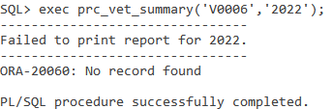

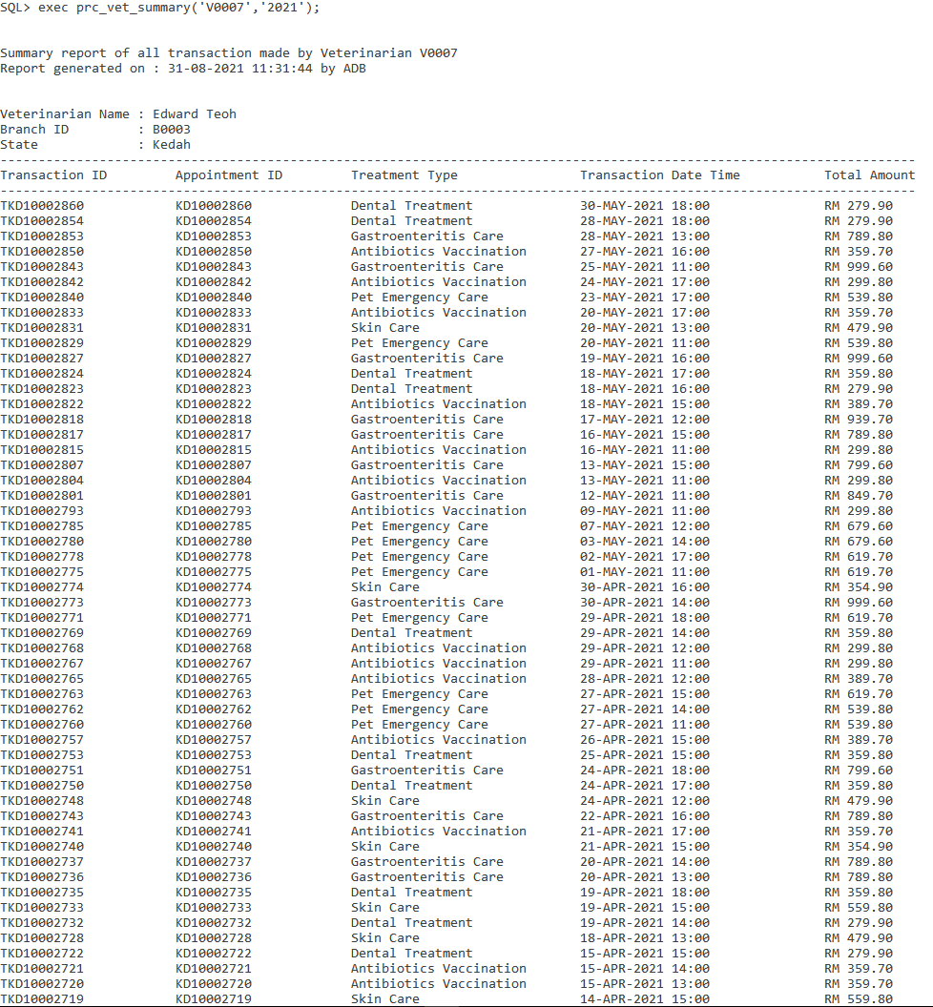

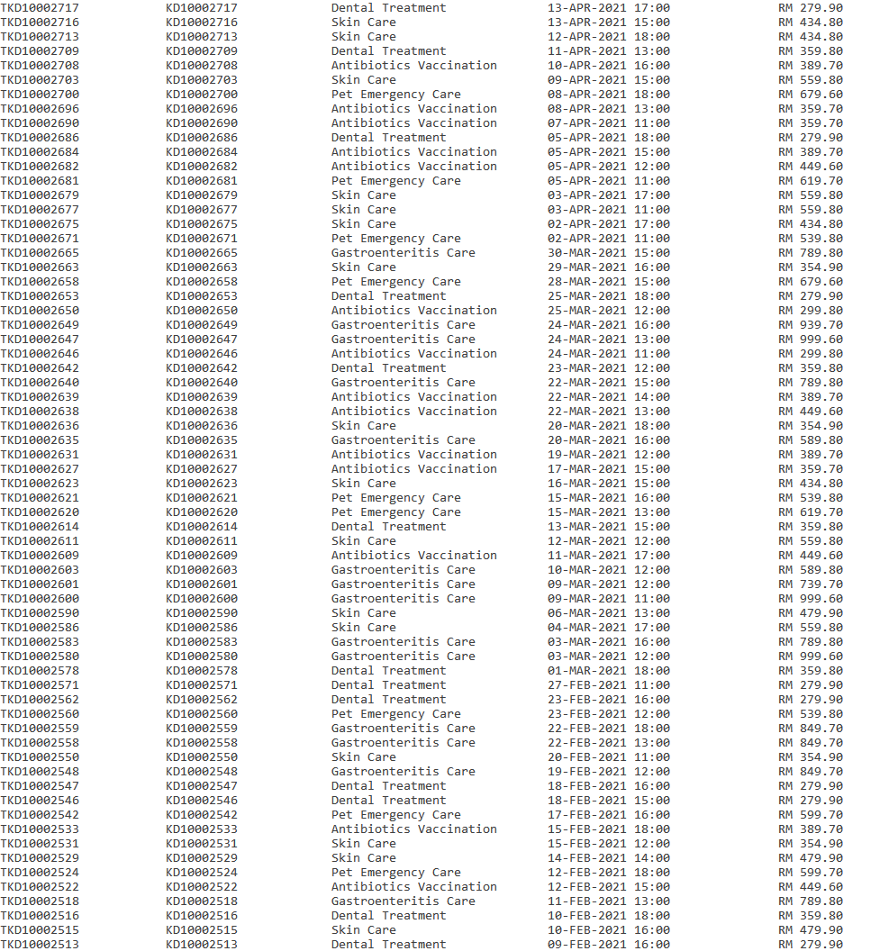

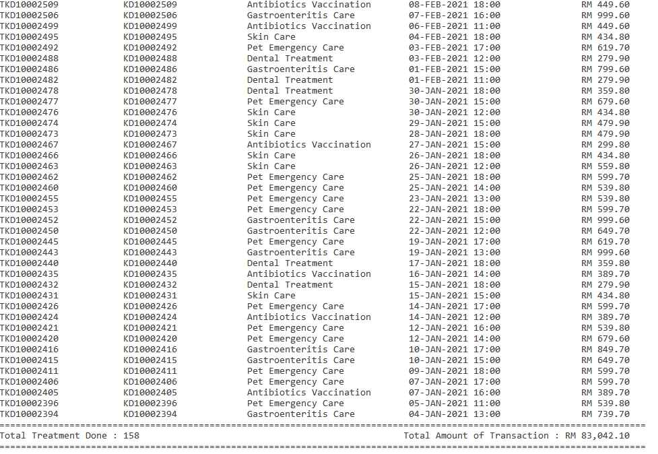

**4.1.9 Report 2: Detail report of Customer list in specific state with appointment made in a year**

**Purpose: The purpose of this report is to list all customers with all of their appointments made in a specific state, in a selected year along with their details. It will provide in detail every appointment made by the customers in a year. Organizations in the clinic can view all the appointments made by every customer to see their potential loyal customers.**

CREATE OR REPLACE PROCEDURE prc_less_appointment(IN_state IN VARCHAR2,IN_year IN NUMBER) AS

counter NUMBER;

record_count NUMBER;

e_norecord EXCEPTION;

PRAGMA EXCEPTION_INIT(e_norecord,-20062);

CURSOR cust_cursor IS

SELECT owner_id, owner_name, owner_gender, owner_contact, state

FROM petowner

WHERE state = IN_state;

CURSOR app_cursor IS

SELECT t.owner_id, a.appointment_id, a.pet_id, p.pet_name, pt.type_name, a.treatment_id, tr.treatment_type, a.vet_id, v.vet_name, a.appointment_dateTime

FROM appointment a, transaction t, treatment tr, veterinarian v, pet p, pettype pt

WHERE t.appointment_id=a.appointment_id AND a.treatment_id=tr.treatment_id AND a.vet_id=v.vet_id AND a.pet_id=p.pet_id AND p.type_id=pt.type_id AND EXTRACT(YEAR FROM a.appointment_dateTime) = IN_year;

BEGIN

record_count := 0;

SELECT COUNT(*) INTO record_count

FROM transaction t, appointment a, branch b

WHERE t.appointment_id=a.appointment_id AND EXTRACT(YEAR FROM a.appointment_dateTime) = IN_year AND b.state LIKE IN_state;

IF record_count = 0 THEN

RAISE_APPLICATION_ERROR(-20062,'No record found');

END IF;

DBMS_OUTPUT.PUT_LINE (chr(10));

DBMS_OUTPUT.PUT_LINE ('All customers in '||IN_state||' with appointment made in the year '||IN_year);

DBMS_OUTPUT.PUT_LINE('Report generated on : ' || TO_CHAR(CURRENT_DATE, 'DD-MM-YYYY HH:MI:SS') || ' by ' || USER);

DBMS_OUTPUT.PUT_LINE (chr(10));

FOR cust IN cust_cursor LOOP

counter := 0;

DBMS_OUTPUT.PUT_LINE ('Customer ID : '||cust.owner_ID);

DBMS_OUTPUT.PUT_LINE ('Customer Name : '||cust.owner_name);

DBMS_OUTPUT.PUT_LINE ('Contact : '||cust.owner_contact);

DBMS_OUTPUT.PUT_LINE ('Gender : '||cust.owner_gender);

DBMS_OUTPUT.PUT_LINE ('State : '||cust.state);

DBMS_OUTPUT.PUT_LINE(LPAD('-', 135, '-'));

DBMS_OUTPUT.PUT_LINE(RPAD('Appointment ID', 20, ' ') || RPAD('Pet', 28, ' ') || RPAD('Treatment', 35, ' ')|| RPAD('Veterinarian Handled', 31, ' ') || RPAD('Appointment Date Time', 25, ' '));

DBMS_OUTPUT.PUT_LINE(LPAD('-', 135, '-'));

FOR app IN app_cursor LOOP

IF app.owner_ID = cust.owner_ID THEN

DBMS_OUTPUT.PUT_LINE(RPAD(app.appointment_id, 20, ' ') || RPAD((app.pet_id||' '||app.pet_name||' ( '||app.type_name||')'), 28, ' ') || RPAD((app.treatment_id||' '||app.treatment_type), 35, ' ')|| RPAD((app.vet_id||' '||app.vet_name), 31, ' ') || RPAD(app.appointment_dateTime, 20, ' '));

counter := counter + 1;

END IF;

END LOOP;

DBMS_OUTPUT.PUT_LINE(LPAD('=', 135, '='));

DBMS_OUTPUT.PUT_LINE(RPAD('*',113,' ')||'No of record found: '||counter);

DBMS_OUTPUT.PUT_LINE(CHR(10));

END LOOP;

EXCEPTION

WHEN NO_DATA_FOUND THEN

DBMS_OUTPUT.PUT_LINE ('No Veterinarian found');

WHEN e_norecord THEN

DBMS_OUTPUT.PUT_LINE('---------------------------------------------------');

DBMS_OUTPUT.PUT_LINE('No record found for state '||IN_state||' in year '||IN_year||'.');

DBMS_OUTPUT.PUT_LINE('---------------------------------------------------');

DBMS_OUTPUT.PUT_LINE(SQLERRM);

END;

/

exec prc_less_appointment('Kedah',2020);

**Sample Output:**

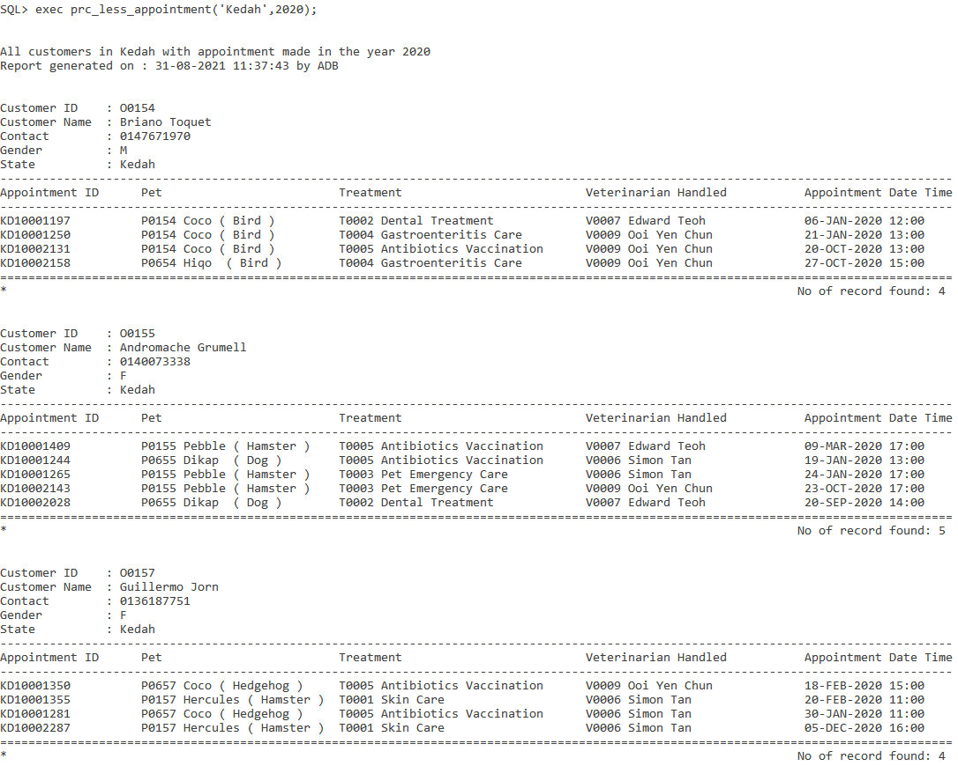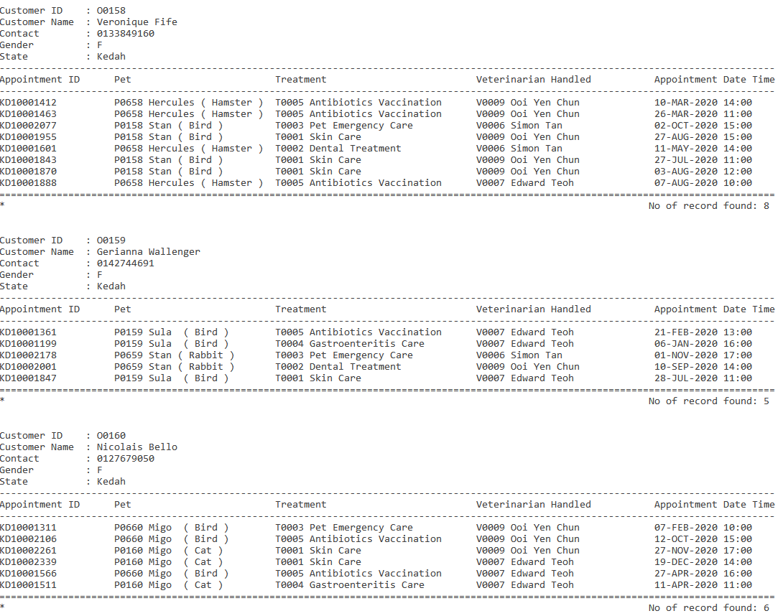

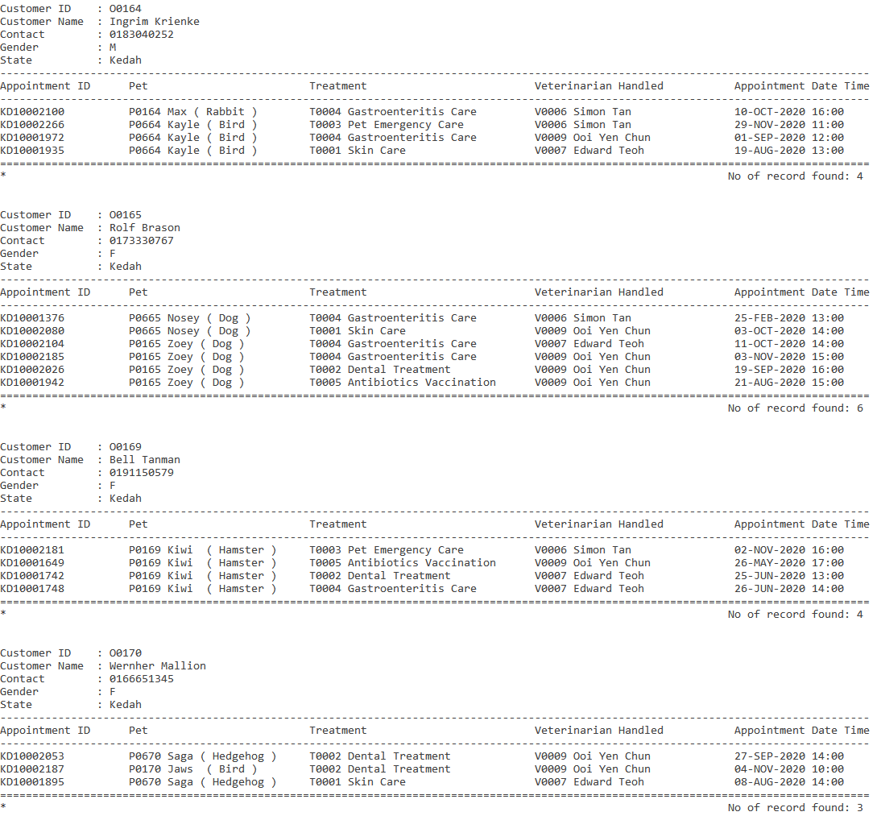

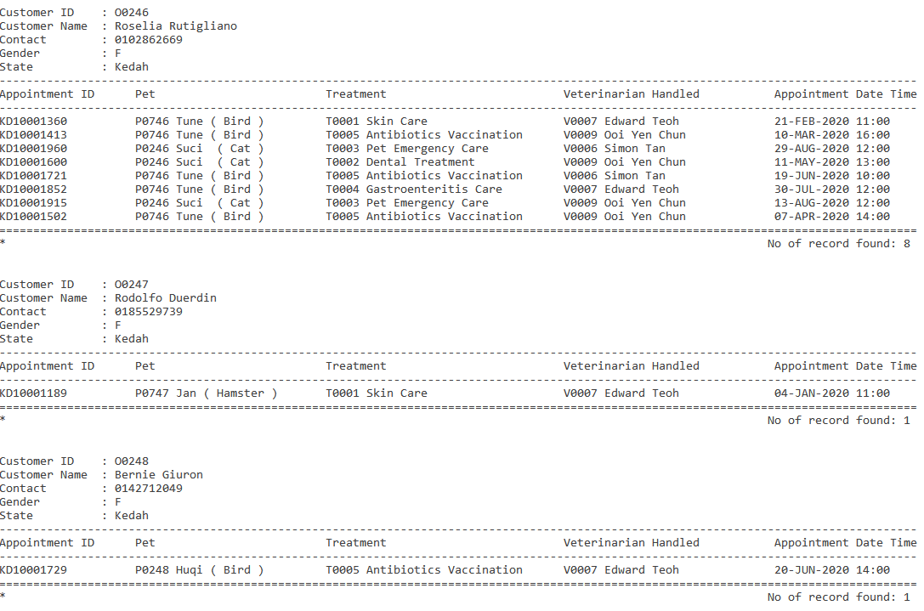

**4.1.10 Report 3: On demand report of Customer list who do transaction for less than three times in a year**

**Purpose: The purpose of this report is to list out the customers who have less than 3 transactions done in a year. This can let the management to predict the churn customer by viewing this report which also includes the last transaction made by the customer. In this way, they can try to ask the listed customers for their feedback and satisfaction against the clinic to know why they will be churning.**

CREATE OR REPLACE PROCEDURE prc_less_appointment(IN_year IN NUMBER) AS

counter NUMBER;

record_count NUMBER;

e_norecord EXCEPTION;

PRAGMA EXCEPTION_INIT(e_norecord,-20061);

CURSOR cust_trans IS

SELECT po.owner_id, po.owner_name, po.owner_contact, po.owner_gender, po.state, COUNT(t.transaction_dateTime) AS TotalTransaction, MAX(t.transaction_dateTime) AS LastTransaction

FROM petowner po, transaction t

WHERE t.owner_id=po.owner_id AND EXTRACT(YEAR FROM t.transaction_dateTime) = IN_year

GROUP BY po.owner_id, po.owner_name, po.owner_contact, po.owner_gender, po.state;

BEGIN

counter := 0;

record_count := 0;

SELECT COUNT(*) INTO record_count

FROM petowner po, transaction t

WHERE t.owner_id=po.owner_id AND EXTRACT(YEAR FROM t.transaction_dateTime) = IN_year;

IF record_count = 0 THEN

RAISE_APPLICATION_ERROR(-20061,'No record found');

END IF;

DBMS_OUTPUT.PUT_LINE (chr(10));

DBMS_OUTPUT.PUT_LINE ('List of customer who do transaction for less than 3 times in the year '||IN_year);

DBMS_OUTPUT.PUT_LINE('Report generated on : ' || TO_CHAR(CURRENT_DATE, 'DD-MM-YYYY HH:MI:SS') || ' by ' || USER);

DBMS_OUTPUT.PUT_LINE (chr(10));

DBMS_OUTPUT.PUT_LINE(LPAD('-', 137, '-'));

DBMS_OUTPUT.PUT_LINE(RPAD('Customer ID', 15, ' ') || RPAD('Customer Name', 26, ' ') || RPAD('Customer Contact', 20, ' ')|| RPAD('Gender', 10, ' ') || RPAD('State', 20, ' ') || RPAD('No of Transaction made', 25, ' ') || RPAD('Last Transaction Date', 30, ' '));

DBMS_OUTPUT.PUT_LINE(LPAD('-', 137, '-'));

FOR cust_record IN cust_trans LOOP

IF cust_record.totaltransaction < 3 THEN

DBMS_OUTPUT.PUT_LINE(RPAD(cust_record.owner_id, 15, ' ') || RPAD(cust_record.owner_name, 26, ' ') || RPAD(cust_record.owner_contact, 20, ' ')|| RPAD(cust_record.owner_gender, 10, ' ') || RPAD(cust_record.state, 20, ' ') || RPAD(cust_record.totaltransaction, 25, ' ') || RPAD(cust_record.lasttransaction, 30, ' '));

counter := counter + 1;

END IF;

END LOOP;

DBMS_OUTPUT.PUT_LINE(LPAD('=', 137, '='));

DBMS_OUTPUT.PUT_LINE(RPAD('*',110,' ')||'Total No of Customer: '||counter);

DBMS_OUTPUT.PUT_LINE(LPAD('=', 137, '='));

EXCEPTION

WHEN NO_DATA_FOUND THEN

DBMS_OUTPUT.PUT_LINE ('No Veterinarian found');

WHEN e_norecord THEN

DBMS_OUTPUT.PUT_LINE('--------------------------------');

DBMS_OUTPUT.PUT_LINE('Failed to print report for ' || IN_year || '.');

DBMS_OUTPUT.PUT_LINE('--------------------------------');

DBMS_OUTPUT.PUT_LINE(SQLERRM);

END;

/

exec prc_less_appointment(2020);

**Sample Output:**

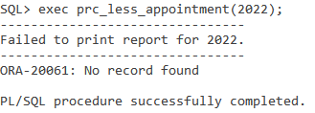



**4.2 (Tan Teoh Xin Ee)**

**4.2.1 Query 1:Top Medicine Used in each branch (Strategic)**

**Purpose: The purpose of this query is to analyze the most used medicine in each branch. Therefore, we are able to tackle each and every branch using this query. For example, this medicine has the highest use in this branch, therefore the medicine is in demand in this area which we will have to focus the growth and stock in more of that kind of medicine to that branch.**

SQL statement:

clear break

clear compute

set linesize 80

set pagesize 100

break on state on branch_id skip 1

compute SUM Label TOTAL of quantity percentage amount on branch_id

TTITLE ON

TTITLE CENTER 'Top Medicine Used in each branch' SKIP 1-

CENTER ================================ SKIP 2

column branch_id format a10

column branch_id heading 'Branch ID'

column state format a13

column medic_name format a20

column medic_name heading 'Medicine Name'

column quantity heading 'Medicine|Used'

column amount format 99999999.99

column amount heading 'Total|Amount|(RM)'

create or replace view medicalUsed As

select t.branch_id, d.medic_id, m.medic_name, sum(d.line_qty) as quantity, sum(d.line_total) as amount

from transaction t, branch b, transactiondetail d, medicalsupply m

where b.branch_id = t.branch_id

and t.transaction_id = d.transaction_id

and d.medic_id = m.medic_id

group by t.branch_id, d.medic_id,m.medic_name

order by t.branch_id,sum(d.line_qty) DESC;

select u.branch_id, b.state, u.medic_name, u.quantity, u.amount,

RANK() over(partition by u.branch_id order by u.quantity DESC) Ranks

from medicalused u, transaction t, branch b

where u.branch_id = t.branch_id

and u.branch_id = b.branch_id

group by u.branch_id, b.state, u.medic_name, u.quantity, u.amount

order by u.branch_id,u.quantity DESC;

**Sample Output:**

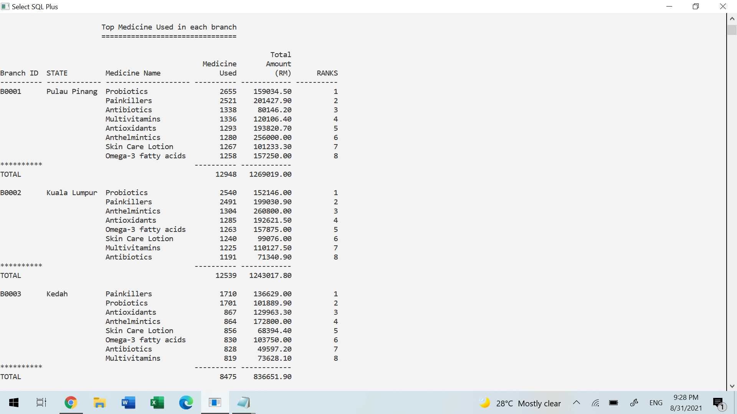

**4.2.2 Query 2: Top Veterinarian in each branch (Tactical)**

**Purpose: The purpose of this query is to know the most appointments received by each veterinarian in every branch. Therefore, we can revise the staffing levels by looking at their performance. For example, the most appointed veterinarian can be promoted to senior veterinarian.**

SQL statement:

clear break

clear compute

set linesize 80

set pagesize 100

break on state on branch_id skip 1

compute SUM Label TOTAL of noofapp on branch_id

TTITLE ON

TTITLE CENTER 'Top Veterinarian in each branch' SKIP 1-

CENTER =============================== SKIP 2

column branch_id format a10

column branch_id heading 'Branch ID'

column state format a13

column vet_id format a6

column vet_id heading 'Vet ID'

column vet_name format a15

column vet_name heading 'Vet Name'

column noofapp heading 'Appointment|Received'

create or replace view appointNum As

select count(appointment_id) as NoOfapp, vet_id

from appointment

group by vet_id

order by count(appointment_id) desc;

select b.branch_id, b.state, v.vet_name, a.vet_id, a.noofapp,

RANK() over(partition by b.branch_id order by a.noofapp DESC) RANKS

from branch b, veterinarian v, appointNum a

where a.vet_id = v.vet_id

and v.branch_id = b.branch_id

group by b.branch_id, b.state, v.vet_name, a.vet_id, a.noofapp

order by b.branch_id,a.noofapp DESC;

**Sample Output:**

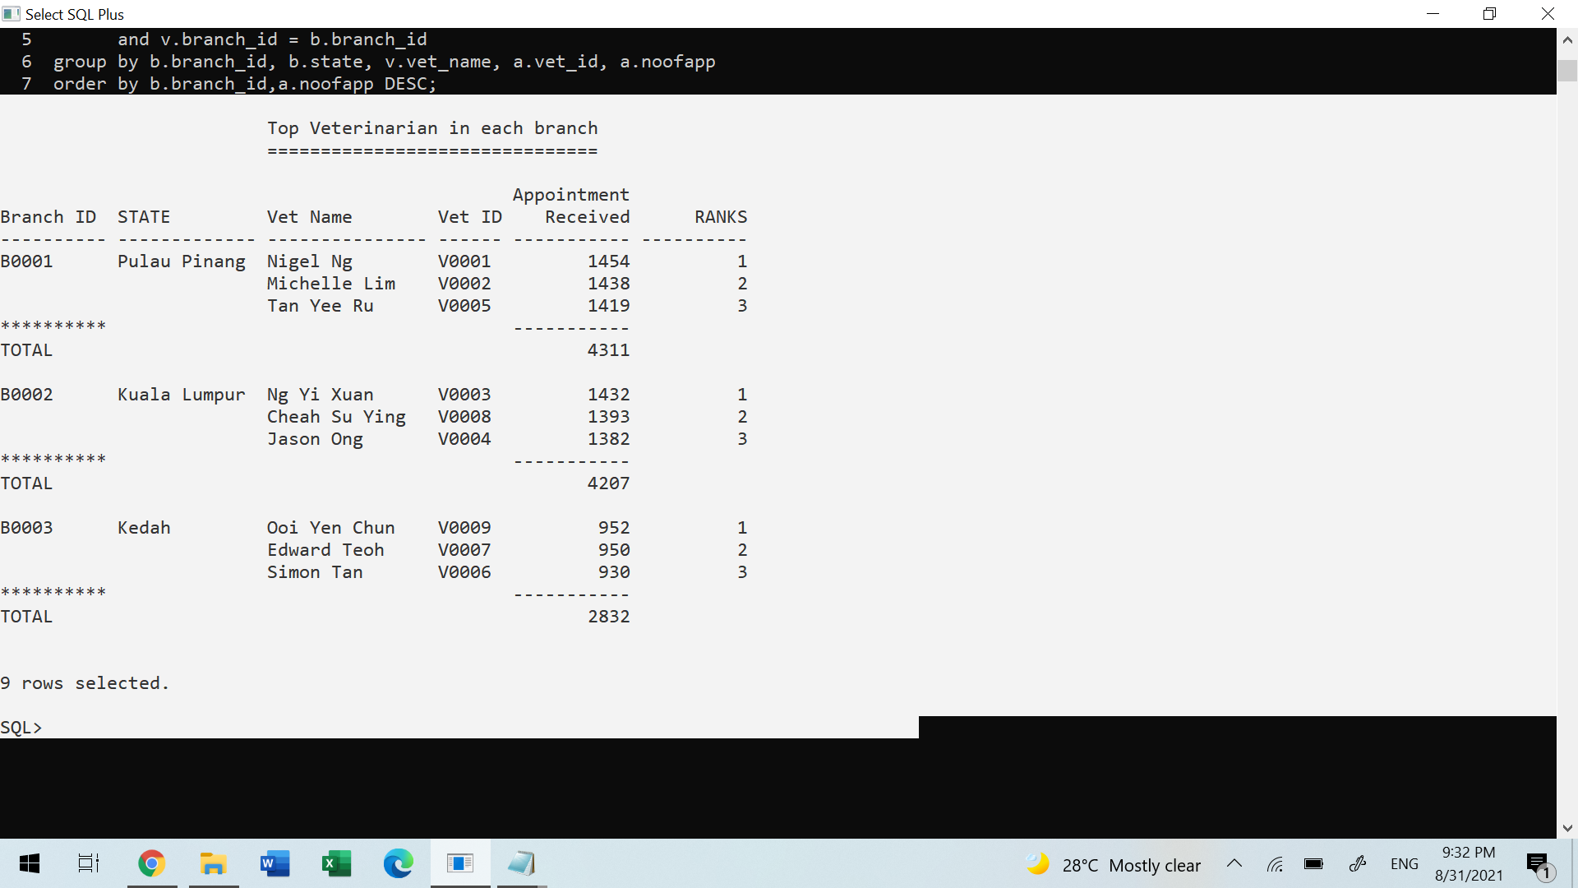

**4.2.3 Query 3: Late Supplier List (Operational)**

**Purpose: The purpose of this query is to know the most frequent late supplier. By using this query, we are able to manage our stock such as the correct order/stock delay. This query is normally used by the low level staff in the shop.**

SQL statement:

clear break

clear compute

set linesize 100

set pagesize 150

BREAK ON REPORT

break on supplier_contact on supplier_name skip 1

compute Count Label NO.LATE of duration on supplier_name

TTITLE ON

TTITLE CENTER 'Late Supplier list' SKIP 1-

CENTER ================== SKIP 2

column supplier_name format a27

column supplier_contact format a10

column supplier_contact heading 'Contact No'

column purchase_id format a11

column purchase_id heading 'Purchase ID'

column purchase_date format a9

column purchase_date heading 'Purchase|Date'

column receive_date format a9

column receive_date heading 'Receive|Date'

column duration heading 'Duration|(Day)'

create or replace view difdate as

select purchase_id, supplier_id, purchase_date, receive_date,(receive_date-purchase_date) as duration

from purchaseTransaction

where receive_date-purchase_date>6

group by purchase_id,supplier_id, purchase_date, receive_date

order by supplier_id;

select s.supplier_name, s.supplier_contact,d.purchase_id, d.purchase_date, d.receive_date,d.duration

from difdate d, supplier s

where d.supplier_id = s.supplier_id

group by s.supplier_name, s.supplier_contact,d.purchase_id, d.purchase_date, d.receive_date,d.duration

order by s.supplier_name;

**Sample Output:**

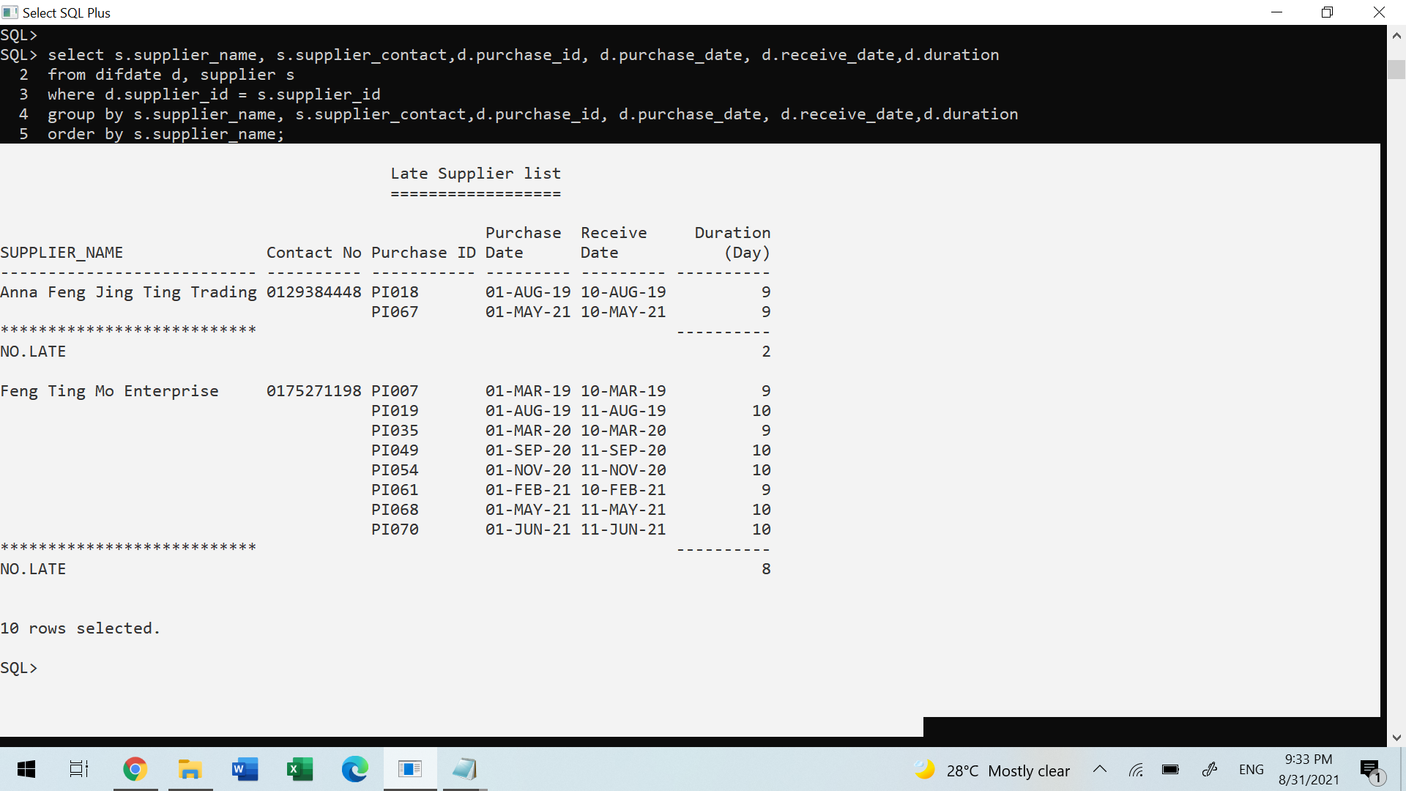

**4.2.4 Procedure 1: Add Medical Supply**

**Purpose: The purpose of this procedure is to add new medicine into our database. If the user wishes to add new medicine, he/she can just call this procedure with two parameters(medicine name & price). Then the new record will auto be generated.**

SQL statement:

DROP SEQUENCE MEDICID;

CREATE SEQUENCE MEDICID

MINVALUE 8

MAXVALUE 9999

START WITH 9

INCREMENT BY 1;

CREATE OR REPLACE PROCEDURE PRC_MEDICADD (IN_MEDICNAME IN VARCHAR, IN_MEDICPRICE IN NUMBER) As

v_insertID char(5);

NEXT NUMBER;

BEGIN

NEXT:=MEDICID.NEXTVAL;

IF (NEXT<10) THEN

V_INSERTID := TO_CHAR('M000'||NEXT);

ELSIF (NEXT<100) THEN

V_INSERTID := TO_CHAR('M00'||NEXT);

ELSIF (NEXT<1000) THEN

V_INSERTID := TO_CHAR('M0'||NEXT);

ELSIF (NEXT<10000) THEN

V_INSERTID := TO_CHAR('M'||NEXT);

END IF;

INSERT INTO MEDICALSUPPLY VALUES(V_INSERTID,IN_MEDICNAME,0,IN_MEDICPRICE);

END;

/

**Sample Output:**

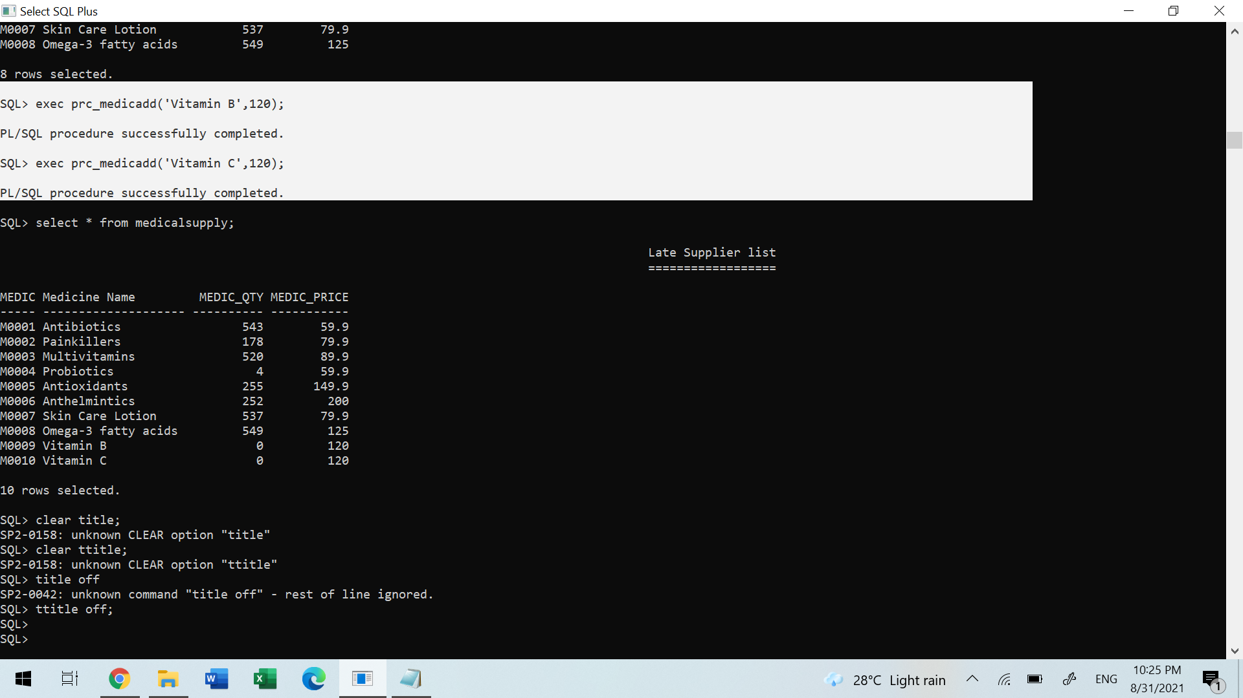

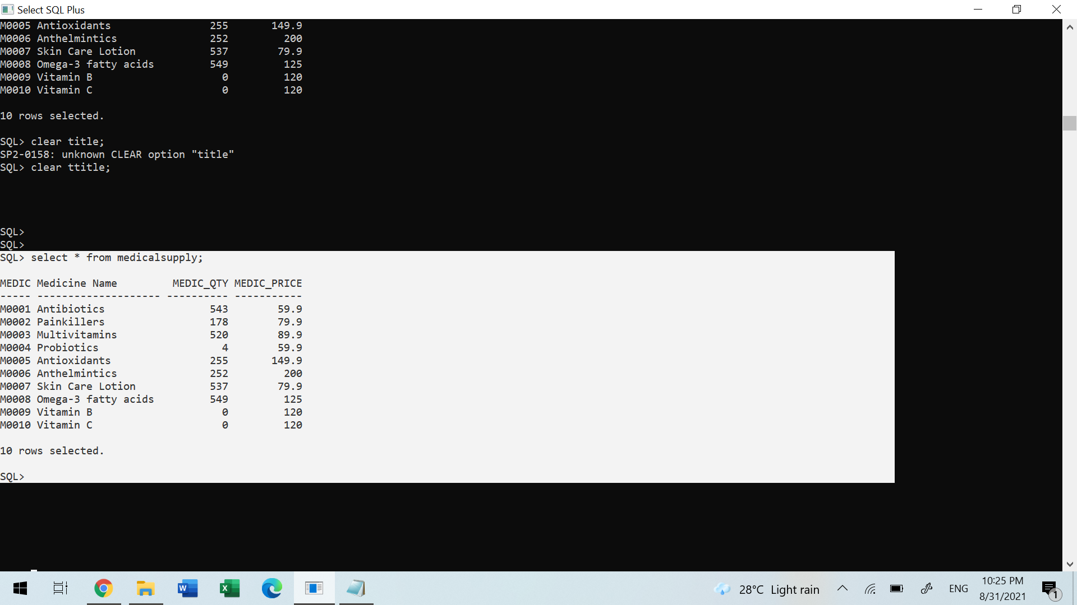

**4.2.5 Procedure 2: Delete Medical Supply**

**Purpose: The purpose of this procedure is to delete unwanted medicine from our database. If the user wishes to delete the medicine, he/she can just call this procedure with one parameter(medicine id). Then the specific record will be deleted permanently.**

SQL statement:

CREATE OR REPLACE PROCEDURE PRC_MEDICDELETE(IN_MEDICID IN CHAR) AS

BEGIN

DELETE FROM medicalsupply

WHERE medic_id = IN_MEDICID;

Exception

WHEN NO_DATA_FOUND THEN

DBMS_OUTPUT.PUT_LINE('NO SUCH MEDICINE!!!');

END;

/

**Sample Output:**

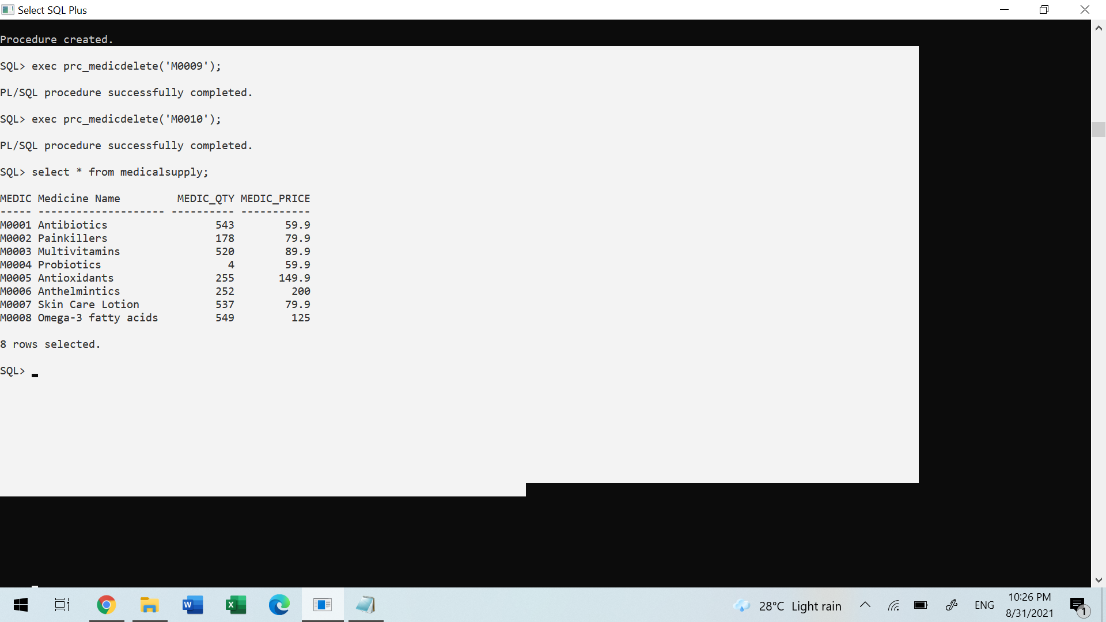

**4.2.6 Trigger 1: Add Stock Quantity (Add after purchasing stock)**

**Purpose: The purpose of this trigger is used to trigger after purchasing stock. For example, it will automatically update and add specific quantities of stock, after the company has purchased stock.**

SQL statement:

CREATE OR REPLACE TRIGGER TRG_Add_Stock_Quantity

After Insert ON PurchaseItem

FOR EACH ROW

BEGIN

Update MedicalSupply

SET medic_qty = medic_qty + :new.purchase_qty

where medic_id = :new.medic_id;

END;

/

**4.2.7 Trigger 2: Minus Stock Quantity (Minus after adding transaction detail)**

**Purpose: The purpose of this trigger is used to trigger after transaction detail. For example, it will automatically update and delete specific quantities of stock, after every transaction is made by the customer.**

SQL statement:

CREATE OR REPLACE TRIGGER TRG_Minus_Stock_Quantity

After Insert ON TransactionDetail

FOR EACH ROW

BEGIN

Update MedicalSupply

SET medic_qty = medic_qty - :new.line_qty

where medic_id = :new.medic_id;

END;

/

**4.2.8 Report 1: Detail report of Veterinarian Performance**

**Purpose: The purpose of this report is to know every veterinarian's performance in their branch such as how many transactions they have made and how much profit they bring toward the company. At the end, we are also able to know the grand total made by these three branches.**

SQL statement:

CREATE OR REPLACE PROCEDURE PRC_VET_PERFORMANCE IS

CURSOR BRANCH_CURSOR IS

SELECT DISTINCT b.state

FROM veterinarian v, branch b

where v.branch_id = b.branch_id

ORDER BY b.state desc;

cursor vet_cursor (branches in char)is

select v.vet_id, b.state, v.vet_name, v.vet_contact, v.vet_gender, count(t.transaction_id) as transaction, sum(t.total_amount)as amount

from veterinarian v, appointment a, transaction t, branch b

where v.vet_id= a.vet_id

and v.branch_id = b.branch_id

and b.state = branches

and a.appointment_id = t.appointment_id

group by v.vet_id, b.state, v.vet_name, v.vet_contact, v.vet_gender

order by v.vet_id;

v_totalAmt NUMBER(17,2) := 0;

v_totalTrans NUMBER(10) := 0;

v_grandTotal NUMBER(17,2) := 0;

v_grandTrans NUMBER(10) := 0;

BEGIN

DBMS_OUTPUT.PUT_LINE(chr(10));

DBMS_OUTPUT.PUT_LINE(RPAD('*', 48, ' ') || 'Report generated on : ' || TO_CHAR(CURRENT_DATE, 'DD-MM-YYYY HH:MI:SS') || 'by ' || USER);

DBMS_OUTPUT.PUT_LINE(chr(10));

FOR branches IN BRANCH_CURSOR LOOP

DBMS_OUTPUT.PUT_LINE(RPAD('Branch', 20, ' ') || ': ' ||RPAD(UPPER(branches.state), 60, ' '));

DBMS_OUTPUT.PUT_LINE(LPAD('-', 95, '-'));

DBMS_OUTPUT.PUT_LINE(RPAD('Staff ID', 10, ' ') || RPAD('StaffName', 25, ' ') || RPAD('Staff Tel', 15, ' ') || RPAD('Gender', 10, ' ')|| RPAD('Total Transactions', 20, ' ') || RPAD('Total Amount', 17, ' '));

DBMS_OUTPUT.PUT_LINE(LPAD('-', 95, '-'));

v_totalTrans := 0;

v_totalAmt := 0;

FOR vet_rec IN vet_CURSOR(branches.state) LOOP

DBMS_OUTPUT.PUT_LINE(RPAD(vet_rec.vet_id, 10, ' ') ||RPAD(vet_rec.vet_name, 25, ' ') || RPAD(vet_rec.vet_contact, 15, ' ') || RPAD(vet_rec.vet_gender, 10, ' ')|| RPAD(vet_rec.transaction, 20, ' ') || 'RM ' ||RPAD(TRIM(TO_CHAR(vet_rec.amount, '999G999G999D99')), 20, ' '));

v_totalTrans := v_totalTrans + vet_rec.transaction;

v_totalAmt := v_totalAmt + vet_rec.amount;

END LOOP;

DBMS_OUTPUT.PUT_LINE(LPAD('-', 95, '-'));

DBMS_OUTPUT.PUT_LINE(RPAD('*', 51, ' ') || 'Subtotal:' ||RPAD(v_totalTrans, 4, ' ') || RPAD(' ', 16, ' ') || 'RM ' ||RPAD(TRIM(TO_CHAR(v_totalAmt, '9G999G999G999D99')), 20, ' '));

DBMS_OUTPUT.PUT_LINE(LPAD('-', 95, '-'));

DBMS_OUTPUT.PUT_LINE(chr(10));

v_grandTrans := v_grandTrans + v_totalTrans;

v_grandTotal := v_grandTotal + v_totalAmt;

END LOOP;

DBMS_OUTPUT.PUT_LINE(LPAD('-', 95, '-'));

DBMS_OUTPUT.PUT_LINE(RPAD('*', 48, ' ') || 'Grand Total:' ||RPAD(v_grandTrans, 5, ' ') || RPAD(' ', 15, ' ') || 'RM ' ||RPAD(TRIM(TO_CHAR(v_grandTotal, '9G999G999G999D99')), 25, ' ') || RPAD(' ', 3, ' '));

DBMS_OUTPUT.PUT_LINE(chr(10));

END;

/

exec PRC_VET_PERFORMANCE

**Sample Output:**

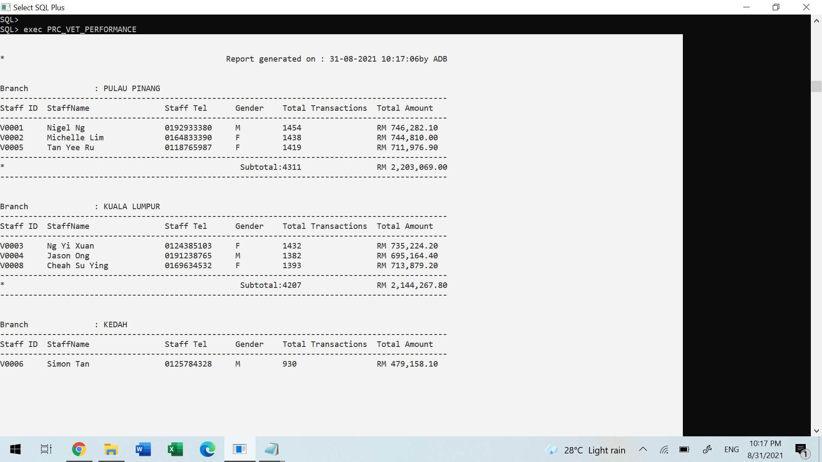

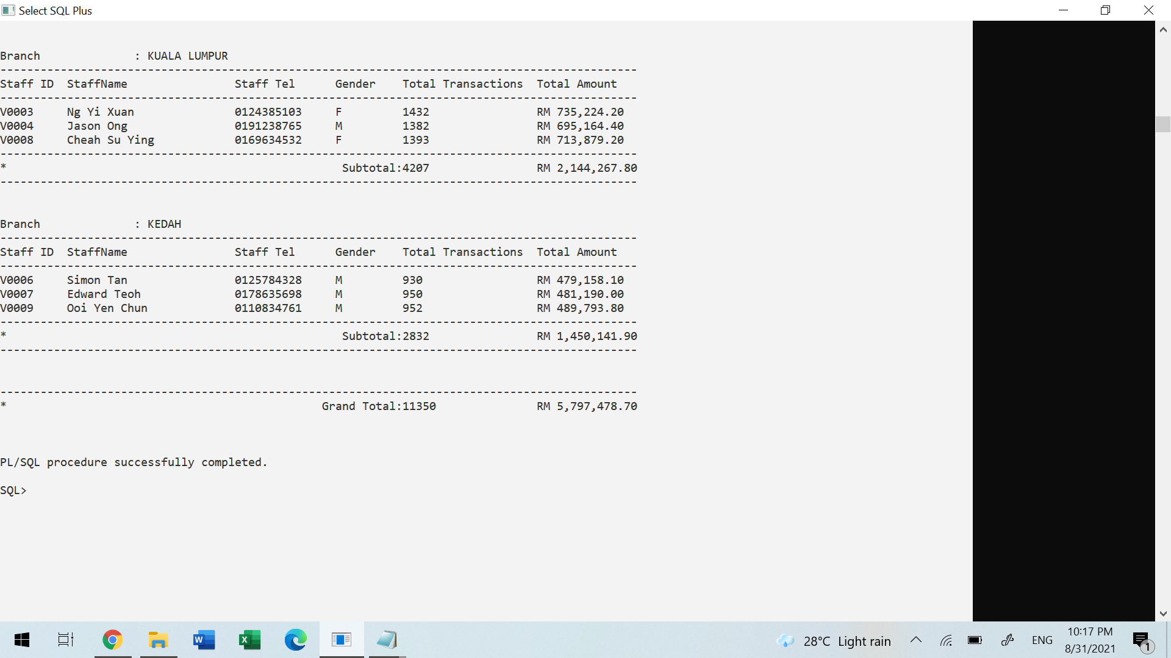

**4.2.9 Report 2: Summary report of Supplier Profile**

**Purpose: The purpose of this report is to summarize the supplier information such as the company details, what product they supplied to us and the purchase transaction details with them. At the end, we can know the total transaction made and total stock we get supplied from the specific supplier.**

SQL statement:

ALTER SESSION SET NLS_DATE_FORMAT = 'DD-MM-YYYY';

create or replace procedure prc_supplier_report(suppliercode in CHAR) Is

cursor purchaseTransaction_cursor Is

select p.purchase_id, p.purchase_date, p.receive_date, p.purchase_amount

from purchaseTransaction p, supplier s

where s.supplier_id = p.supplier_id

and p.supplier_id = suppliercode;

cursor purchaseItem_cursor Is

select m.medic_id, m.medic_name, sum(p.purchase_qty) as quantity

from medicalsupply m, purchaseItem p, purchaseTransaction t

where m.medic_id = p.medic_id

and t.purchase_id = p.purchase_id

and t.supplier_id = suppliercode

group by m.medic_id, m.medic_name

order by m.medic_id;

EXCE_SUPPLIERCODE EXCEPTION;

PRAGMA EXCEPTION_INIT(EXCE_SUPPLIERCODE, -20310);

totalorder number(11,2);

totalitem number(12,2):=0;

totalqty number(12,2):=0;

v_supplierID CHAR(6);

v_supplierName VARCHAR2(30);

v_suppliercontact NUMBER(15):=0;

V_VALIDSUPPLIERID CHAR(6);

V_prodrate NUMBER(5,2);

BEGIN

V_VALIDSUPPLIERID := SUPPLIERCODE;

IF V_VALIDSUPPLIERID = ' ' THEN

RAISE EXCE_SUPPLIERCODE;

ELSE

DBMS_OUTPUT.put_line(chr(10));

DBMS_OUTPUT.PUT_LINE('SUPPLIER SUMMARY REPORT FOR '||UPPER(SUPPLIERCODE));

DBMS_OUTPUT.PUT_LINE('*************************************');

SELECT S.supplier_id, supplier_name, supplier_contact INTO v_supplierid,v_suppliername,v_suppliercontact

FROM supplier S

WHERE S.supplier_id = suppliercode;

SELECT sum(purchase_qty) as TotalQty INTO TotalItem

FROM purchaseItem;

DBMS_OUTPUT.put_line(rpad('Supplier ID',20,' ')||':'||v_supplierid);

DBMS_OUTPUT.put_line(rpad('Supplier Name',20,' ')|| ':'||v_supplierName);

DBMS_OUTPUT.put_line(rpad('Supplier Contact',20,' ')|| ':'||v_suppliercontact);

DBMS_OUTPUT.put_line(chr(10));

totalorder := 0;

DBMS_OUTPUT.PUT_LINE('Past Supplied Record:');

DBMS_OUTPUT.PUT_LINE('|'||rpad('-',33,'-')||'|');

DBMS_OUTPUT.PUT_LINE('|'||rpad('Purchase ID',15,' ') ||' | '||rpad('Supplied Date',15,' ')||'|');

DBMS_OUTPUT.PUT_LINE('|'||rpad('-',33,'-')||'|');

for purch_rec in purchaseTransaction_cursor loop

IF purch_rec.receive_date IS NULL THEN

DBMS_OUTPUT.PUT_LINE('|'||rpad(purch_rec.purchase_id,15,' ') || ' | '||rpad('-',15,' ')||'|');

ELSE

DBMS_OUTPUT.PUT_LINE('|'||rpad(purch_rec.purchase_id,15,' ') || ' | '||rpad(purch_rec.receive_date,15,' ')||'|');

totalorder := totalorder + 1;

END IF;

END LOOP;

totalqty := 0;

DBMS_OUTPUT.PUT_LINE('|'||rpad('-',33,'-')||'|');

DBMS_OUTPUT.put_line(chr(10));

DBMS_OUTPUT.PUT_LINE('Top Items Supplied Percentage:');

DBMS_OUTPUT.PUT_LINE(rpad('-',54,'-'));

for purch_item in purchaseItem_cursor loop

V_prodrate:=0;

V_prodrate:= (purch_item.quantity/totalitem)*100;

DBMS_OUTPUT.PUT_LINE(rpad(purch_item.medic_id,8,' ') ||' * '|| rpad(purch_item.medic_name,30,' ')||' * ' ||lpad(V_prodrate,8,' ')||'%');

DBMS_OUTPUT.PUT_LINE(rpad('-',54,'-'));

totalqty := totalqty + purch_item.quantity;

END LOOP;

DBMS_OUTPUT.PUT_LINE(chr(10));

DBMS_OUTPUT.PUT_LINE('Total Orders Made :' ||totalorder);

DBMS_OUTPUT.PUT_LINE('Total Items Supplied :' ||totalqty);

END IF;

EXCEPTION

WHEN EXCE_SUPPLIERCODE THEN

DBMS_OUTPUT.PUT_LINE(-20310||'INVALID SUPPLIER CODE.');

END;

/

exec PRC_SUPPLIER_REPORT('S0001');

**Sample Output:**

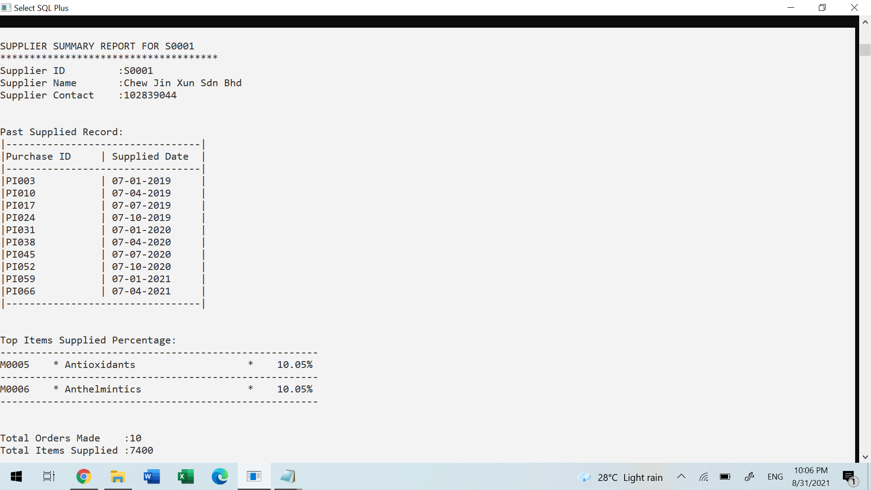

**4.2.10 Report 3: On demand report of Inventory value**

**Purpose: The purpose of this report is to get the detail of our company inventory value such as how many stocks we left for every medicine and how much does it cost, which means the property company has in the warehouse. At the end, we can know the total amount of inventory and cost.**

SQL statement:

set pagesize 1000

set linesize 200

create or replace procedure PRC_INVENTORY_REPORT is

cursor medic_cursor Is

select medic_id, medic_name, medic_qty, medic_price, (medic_qty*medic_price) as amount

from medicalsupply

group by medic_id, medic_name, medic_qty, medic_price

order by medic_id;

medic_c medic_cursor% ROWTYPE;

subtotal NUMBER;

totalqty NUMBER;

tunitcost NUMBER;

tproduct NUMBER;

grandqty NUMBER;

grandtotal NUMBER;

BEGIN

DBMS_OUTPUT.put_line(chr(10));

DBMS_OUTPUT.PUT_LINE(rpad(chr(9),7,chr(9))||rpad('Date',17,' ')||':'|| SYSDATE);

DBMS_OUTPUT.PUT_LINE(rpad(chr(9),7,chr(9))||rpad('Time',17,' ')||':'||TO_CHAR(SYSDATE,'HH24:MI:SS'));

DBMS_OUTPUT.PUT_LINE(rpad(chr(9),7,chr(9))||rpad('Day',17,' ')||':'||TO_CHAR(SYSDATE,'DAY'));

DBMS_OUTPUT.PUT_LINE(rpad(chr(9),7,chr(9))||rpad('Generated By',17,' ')||':' || USER);

DBMS_OUTPUT.put_line(chr(10));

DBMS_OUTPUT.PUT_LINE(' LATEST TOTAL INVENTORY VALUE REPORT');

DBMS_OUTPUT.PUT_LINE('***********************************');

DBMS_OUTPUT.PUT_LINE(rpad('-',7,'-')||' '||rpad('-',34,'-')||' '||rpad('-',11,'-')|| ' '||rpad('-',11,'-')||' '||rpad('-',17,'-'));

DBMS_OUTPUT.PUT_LINE(rpad('MedicID',8,' ')||rpad('Medic Name',35,' ')|| rpad('Stock Qty',12,' ')|| rpad('Unit Cost',13,' ')||rpad('Cost',15,' '));

DBMS_OUTPUT.PUT_LINE(rpad('-',7,'-')||' '||rpad('-',34,'-')||' '||rpad('-',11,'-')|| ' '||rpad('-',11,'-')||' '||rpad('-',17,'-'));

tproduct:=0;

Subtotal:=0;

totalqty:=0;

tunitcost:=0;

OPEN medic_cursor;

LOOP

FETCH medic_cursor INTO medic_c;

EXIT WHEN medic_cursor%NOTFOUND;

DBMS_OUTPUT.PUT_LINE(rpad(medic_c.medic_id,8,' ')||rpad(medic_c.medic_name,35,' ')|| rpad(medic_c.medic_qty,12,' ')||'RM'||lpad(TRIM(TO_CHAR(medic_c.medic_price,'999G999D99')),9,' ')||' RM'||lpad( TRIM(TO_CHAR(medic_c.Amount,'999G999D99')),15,' '));

subtotal:= subtotal + medic_c.Amount;

totalqty:=totalqty + medic_c.medic_qty;

tunitcost:=tunitcost+ medic_c.medic_price;

tproduct:= tproduct + 1;

END LOOP;

grandqty := totalqty;

grandtotal := subtotal;

DBMS_OUTPUT.PUT_LINE(rpad('-',7,'-')||' '||rpad('-',34,'-')||' '||rpad('-',11,'-')|| ' '||rpad('-',11,'-')||' '||rpad('-',17,'-'));

DBMS_OUTPUT.PUT_LINE(rpad('*',43,' ')||rpad(totalqty,12,' ')||'RM'|| lpad(TRIM(TO_CHAR(tunitcost,'999G999D99')),9,' ')||' RM'||lpad(TRIM(TO_CHAR(subtotal,'999G999G999D99')),15,' '));

DBMS_OUTPUT.PUT_LINE(rpad('-',7,'-')||' '||rpad('-',34,'-')||' '||rpad('-',11,'-')|| ' '||rpad('-',11,'-')||' '||rpad('-',17,'-'));

DBMS_OUTPUT.put_line(chr(10));

DBMS_OUTPUT.put_line('SUMMARY');

DBMS_OUTPUT.PUT_LINE(rpad('Total Inventory Items Count ',40,' ')||':'||grandqty|| ' item(s)' );

DBMS_OUTPUT.PUT_LINE(rpad('Total Inventory Value ',40,' ')||':RM'||TRIM(TO_CHAR(grandtotal,'999G999G999D99')) );

DBMS_OUTPUT.PUT_LINE(rpad('Total In House Product ',40,' ')||':'||tproduct|| ' product(s)' );

END;

/

EXEC PRC_INVENTORY_REPORT

**Sample Output:**

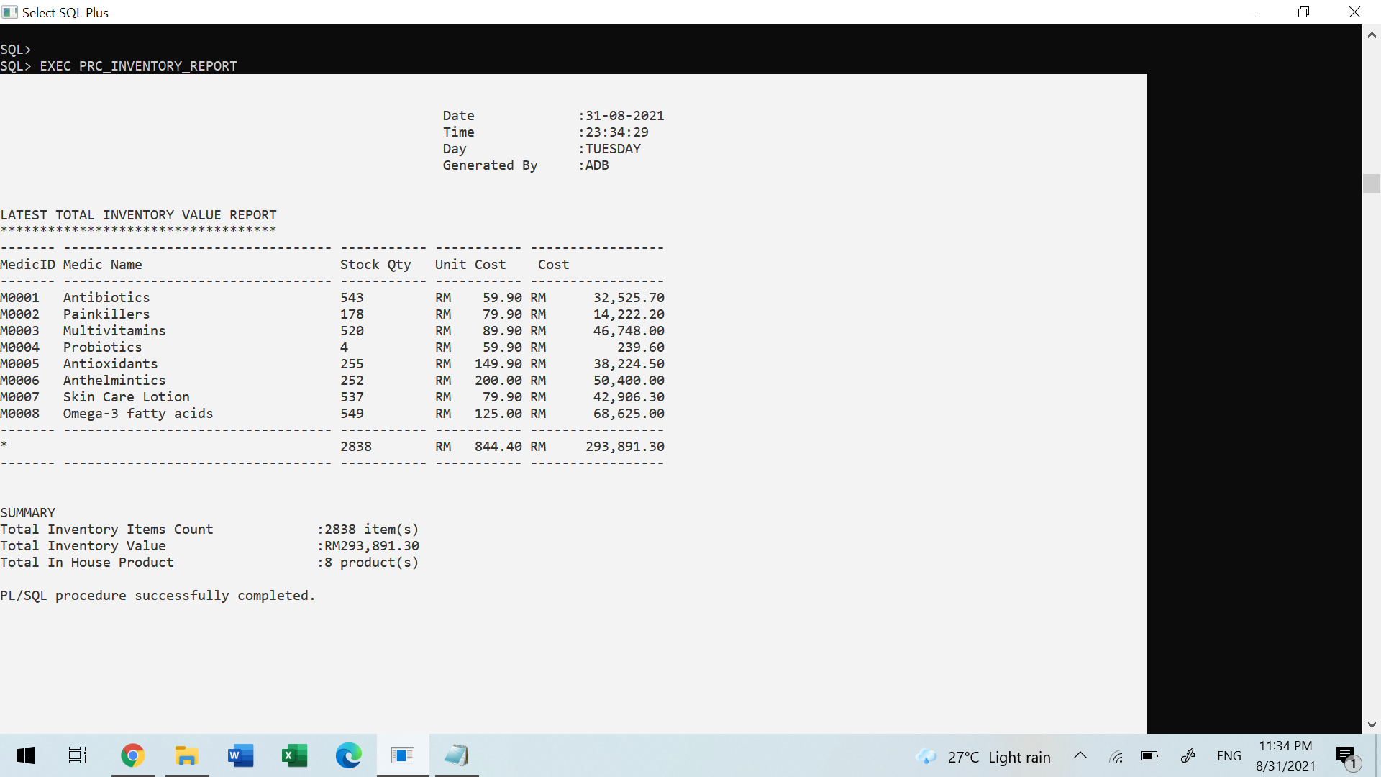

**4.3 (Tan Wei Siong)**

**4.3.1 Query 1: Top and Least Treatment Last Year for Each Branch**

**Purpose: The purpose of this query is to let the manager to view the top and least treatment in the last year for each branch. With the query, the manager can determine which treatment is not famous in the branch. Thus, the manager can make the pricing strategy to promote their least treatment to their customer. The manager can also know the quantity difference between the most and the least treatment .**

SET LINESIZE 150;

SET PAGESIZE 150;

COLUMN TREATMENT_TYPE FORMAT A30;

TTITLE CENTER ('TOP AND LEAST TREATMENT LAST YEAR FOR EACH BRANCH') SKIP 2

WITH outlets AS

(SELECT b.branch_id, t.treatment_id, t.treatment_type, COUNT(t.treatment_id) AS Branch_total_qty

FROM Treatment t, Appointment a, Transaction v, Branch b

WHERE t.treatment_id = a.treatment_id AND

a.appointment_id = v.appointment_id AND

b.branch_id = v.branch_id AND

Extract(year from Appointment_datetime) = Extract(year from sysdate)-1

GROUP by b.branch_id, t.treatment_id, t.treatment_type

order by 1,4),

mn_trans AS

(SELECT branch_id, MIN(Branch_total_qty) AS Least

FROM outlets

group by branch_id

ORDER BY 1),

mx_trans AS

(SELECT branch_id,MAX(Branch_total_qty) AS Top

FROM outlets

group by branch_id

ORDER BY 1)

SELECT A.branch_id,C.treatment_id, C.treatment_type, A.Least, D.treatment_id,D.treatment_type, B.Top

From mn_trans A JOIN mx_trans B ON (A.branch_id = B.branch_id)

JOIN outlets C ON (A.branch_id = C.branch_id) AND c.Branch_total_qty = A.Least

JOIN outlets D ON (A.branch_id = D.branch_id) AND D.Branch_total_qty = B.Top

ORDER BY 1;

**Sample Output:**

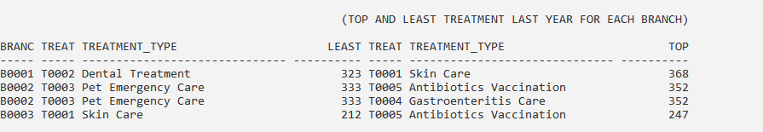

**4.3.2 Query 2: Selected Pet Type Age Group and Respective Visit Quantity**

**Purpose: The purpose of this query is to find the selected pet type and the total visit quantity. With this query, the management can determine the number of selected pet type age groups and the total visit for the age group. The management can find the most number of the age group for the pet but having the low number of visits and propose the strategy to attract the age group. For instance, if the newborn pet dog has a large quantity but low visit, the management can make a promotion plan on the suitable treatment to attract the potential customer.**

BREAK ON REPORT

TTITLE CENTER ('AGE GROUP PET AND TOTAL VISIT') SKIP 2

COMPUTE SUM OF Total_Visit ON REPORT;

COMPUTE SUM OF Total_Qty_Age_Group ON REPORT;

COLUMN type_id HEADING 'TYPE|ID';

COLUMN type_name HEADING 'TYPE|NAME';

COLUMN Total_Qty_Age_Group HEADING 'TOTAL|QTY|AGE|GROUP';

COLUMN Total_Visit HEADING 'TYPE|VISIT';

SET LINESIZE 80;

Accept life_span prompt "Please enter Max Life Span for the pet: " default 10

Accept petType_id prompt "Please enter PetType_ID: " default 10

WITH ageGroup as(

SELECT CASE

WHEN (EXTRACT (YEAR FROM sysdate) - EXTRACT(YEAR FROM p.pet_dob) > ROUND(&life_span * 2/3)) THEN 'Old'

WHEN (EXTRACT (YEAR FROM sysdate) - EXTRACT(YEAR FROM p.pet_dob) > ROUND(&life_span * 1/3)) THEN 'Adult'

ELSE 'New Born'

END AS age_group, p.pet_id, p.type_id, t.type_name

FROM Pet p, PetType t

WHERE p.type_id = t.type_id

ORDER BY 1

),

visitTime as (SELECT b.type_id, b.type_name, b.age_group,

COUNT(a.appointment_dateTime) AS Total_Visit

FROM ageGroup b, Appointment a

WHERE a.pet_id = b.pet_id

GROUP BY type_id, type_name, age_group

),

totalQtyAgeGroup as (SELECT type_id, type_name, age_group, COUNT(age_group) As Total_QTY_Age_Group

FROM ageGroup

GROUP BY type_id, type_name, age_group

)

SELECT V.type_id, v.type_name, v.age_group, t.Total_Qty_Age_Group, v.Total_Visit

FROM visitTime V

LEFT JOIN totalQtyAgeGroup t ON V.type_id = t.type_id AND t.age_group = v.age_group

WHERE V.type_id = UPPER('&petType_id')

ORDER BY 1,2;

**Sample Output:**



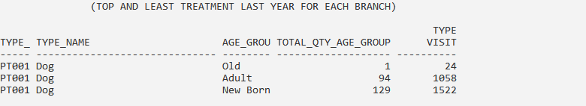

**4.3.3 Query 3: Gross Profit and Net Profit Previous Year**

**Purpose: The purpose of this query is to view the gross profit and net profit in the previous year. The profit will be listed in each month so that the management can know the performance of the pet clinic. The gross profit is calculated based on the transaction for all branches and the purchase amount is the sum of the purchase medicine stock price. The net profit will be calculated by gross profit - purchase amount.**

COLUMN GROSS_PROFIT FORMAT '9,999,999.99';

COLUMN PURCHASE_AMOUNT FORMAT '9,999,999.99';

COLUMN NET_PROFIT FORMAT '9,999,999.99';

COLUMN GROSS_PROFIT HEADING 'GROSS|PROFIT';

COLUMN PURCHASE_AMOUNT HEADING 'PURCHASE|AMOUNT';

COLUMN NET_PROFIT HEADING 'NET|PROFIT';

TTITLE CENTER ('GROSS AND NET PROFIT IN LAST YEAR') SKIP 2

SET LINESIZE 100;

SET PAGESIZE 200;

BREAK ON REPORT

COMPUTE SUM OF NET_PROFIT ON REPORT

COMPUTE SUM OF NO_Of_Transaction ON REPORT;

COMPUTE SUM OF GROSS_PROFIT ON REPORT;

COMPUTE SUM OF PURCHASE_AMOUNT ON REPORT;

COMPUTE SUM OF NET_PROFIT ON REPORT;

WITH last_year_transaction AS(

SELECT transaction_id, transaction_dateTime

FROM Transaction

WHERE Extract(year from(transaction_dateTime)) = extract(year from sysdate)-1),

last_year_purchase AS(

SELECT purchase_id , purchase_Date, purchase_Amount

FROM PurchaseTransaction

WHERE Extract(year from(purchase_Date)) = Extract(year from sysdate)-1),

purchase_detail AS(

SELECT EXTRACT(Month from v.purchase_Date) AS Month_NO,

TO_CHAR(v.purchase_Date,'MON') as Month,

COUNT(v.purchase_id) AS NO_Of_Purchase,

SUM(v.purchase_Amount) AS PURCHASE_AMOUNT

FROM last_year_purchase v

GROUP BY EXTRACT (Month from v.purchase_Date),

TO_CHAR(v.purchase_Date,'MON')

)

SELECT EXTRACT(Month from v.transaction_dateTime) AS Month_NO,

TO_CHAR(v.transaction_dateTime,'MON') as Month,

COUNT(v.transaction_id) AS NO_Of_Transaction,

SUM(t.total_amount) AS GROSS_PROFIT,

l.purchase_Amount AS PURCHASE_AMOUNT,

SUM(t.total_amount) - l.purchase_Amount AS NET_PROFIT

FROM last_year_transaction v, Transaction t

LEFT JOIN purchase_detail l ON l.Month_NO =

EXTRACT(Month from transaction_dateTime)

WHERE v.transaction_id = t.transaction_id

GROUP BY EXTRACT (Month from v.transaction_dateTime),

TO_CHAR(v.transaction_dateTime,'MON'),

l.purchase_Amount

ORDER BY 1;

**Sample Output:**

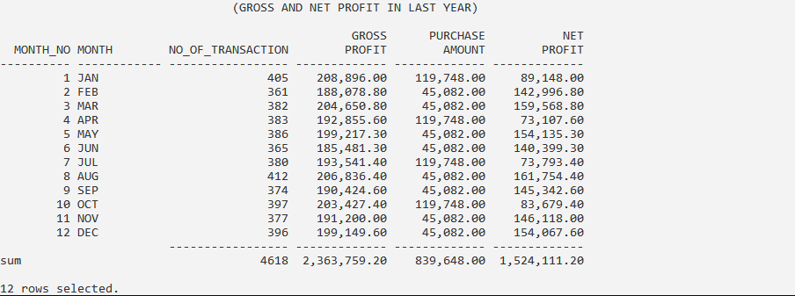

**4.3.4 Procedure 1: Pet Registration**

**Purpose: The purpose of this procedure is to let the staff register the pet in an easier way. The staff is only required to input the owner's phone number and their pet information into this procedure and the data will be stored in the database. If the owner contact is not found, an error message will appear to alert the user to check the contact number input or ask them to register the pet owner first before registering the pet details.**

**Procedure code:**

CREATE OR REPLACE Procedure Prc_register_pet(in_owner_Contact IN VARCHAR2, in_pet_Name IN VARCHAR2, in_pet_dob IN Date, in_pet_type IN CHAR) AS

No_owner_found EXCEPTION;

PRAGMA exception_init(No_owner_found,-20201);

v_petOwner_id PetOwner.owner_id%TYPE;

v_owner_name PetOwner.owner_name%TYPE;

v_pet_id Pet.pet_id%TYPE;

v_sequence NUMBER;

BEGIN

SELECT owner_id, owner_name INTO v_petOwner_id, v_owner_name

FROM PetOwner

WHERE owner_contact = in_owner_Contact;

IF SQL%FOUND THEN

SELECT pet_seq.nextVal INTO v_sequence FROM dual;

v_pet_id := TO_CHAR('P'||v_sequence);

Insert into Pet values(v_pet_id, v_petOwner_id, in_pet_Name, in_pet_dob, in_pet_type);

dbms_output.put_line('The pet has been inserted.');

dbms_output.put_line(chr(10));

dbms_output.put_line('PET REGISTER DETAIL');

dbms_output.put_line((LPAD('=',20,'=')));

dbms_output.put_line('Owner ID :'||v_petOwner_id);

dbms_output.put_line('Owner Name :'||v_owner_name);

dbms_output.put_line('Pet ID :'||v_pet_id);

dbms_output.put_line('Pet Name :'||in_pet_Name);

dbms_output.put_line('Pet Dob :'||in_pet_dob);

dbms_output.put_line('Pet Type :'||in_pet_type);

END IF;

EXCEPTION

WHEN NO_DATA_FOUND THEN

RAISE_application_error(-20201,'The owner is not exist! Check Phone No or create new owner.');

END;

/

**Sample Output:**

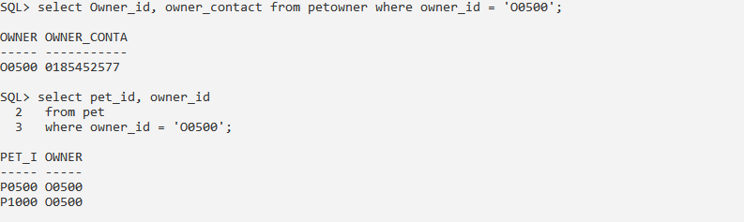

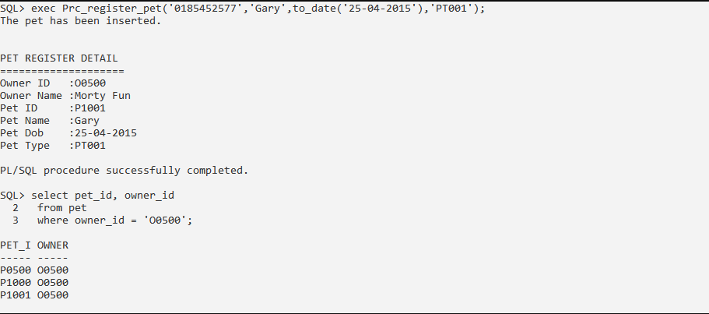

**Exception**

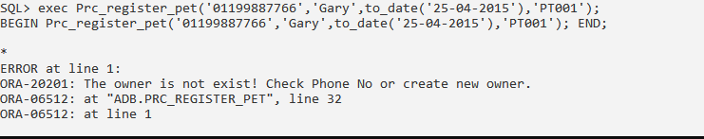

**4.3.5 Procedure 2: Display Owner Information**

**Purpose: The purpose of this procedure is to list the owner's pet information. With this procedure, the staff can know all the pet details of the owner. For instance, last visit date for the pet and total visit quantity.**

**Procedure code:**

CREATE OR REPLACE Procedure Prc_show_owner_info(in_owner_Contact IN VARCHAR2) AS

CURSOR owner_list IS

SELECT o.owner_id, o.owner_name, p.pet_id, p.pet_name,

t.type_name AS pet_Type, MAX(appointment_datetime) AS last_Vist,

COUNT(appointment_datetime) AS Total_Visit

FROM PetOwner o, Pet p, Appointment a, PetType t

WHERE o.owner_contact = 0185452577 AND

a.pet_id = p.pet_id AND

t.type_id = p.type_id AND

o.owner_id = p.owner_id

Group by o.owner_id, o.owner_name, p.pet_id, p.pet_name, t.type_name

Order by 3;

owner_r owner_list%ROWTYPE;

v_count NUMBER;

BEGIN

v_count := 0;

OPEN owner_list;

LOOP

FETCH owner_list INTO owner_r;

EXIT WHEN owner_list%NOTFOUND;

IF (v_count = 0) THEN

dbms_output.put_line(' OWNER DETAIL');

dbms_output.put_line((LPAD('=',22,'=')));

dbms_output.put_line('Owner ID :'||owner_r.owner_id);

dbms_output.put_line('Owner Name :'||owner_r.owner_name);

dbms_output.put_line(chr(10));

dbms_output.put_line(' PET DETAIL');

dbms_output.put_line((LPAD('=',22,'=')));

END IF;

dbms_output.put_line('Pet ID :'||owner_r.pet_id);

dbms_output.put_line('Pet Name :'||owner_r.pet_name);

dbms_output.put_line('Pet Type :'||owner_r.pet_Type);

dbms_output.put_line('Last Visit On :'||owner_r.last_Vist);

dbms_output.put_line('Total Visit :'||owner_r.Total_Visit);

dbms_output.put_line(chr(10));

v_count := v_count + 1;

END LOOP;

CLOSE owner_list;

END;

/

**Sample Output:**

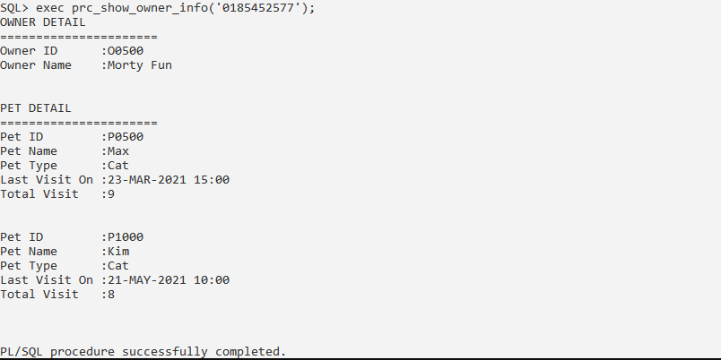

**4.3.6 Trigger 1: Check Owner Age**

**Purpose: The purpose of this trigger is to check the owner's age. If the owner is less than 18, this trigger will occur and generate the error message and disallow the data insert into the database.**

**Trigger code:**

CREATE OR REPLACE TRIGGER trgOwnerAge

BEFORE INSERT OR UPDATE ON PetOwner

FOR EACH ROW

BEGIN

IF((ROUND((SYSDATE-:new.owner_dob )/365)) < 18) THEN

RAISE_APPLICATION_ERROR(-20004, 'Pet Owner must be at least 18 years old.' );

END IF;

END;

/

**Sample Output:**

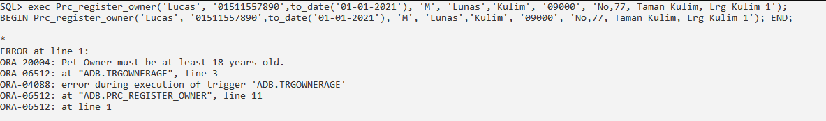

**4.3.7 Trigger 2: Check Appointment Date Time**

**Purpose: The purpose of this trigger is to check the appointment date time. If the selected date and time for the selected vet has been appointed, this trigger will not allow the appointment to be made and prompt the suggested time to the user.**

**Trigger code:**

ALTER SESSION SET NLS_DATE_FORMAT = 'DD-MM-YYYY HH24:MI:SS';

CREATE OR REPLACE TRIGGER TRG_CHK_APPOINTMENT_DATE

BEFORE INSERT ON Appointment

FOR EACH ROW

DECLARE

Date_Time_Booked EXCEPTION;

PRAGMA exception_init(Date_Time_Booked, -20200 );

v_tempDate DATE;

v_startDate DATE;

v_BOOKED_APPOINTMENT DATE;

v_appointment_dateTime DATE;

v_count NUMBER;

v_check NUMBER;

v_cursorLength NUMBER;

CURSOR c1 IS

SELECT appointment_dateTime

FROM Appointment

WHERE EXTRACT(YEAR FROM(appointment_dateTime)) = EXTRACT(YEAR FROM(:new.appointment_dateTime)) AND

EXTRACT(Month FROM(appointment_dateTime)) = EXTRACT(Month FROM(:new.appointment_dateTime)) AND

EXTRACT(DAY FROM(appointment_dateTime)) = EXTRACT(DAY FROM(:new.appointment_dateTime)) AND

vet_id = :new.vet_id;

CURSOR c2 IS

SELECT appointment_dateTime

FROM Appointment

WHERE EXTRACT(YEAR FROM(appointment_dateTime)) = EXTRACT(YEAR FROM(:new.appointment_dateTime)) AND

EXTRACT(Month FROM(appointment_dateTime)) = EXTRACT(Month FROM(:new.appointment_dateTime)) AND

EXTRACT(DAY FROM(appointment_dateTime)) = EXTRACT(DAY FROM(:new.appointment_dateTime)) AND

vet_id = :new.vet_id;

BEGIN

v_startDate := TRUNC(:new.appointment_dateTime);

v_count := 0;

v_cursorLength := 0;

SELECT a.appointment_dateTime into V_appointment_dateTime

FROM Appointment a

WHERE a.appointment_dateTime = :new.appointment_dateTime AND

a.vet_id = :new.vet_id;

IF SQL%FOUND THEN

dbms_output.put_line('The time has been book.');

OPEN c1;

LOOP

FETCH c1 INTO v_tempDate;

EXIT WHEN c1%NOTFOUND;

v_cursorLength := v_cursorLength+1;

END LOOP;

IF v_cursorLength > 7 THEN

dbms_output.put_line('The vet is fulled on this date. Please choose other vet or change date.');

RAISE_application_error(-20200,'The Date Time has been booked');

END IF;

v_startDate := v_startDate + 10/24;

dbms_output.put_line('Suggested Date Time');

dbms_output.put_line('===================');

WHILE v_count <= 7

LOOP

v_check := 0;

OPEN c2;

LOOP

FETCH c2 INTO v_booked_appointment;

EXIT WHEN c2%NOTFOUND;

IF (v_startDate != v_booked_appointment AND v_check <= v_cursorLength) THEN

v_check := v_check + 1;

END IF;

END LOOP;

CLOSE c2;

IF v_check = v_cursorLength THEN

dbms_output.put_line(v_startDate);

END IF;

v_count := v_count + 1;

v_startDate := v_startDate + 1/24;

END LOOP;

dbms_output.put_line('===================');

dbms_output.put_line('Available time slot on '|| v_startDate ||' for the selected vet is shown above.' );

RAISE_application_error(-20200,'The Date Time has been booked');

END IF;

EXCEPTION

WHEN NO_DATA_FOUND THEN

dbms_output.put_line('The appointment has been add.');

END;

/

**Sample Output:**

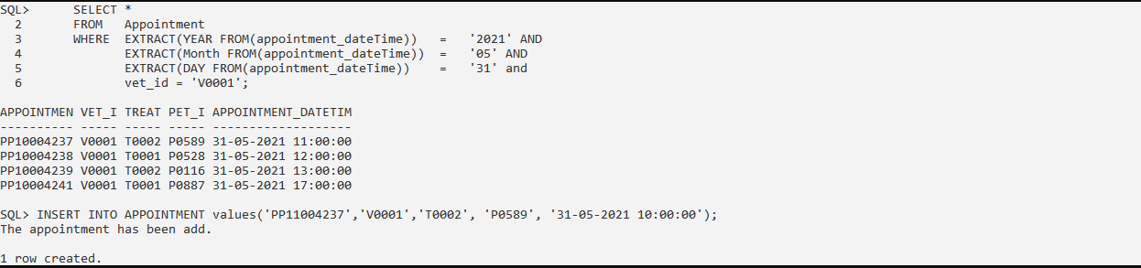

**4.3.8 Report 1: Summary Report of Treatment Revenue in Selected Year**

**Purpose: The purpose of this summary report is to show the treatment revenue for the selected year. This report can help the management to understand the total treatment quantity and revenue for each branch in the selected year. This report can help the management to know which treatment is most famous or profitable in each branch. This report can help the management to gain the insight of the treatment for each branch.**

**Report code:**

set linesize 175;

set pagesize 200;

e_invalid_year EXCEPTION;

PRAGMA EXCEPTION_INIT(e_invalid_year, -20166);

CURSOR pet_detail_list IS

CREATE OR REPLACE PROCEDURE rpt_treatment_revenue(IN_YEAR IN NUMBER) AS

CURSOR treatment_list IS

SELECT b.branch_id, t.treatment_id, t.treatment_type as treatment_name,

t.treatment_price as Price,

COUNT(t.treatment_price) as qty,

SUM(t.treatment_price) as Total_Treatment_Earn

FROM Treatment t, Appointment a, Branch b, Transaction v

WHERE b.branch_id = v.branch_id AND

v.appointment_id = a.appointment_id AND

a.treatment_id = t.treatment_id AND

EXTRACT(YEAR FROM(v.transaction_dateTime)) = IN_YEAR

GROUP BY b.branch_id, t.treatment_id, t.treatment_type,

t.treatment_price

ORDER BY 1;

treatment_list_r treatment_list%ROWTYPE;

v_count NUMBER;

v_revenue NUMBER;

v_total_revenue NUMBER;

v_branch_id VARCHAR2(5);

BEGIN

IF IN_YEAR > Extract(Year From(sysdate)+1) or IN_YEAR < 2019 THEN

RAISE_application_error(-20166,'Invalid year');

END IF;

DBMS_OUTPUT.PUT_LINE(chr(10));

DBMS_OUTPUT.PUT_LINE(RPAD('*', 50, ' ') || 'Summary Treatment Revenue Report in '|| IN_YEAR);

DBMS_OUTPUT.PUT_LINE(RPAD('*', 50, ' ') || RPAD('_', 40,'_'));

DBMS_OUTPUT.PUT_LINE(chr(10));

DBMS_OUTPUT.PUT_LINE(RPAD('*', 72, ' ') || 'Report generated on : ' ||

TO_CHAR(CURRENT_DATE, 'DD-MM-YYYY HH:MI:SS ') ||

'by ' || USER);

DBMS_OUTPUT.PUT_LINE(chr(10));

v_count := 0;

v_revenue :=0;

v_total_revenue :=0;

v_branch_id := ' ';

OPEN treatment_list;

LOOP

FETCH treatment_list INTO treatment_list_r;

EXIT WHEN treatment_list%NOTFOUND;

IF v_count > 0 AND v_branch_id != treatment_list_r.branch_id THEN

DBMS_OUTPUT.PUT_LINE(LPAD('-', 120, '-'));

DBMS_OUTPUT.PUT_LINE(chr(10));

DBMS_OUTPUT.PUT_LINE(RPAD('--------------------', 75, ' ') ||'--------------------');

DBMS_OUTPUT.PUT_LINE(RPAD('Total Earn :', 83, ' ') ||'RM ' || v_revenue);

DBMS_OUTPUT.PUT_LINE(RPAD('--------------------', 75, ' ') ||'--------------------');

DBMS_OUTPUT.PUT_LINE(chr(10));

DBMS_OUTPUT.PUT_LINE(chr(10));

v_total_revenue := v_total_revenue + v_revenue;

v_revenue :=0;

END IF;

IF v_count = 0 OR v_branch_id != treatment_list_r.branch_id THEN

DBMS_OUTPUT.PUT_LINE(LPAD('-', 30, '-'));

DBMS_OUTPUT.PUT_LINE(RPAD('Branch ID', 15, ' ') || ': ' ||

RPAD(UPPER(treatment_list_r.branch_id), 10, ' '));

DBMS_OUTPUT.PUT_LINE(LPAD('-', 30, '-'));

DBMS_OUTPUT.PUT_LINE(chr(10));

DBMS_OUTPUT.PUT_LINE(LPAD('=', 120, '='));

DBMS_OUTPUT.PUT_LINE(RPAD('Treatment ID', 20, ' ') ||

RPAD('Treatment Name', 30, ' ') ||

RPAD('Price',18, ' ') ||

RPAD('Quantity',15, ' ') ||

RPAD('Revenue',20, ' ')

);

DBMS_OUTPUT.PUT_LINE(LPAD('=', 120, '='));

END IF;

DBMS_OUTPUT.PUT_LINE(RPAD(treatment_list_r.treatment_id, 20, ' ')||

RPAD(treatment_list_r.treatment_name, 30, ' ')||

'RM ' ||RPAD(treatment_list_r.Price, 15, ' ')||

RPAD(treatment_list_r.qty, 15, ' ')||

'RM ' ||RPAD(treatment_list_r.Total_Treatment_Earn, 20, ' ')

);

v_count := v_count + 1;

v_revenue := v_revenue + treatment_list_r.Total_Treatment_Earn;

v_branch_id := treatment_list_r.branch_id;

END LOOP;

DBMS_OUTPUT.PUT_LINE(LPAD('-', 120, '-'));

DBMS_OUTPUT.PUT_LINE(chr(10));

DBMS_OUTPUT.PUT_LINE(RPAD('--------------------', 77, ' ') ||'--------------------');

DBMS_OUTPUT.PUT_LINE(RPAD('Total Earn :', 83, ' ') ||'RM ' || v_revenue);

DBMS_OUTPUT.PUT_LINE(RPAD('--------------------', 77, ' ') ||'--------------------');

DBMS_OUTPUT.PUT_LINE(chr(10));

v_total_revenue := v_total_revenue + v_revenue;

DBMS_OUTPUT.PUT_LINE(RPAD('=========================', 77, ' ') ||'====================');

DBMS_OUTPUT.PUT_LINE(RPAD('Total Treatment Revenue: ', 83, ' ') || 'RM ' || v_total_revenue);

DBMS_OUTPUT.PUT_LINE(RPAD('=========================', 77, ' ') ||'====================');

DBMS_OUTPUT.PUT_LINE(chr(10));

DBMS_OUTPUT.PUT_LINE(RPAD('*', 92, ' ')||'End of report');

END;

/

**Sample Output:**

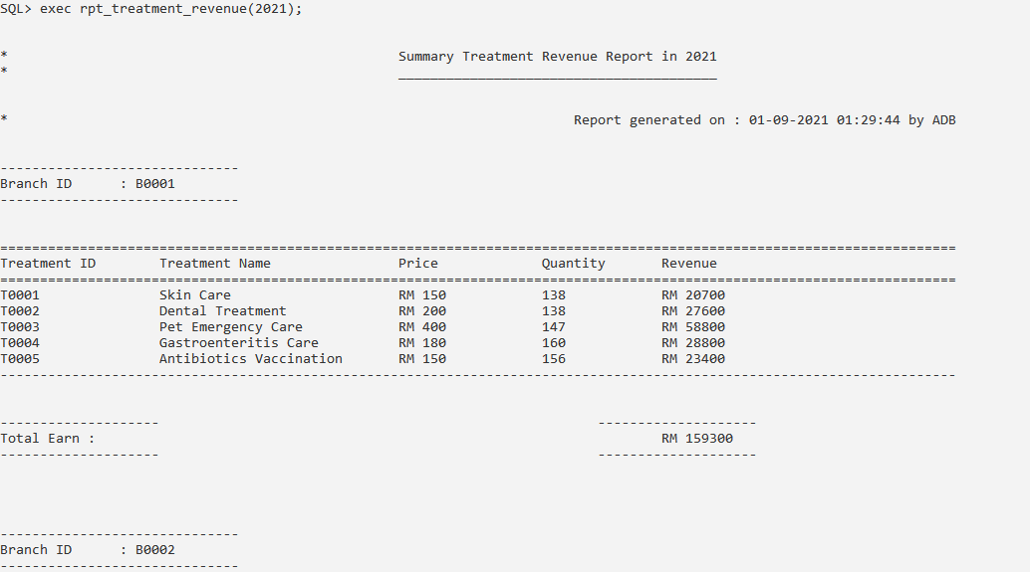

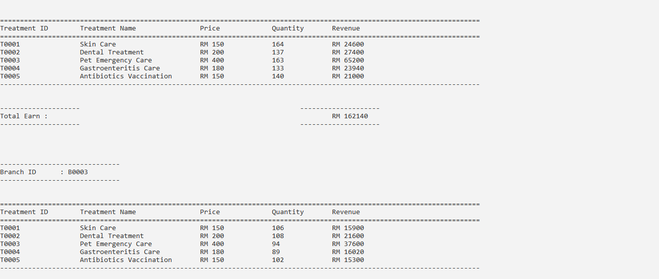

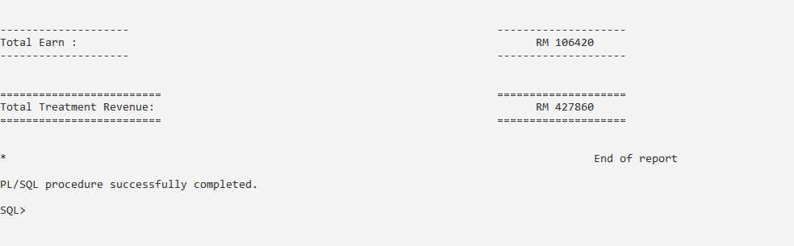

**4.3.9 Report 2: Detail Report of Medic Performance**

**Purpose: The purpose of this detailed report is to show all medic performance from the start of the business until today. It will show the total purchase, total sales, stock quantity, gross profit and gross profit margin for each medicine. This report can help the management to know the performance of their medicine.**

**The calculation is show below:**

**Stock Quantity = Purchase quantity - sold quantity**

**Revenue = Sales price * sold quantity**

**Cost of good sold(COSG) = Purchase price * sold quantity**

**Gross profit = Revenue - COSG**

**Gross profit margin = Gross profit / Revenue * 100**

**Report code:**

ALTER SESSION SET NLS_DATE_FORMAT = 'DD-MM-YYYY';

set linesize 170;

set pagesize 200;

CREATE OR REPLACE PROCEDURE rpt_medic_performance AS

CURSOR medic_list IS

SELECT s.supplier_id, s.supplier_name, s.supplier_contact, m.medic_id,

m.medic_name, i.purchase_price, SUM(i.purchase_qty) as Purchase_qty,

m.medic_price as Sales_price, m.medic_qty as stock,

(SUM(i.purchase_qty)- m.medic_qty) as Sold_qty

FROM Supplier s, PurchaseTransaction p, PurchaseItem i,

MedicalSupply m

WHERE s.supplier_id = p.supplier_id AND

p.purchase_id = i.purchase_id AND

i.medic_id = m.medic_id

GROUP BY s.supplier_id, s.supplier_name, s.supplier_contact,

m.medic_id, m.medic_name, i.purchase_price,

m.medic_price, m.medic_qty

ORDER BY 1;

medic_list_r medic_list%ROWTYPE;

v_supplier_id VARCHAR(5);

v_count NUMBER;

v_count2 NUMBER;

grossProfit NUMBER(11,2);

grossProfitMargin NUMBER(11,2);

revenue NUMBER(15,2);

COGS NUMBER(15,2);

totalGrossProfit NUMBER(15,2);

BEGIN

v_count := 0;

v_count2 := 0;

grossProfit := 0;

grossProfitMargin := 0;

revenue := 0;

COGS := 0;

v_supplier_id := ' ';

totalGrossProfit := 0;

DBMS_OUTPUT.PUT_LINE(chr(10));

DBMS_OUTPUT.PUT_LINE(RPAD('*', 60, ' ') || 'Detail Medic Performance Report');

DBMS_OUTPUT.PUT_LINE(RPAD('*', 60, ' ') || 'Since 01-01-2019' ||' to '|| sysdate);

DBMS_OUTPUT.PUT_LINE(RPAD('*', 60, ' ') || RPAD('_', 31,'_'));

DBMS_OUTPUT.PUT_LINE(chr(10));

DBMS_OUTPUT.PUT_LINE(RPAD('*', 92, ' ') || 'Report generated on : ' ||

TO_CHAR(CURRENT_DATE, 'DD-MM-YYYY HH:MI:SS ') ||

'by ' || USER);

DBMS_OUTPUT.PUT_LINE(chr(10));

OPEN medic_list;

LOOP

FETCH medic_list INTO medic_list_r;

EXIT WHEN medic_list%NOTFOUND;

IF v_count > 0 AND v_supplier_id != medic_list_r.supplier_id THEN

DBMS_OUTPUT.PUT_LINE(LPAD('-', 165, '-'));

DBMS_OUTPUT.PUT_LINE('.'||LPAD(v_count2||' records found for supplier ' || v_supplier_id|| '.', 155, ' '));

DBMS_OUTPUT.PUT_LINE(chr(10));

totalgrossprofit := 0;

v_count2 := 0;

END IF;

IF v_count = 0 OR v_supplier_id != medic_list_r.supplier_id THEN

DBMS_OUTPUT.PUT_LINE(LPAD('-', 16, '-'));

DBMS_OUTPUT.PUT_LINE(RPAD('Supplier Detail', 15, ' ') || ': ' ||

RPAD(UPPER(medic_list_r.supplier_id), 8, ' ') ||

RPAD(UPPER(medic_list_r.supplier_name), 30, ' ') ||

RPAD(UPPER(medic_list_r.supplier_contact), 15, ' '));

DBMS_OUTPUT.PUT_LINE(LPAD('-', 16, '-'));

DBMS_OUTPUT.PUT_LINE(chr(10));

DBMS_OUTPUT.PUT_LINE(LPAD('=', 165, '='));

DBMS_OUTPUT.PUT_LINE(RPAD('Medical', 37, ' ') ||

RPAD('Purchase Cost',15, ' ') ||

RPAD('Sales Price',15, ' ') ||

RPAD('Total Purchase',17, ' ') ||

RPAD('Sold Qty',10, ' ') ||

RPAD('Stock',8, ' ') ||

RPAD('Revenue',15, ' ') ||

RPAD('COGS',15, ' ') ||

RPAD('Gross Profit',15, ' ') ||

RPAD('GP Margin %',10, ' ')

);

DBMS_OUTPUT.PUT_LINE(LPAD('=', 165, '='));

END IF;

revenue := medic_list_r.Sales_price* medic_list_r.Sold_qty;

COGS := medic_list_r.purchase_price * medic_list_r.Sold_qty;

grossProfit := revenue - COGS;

grossProfitMargin := grossProfit / revenue * 100;

DBMS_OUTPUT.PUT_LINE(RPAD(medic_list_r.medic_id, 7, ' ') ||

RPAD(medic_list_r.medic_name, 30, ' ') ||

RPAD('RM'||(TRIM(TO_CHAR(medic_list_r.purchase_price, '9999D99'))), 15, ' ') ||

RPAD('RM'||(TRIM(TO_CHAR(medic_list_r.Sales_price, '9999D99'))), 15, ' ') ||

RPAD(medic_list_r.purchase_qty,17, ' ') ||

RPAD(medic_list_r.Sold_qty,10, ' ') ||

RPAD(medic_list_r.stock,8, ' ') ||

RPAD('RM'||(TRIM(TO_CHAR(revenue, '999999999D99'))), 15, ' ') ||

RPAD('RM'||(TRIM(TO_CHAR(COGS, '999999999D99'))), 15, ' ') ||

RPAD('RM'||(TRIM(TO_CHAR(grossprofit, '999999999D99'))), 15, ' ') ||

RPAD(TRIM(TO_CHAR(grossProfitMargin, '999D99')) || '%', 10, ' ')

);

v_count := v_count + 1;

v_count2 := v_count2 + 1;

revenue := 0;

COGS := 0;

v_supplier_id := medic_list_r.supplier_id;

END LOOP;

DBMS_OUTPUT.PUT_LINE(LPAD('-', 165, '-'));

DBMS_OUTPUT.PUT_LINE('.'||LPAD(v_count2||' records found for supplier ' || v_supplier_id|| '.', 155, ' '));

DBMS_OUTPUT.PUT_LINE(chr(10));

DBMS_OUTPUT.PUT_LINE(RPAD('*', 135, ' ')||'End of report');

END;

/

**Sample Output:**

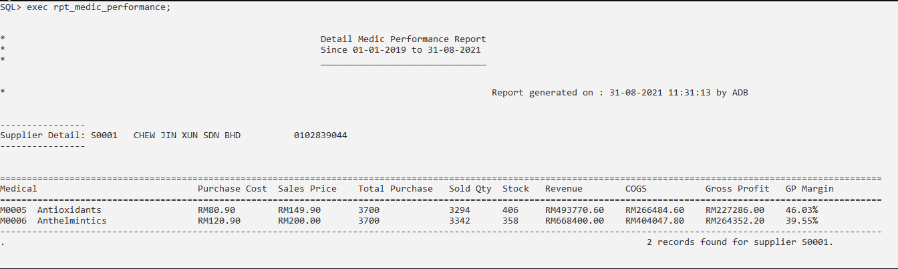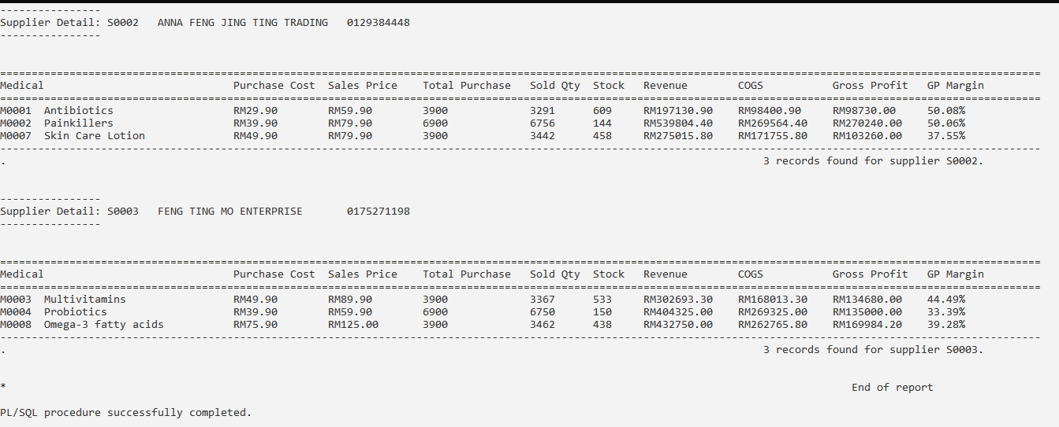

**4.3.10 Report 3: On-demand Report of the Pet Treatment Detail**

**Purpose: The purpose of this on-demand report is to let the veterinarian view the pet treatment history. This report will show all treatment, treatment date and handle veterinarian for the selected pet. It can help the veterinarian to know the condition of the pet and provide the most suitable treatment or medicine for it.**

**Report code:**

ALTER SESSION SET NLS_DATE_FORMAT = 'DD-MM-YYYY HH24:MI:SS';

set linesize 125;

CREATE OR REPLACE PROCEDURE rpt_pet_treatment_detail(IN_PETID IN CHAR) AS

NO_PET_FOUND EXCEPTION;

PRAGMA EXCEPTION_INIT(NO_PET_FOUND, -20202);

CURSOR pet_detail_list IS

SELECT o.owner_id, o.owner_name, p.pet_id,

p.pet_name,t.type_name AS pet_Type,

a.appointment_id,

a.appointment_datetime, m.treatment_id,

m.treatment_type AS treatment_name, v.vet_id, v.vet_name

FROM PetOwner o, Pet p, PetType t,

Veterinarian v,Appointment a,

Treatment m

WHERE o.owner_id = p.owner_id AND

p.type_id = t.type_id AND

p.pet_id = a.pet_id AND

p.pet_id = UPPER(IN_PETID) AND

a.vet_id = v.vet_id AND

m.treatment_id = a.treatment_id

ORDER BY 7;

pet_detail_r pet_detail_list%ROWTYPE;

v_count NUMBER;

BEGIN

DBMS_OUTPUT.PUT_LINE(chr(10));

DBMS_OUTPUT.PUT_LINE(RPAD('*', 50, ' ') || 'Pet Treatment Detail Report');

DBMS_OUTPUT.PUT_LINE(RPAD('*', 50, ' ') || RPAD('_', 30,'_'));

DBMS_OUTPUT.PUT_LINE(chr(10));

DBMS_OUTPUT.PUT_LINE(RPAD('*', 72, ' ') || 'Report generated on : ' ||

TO_CHAR(CURRENT_DATE, 'DD-MM-YYYY HH:MI:SS ') ||

'by ' || USER);

DBMS_OUTPUT.PUT_LINE(chr(10));

v_count := 0;

OPEN pet_detail_list;

LOOP

FETCH pet_detail_list INTO pet_detail_r;

EXIT WHEN pet_detail_list%NOTFOUND;

IF (v_count = 0) THEN

DBMS_OUTPUT.PUT_LINE(LPAD('-', 55, '-'));

DBMS_OUTPUT.PUT_LINE(RPAD('Owner Detail', 15, ' ') || ': ' ||

RPAD(UPPER(pet_detail_r.owner_id), 10, ' ') ||

RPAD(UPPER(pet_detail_r.owner_name), 40, ' '));

DBMS_OUTPUT.PUT_LINE(LPAD('-', 55, '-'));

DBMS_OUTPUT.PUT_LINE(chr(10));

DBMS_OUTPUT.PUT_LINE(RPAD('Pet Detail', 15, ' ' ) || ': ' ||

RPAD(UPPER(pet_detail_r.pet_id), 10, ' ')||

RPAD(UPPER(pet_detail_r.pet_name), 40, ' ')||

RPAD('Type', 10, ' ' ) || ': ' ||

RPAD(UPPER(pet_detail_r.pet_Type), 20, ' '));

DBMS_OUTPUT.PUT_LINE(LPAD('=', 120, '='));

DBMS_OUTPUT.PUT_LINE(RPAD('Appointment ID', 20, ' ') ||

RPAD('Appointment Date Time', 25, ' ') ||

RPAD('Treatment ID',15, ' ') ||

RPAD('Treatment Name',30, ' ') ||

RPAD('Handle By:',40, ' ')

);

DBMS_OUTPUT.PUT_LINE(LPAD('=', 120, '='));

END IF;

DBMS_OUTPUT.PUT_LINE(RPAD(pet_detail_r.appointment_id, 20, ' ')||

RPAD(pet_detail_r.appointment_datetime, 25, ' ')||

RPAD(pet_detail_r.treatment_id, 15, ' ')||

RPAD(pet_detail_r.treatment_name, 30, ' ')||

RPAD(pet_detail_r.vet_id, 7, ' ')||

RPAD(pet_detail_r.vet_name, 30, ' ')

);

v_count := v_count + 1;

END LOOP;

IF v_count = 0 THEN

RAISE_application_error(-20202,'No pet found');

END IF;

DBMS_OUTPUT.PUT_LINE(LPAD('-', 120, '-'));

DBMS_OUTPUT.PUT_LINE(chr(10));

DBMS_OUTPUT.PUT_LINE(RPAD('====================', 85, ' ') ||'====================');

DBMS_OUTPUT.PUT_LINE(RPAD('Total Appointment :', 95, ' ') || v_count);

DBMS_OUTPUT.PUT_LINE(RPAD('====================', 85, ' ') ||'====================');

DBMS_OUTPUT.PUT_LINE(chr(10));

DBMS_OUTPUT.PUT_LINE(RPAD('*', 92, ' ')||'End of report');

END;

/

**Sample Output:**

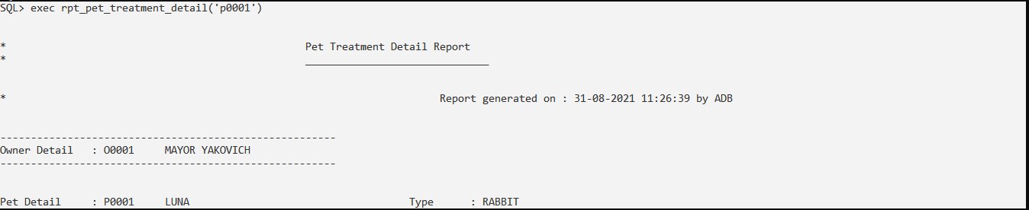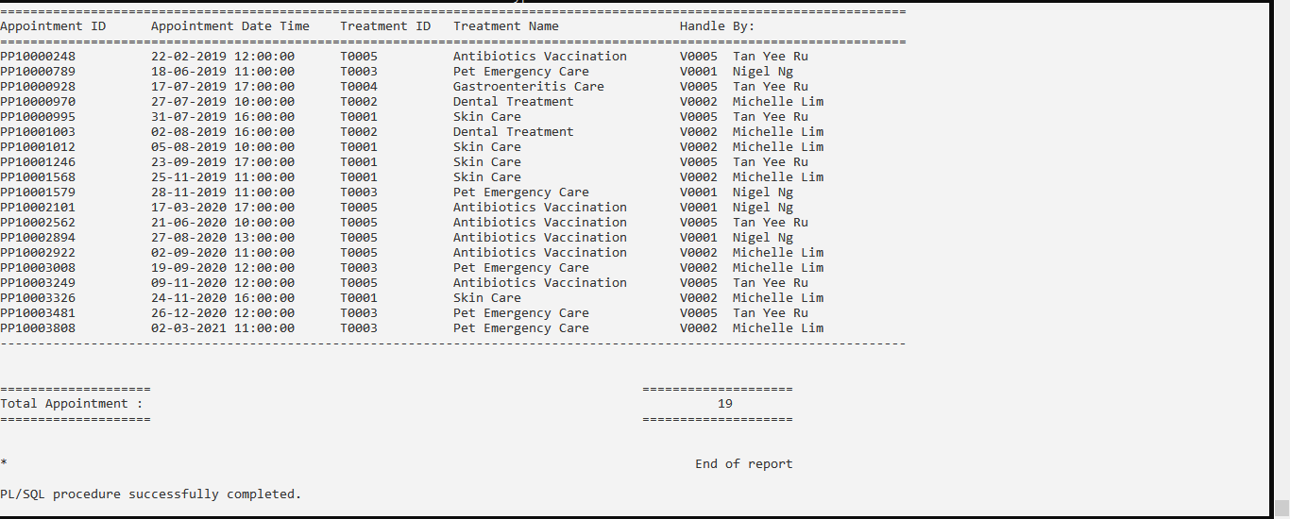

**Exception:**

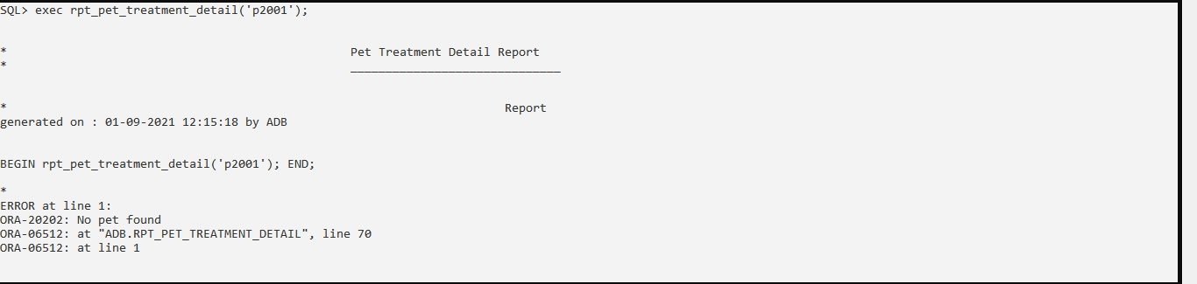

### 4.4 (Nigel Lee Jian Hsee)

**4.4.1 Query 1: Top Three Pets Owner’s Postcode for each Branch based on total**

**transaction amount (Strategic)**

**Purpose: The purpose of this query is to find out where the clinic’s pet’s owners are mostly from each branch. This is able to help top management level staff or the founder of this clinic to make the decision of opening a new branch or moving their current branch in the future which is where most of their owners come from. The query ranks the top three owners’s postcodes based on the transaction amount from each pet’s owner postcode.**

SQL statement:

set pagesize 200

set linesize 80

clear break

clear compute

break on state on branch_id skip 1

COMPUTE SUM LABEL TOTAL OF TOTALSALES TOTAL_ORDER on branch_id

TTITLE ON

TTITLE CENTER 'Top 3 Customer Postcode Revenue for each Clinic Branch' SKIP 1-

CENTER ========================================================= SKIP 2

column branch_id FORMAT a10

column branch_id HEADING 'Branch ID'

column STATE FORMAT a15

column STATE HEADING 'Branch State'

column CITY FORMAT a15

column CITY HEADING 'Customer City'

column POSTCODE FORMAT a10

column TotalSales format 9999999.99

column TotalSales HEADING 'Total |Revenue |(RM) '

column TotalSales format 9999999.99

column TOTAL_ORDER HEADING 'Total|Order'

column TOTAL_ORDER format 9999

column RANK format 99

SELECT branch_id,

state,

city,

postcode,

TotalSales, Total_Order, Rank

FROM

( SELECT T.branch_id,O.state,

O.city,

O.postcode,

sum(Total_Amount) as TotalSales,

count(distinct transaction_id) as Total_Order,

ROW_NUMBER() OVER (PARTITION BY O.state

ORDER BY sum(Total_Amount)

DESC)AS Rank

FROM Transaction T, PetOwner O

Where T.owner_id = O.owner_id

Group by T.branch_id,O.state,O.city,O.postcode

)

WHERE Rank <= 3

ORDER BY branch_id,TotalSales DESC;

**Sample Output:**

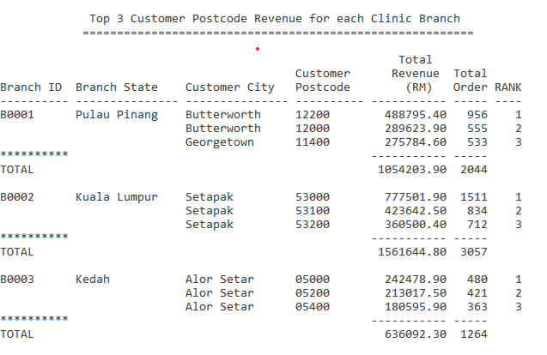

**4.4.2 Query 2: Rank top treatment, to medicine sales and total revenue of a**

**branch ()**

**Purpose: The purpose of this query is to rank the top treatment of a branch. This allows the branch clinic head or manager to know where the income from which type of treatments is. This query also shows that medicine revenue from each type of treatment. From this query, the branch head or manager can promote those treatments that have lower revenue.**

SQL statement:

set pagesize 200

set linesize 160

clear break

clear compute

break on state on branch_id skip 1

COMPUTE SUM LABEL TOTAL OF Treatment_Revenue Medic_Revenue Total_amount on branch_id

TTITLE ON

TTITLE CENTER 'Year 2021 Treatment and Medicine Revenue of a Branch' SKIP 1-

CENTER ========================================================= SKIP 2

column TREATMENT_TYPE HEADING 'Treatment Type'

column TREATMENT_TYPE FORMAT A25

column TREATMENT_REVENUE HEADING 'Treatment|Revenue|(RM)'

column TREATMENT_REVENUE FORMAT 999999999.99

column MEDIC_REVENUE HEADING 'Medic|Revenue|(RM)'

column MEDIC_REVENUE FORMAT 999999999.99

column SOLD_QUANTITY HEADING 'Sold|Medic|Quantity'

column SOLD_QUANTITY FORMAT 99999

column Revenue_Per_Quantity HEADING 'Revenue|Per Medic|Quantity|(RM)'

column Revenue_Per_Quantity FORMAT 99999.99

column Total_Amount HEADING 'Total|Revenue|(RM)'

column Total_Amount FORMAT 9999999999.99

column treatment_id HEADING 'Treatment|ID'

column Percent HEADING 'Percent|over|total|amount'

column Percent FORMAT 99.99

CREATE OR REPLACE VIEW FullRevenueGroupByTreatment2021 AS

select T.branch_id,TT.treatment_id, TT.treatment_type, sum(T.total_amount) as Total_Amount

from transaction T, appointment A, treatment TT

where A.appointment_id = T.appointment_id AND A.treatment_id = TT.treatment_id AND EXTRACT(YEAR FROM T.transaction_datetime) = '2021'

group by T.branch_id,TT.treatment_id, TT.treatment_type

order by branch_id;

CREATE OR REPLACE VIEW MedicRevenueGroupByTreatment2021 AS

select T.branch_id,TT.treatment_id, TT.treatment_type, sum(TD.line_total) AS Medic_Revenue, sum(TD.line_qty) AS Sold_Quantity, (sum(TD.line_total)/sum(TD.line_qty)) AS Revenue_Per_Quantity

from transactiondetail TD, transaction T, appointment A, treatment TT

where TD.transaction_id = T.transaction_id AND A.appointment_id = T.appointment_id AND A.treatment_id = TT.treatment_id AND EXTRACT(YEAR FROM T.transaction_datetime) = '2021'

group by T.branch_id,TT.treatment_id, TT.treatment_type

order by branch_id;

select F.branch_id,F.treatment_id,F.treatment_type, (F.Total_Amount - M.Medic_Revenue) AS Treatment_Revenue,

((F.Total_Amount - M.Medic_Revenue) / F.Total_Amount * 100) AS Percent,

ROW_NUMBER() OVER (ORDER BY (F.Total_Amount - M.Medic_Revenue) DESC)AS Rank,

M.Medic_Revenue,

(M.Medic_Revenue / F.Total_Amount * 100) AS Percent,

ROW_NUMBER() OVER (ORDER BY M.Medic_Revenue DESC)AS Rank,

Sold_Quantity,Revenue_Per_Quantity, F.Total_amount,

ROW_NUMBER() OVER (ORDER BY F.Total_amount DESC)AS Rank

from FullRevenueGroupByTreatment2021 F, MedicRevenueGroupByTreatment2021 M

where F.branch_id = '&branch_id' AND F.branch_id = M.branch_id AND F.treatment_id = M.treatment_id;

**Sample Output:**

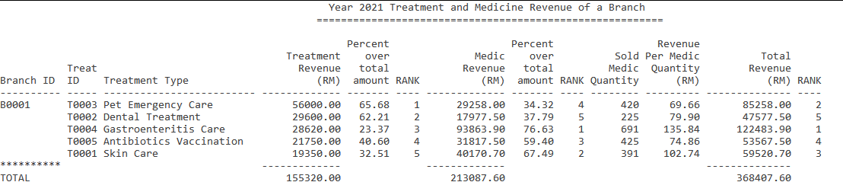

**4.4.3 Query 3: View Customer Transaction History by entering Customer ID (Operational)**

**Purpose: The purpose of this query is to check the previous transaction history by entering the owner ID. This clinic veterinarian checks the transaction history to view all treatments for all the owner’s pets or what medic they have bought previously for their pet. All medical history of the owner’s pets will also be shown.**

clear break

clear compute

transaction history of a customer

set pagesize 200

set linesize 200

alter session set nls_date_format = 'DD-MON-YYYY';

TTITLE ON

TTITLE CENTER 'Transaction History' SKIP 1-

CENTER ========================================================= SKIP 2

break on owner_id on owner_name on pet_id on pet_name on transaction_datetime on transaction_id on total_amount on treatment_price on treatment_type skip 1

column OWNER_ID HEADING 'Owner|ID'

column OWNER_NAME HEADING 'Owner Name'

column OWNER_NAME FORMAT A15

column PET_ID HEADING 'Pet|ID'

column PET_NAME HEADING 'Pet Name'

column PET_NAME FORMAT A15

column TRANSACTION_ID HEADING 'Transaction|ID'

column TRANSACTION_ID FORMAT A11

column TRANSACTION_DATETIME HEADING 'Transaction|Date'

column TREATMENT_TYPE HEADING 'Treatment Type'

column TREATMENT_TYPE FORMAT A25

column TREATMENT_PRICE HEADING 'Treatment|Price|(RM)'

column TREATMENT_PRICE FORMAT 999.99

column MEDIC_ID HEADING 'Medic|ID'

column MEDIC_NAME HEADING 'Medicine|Name'

column MEDIC_PRICE HEADING 'Medicine|Unit|Price|(RM)'

column MEDIC_PRICE FORMAT 999.99

column LINE_QTY HEADING 'Quantity'

column LINE_QTY FORMAT 99

column LINE_TOTAL HEADING 'Line|Total|(RM)'

column LINE_TOTAL FORMAT 9999.99

column Total_Amount HEADING 'Transaction|Total|(RM)'

column Total_Amount FORMAT 9999999999.99

select T.owner_id,PO.owner_name,P.pet_id,P.pet_name,T.transaction_id,

T.transaction_datetime,

TT.treatment_type, TT.treatment_price, M.medic_id,M.medic_name,

M.medic_price, TD.line_qty, TD.line_total,T.total_amount

from medicalsupply M, transactiondetail TD, transaction T, appointment A, treatment TT,PetOwner PO, Pet P

where M.medic_id = TD.medic_id AND TD.transaction_id = T.transaction_id AND T.appointment_id = A.appointment_id

AND A.treatment_id = TT.treatment_id AND A.pet_id = P.pet_id

AND PO.owner_id = T.Owner_id AND PO.Owner_id = '&Owner_id'

order by pet_id,transaction_datetime, medic_id;

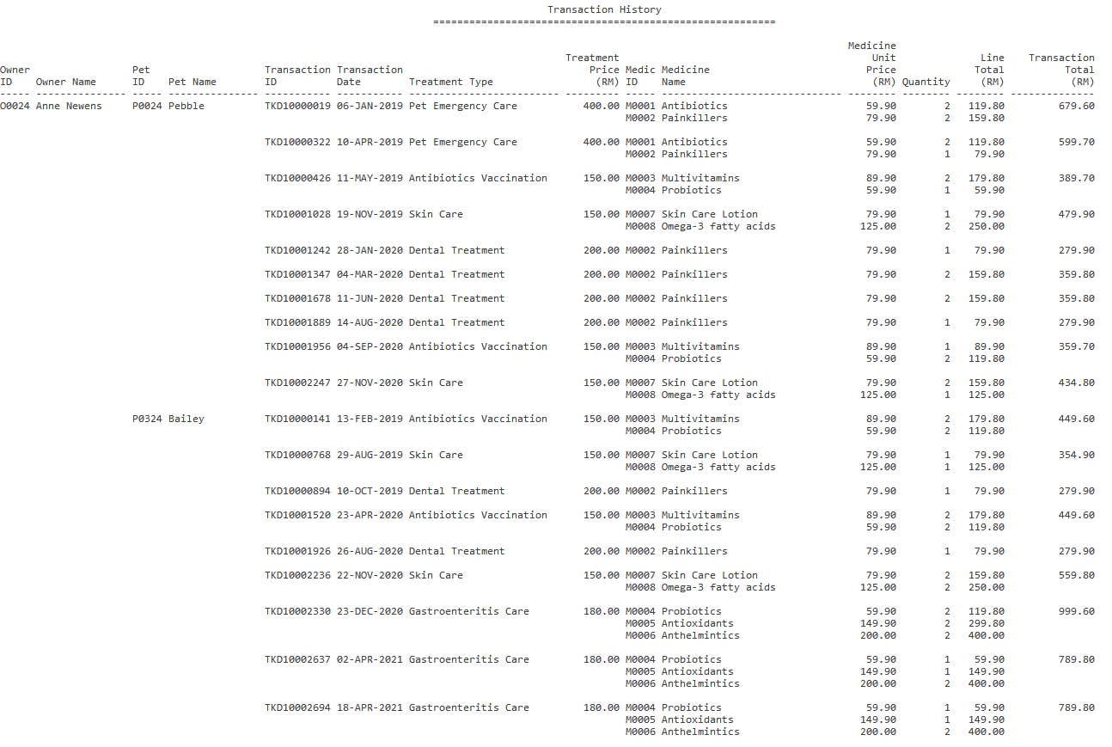

#### 

#### 

**4.4.4 Procedure 1: Create Transaction**

**Purpose: The purpose of this procedure is to allow the staff or veterinarian to create a transaction after the appointment and treatment of the owner’s pet. The procedure will require the appointment id and will auto insert the owner id, branch id, update the total amount of the transition by adding the treatment price, and record the transaction date time. If any appointment id that entered is not found from the appointment table, an exception will be raised. Only existing appointments were able to make payment. The payment must be made after the appointment if not a trigger will be triggered and raise an exception. If the transaction of appointment has been made, an exception will be raised to notify the veterinarian that the transaction for this appointment has been created.**

**Procedure code:**

SET SERVEROUTPUT ON FORMAT WRAPPED

alter session set nls_date_format = 'DD-MON-YYYY HH24:MI';

CREATE OR REPLACE PROCEDURE payment_module (IN_appointment_id in APPOINTMENT.appointment_id%TYPE) IS

appointmentCount NUMBER :=0;

transactionCount NUMBER :=0;

v_transaction_id TRANSACTION.transaction_id%TYPE;

v_treatment_id TREATMENT.treatment_id%TYPE;

v_treatment_price TREATMENT.treatment_price%TYPE;

v_owner_id TRANSACTION.owner_id%TYPE;

v_pet_id PET.pet_id%TYPE;

v_branch_id TRANSACTION.branch_id%TYPE;

v_datetime TRANSACTION.transaction_datetime%TYPE;

v_appointment_time APPOINTMENT.appointment_datetime%TYPE;

v_totalamount TRANSACTION.total_amount%TYPE;

v_treatmenttype TREATMENT.treatment_type%TYPE;

v_pet_name PET.pet_name%TYPE;

v_vet_id APPOINTMENT.vet_id%TYPE;

e_invalid_appointmentid EXCEPTION;

PRAGMA EXCEPTION_INIT(e_invalid_appointmentid, -20150);

e_repeated_transaction EXCEPTION;

PRAGMA EXCEPTION_INIT(e_repeated_transaction, -20151);

BEGIN

DBMS_OUTPUT.PUT_LINE(chr(10));

DBMS_OUTPUT.PUT_LINE(LPAD('4 Golden Duck Wellness Veterinary Clinic',55, ' '));

DBMS_OUTPUT.PUT_LINE(LPAD('=',70,'='));

DBMS_OUTPUT.PUT_LINE(LPAD('Payment Module',40, ' '));

DBMS_OUTPUT.PUT_LINE(LPAD('=',70,'='));

select count(appointment_id) INTO appointmentCount

from appointment

where appointment_id = IN_appointment_id;

IF appointmentCount = 0 THEN

RAISE_APPLICATION_ERROR(-20150, 'Appointment ID not Found !!!', true);

END IF;

select count(transaction_id) INTO transactionCount

from transaction

where appointment_id = IN_appointment_id;

IF transactionCount > 0 THEN

RAISE_APPLICATION_ERROR(-20151, 'Repeated Transaction !!!', true);

END IF;

select treatment_id, pet_id, appointment_datetime, vet_id

INTO v_treatment_id, v_pet_id, v_appointment_time , v_vet_id

FROM appointment

WHERE appointment_id = IN_appointment_id;

select treatment_price, treatment_type

INTO v_treatment_price,v_treatmenttype

FROM treatment

WHERE treatment_id = v_treatment_id;

select owner_id, pet_name

INTO v_owner_id,v_pet_name

FROM pet

WHERE pet_id = v_pet_id;

select branch_id

INTO v_branch_id

from veterinarian

WHERE vet_id = v_vet_id;

select sysdate

into v_datetime

from dual;

v_totalamount := v_treatment_price;

v_transaction_id := TO_CHAR('T'||IN_appointment_id);

DBMS_OUTPUT.PUT_LINE('Branch id : ' || v_Branch_id);

DBMS_OUTPUT.PUT_LINE('Transaction ID : '||v_transaction_id);

DBMS_OUTPUT.PUT_LINE(chr(10));

DBMS_OUTPUT.PUT_LINE('Appointment id : ' || IN_appointment_id);

DBMS_OUTPUT.PUT_LINE('Treatment id : ' || v_treatment_id);

DBMS_OUTPUT.PUT_LINE('Treatment : ' || v_treatmenttype);

DBMS_OUTPUT.PUT_LINE('Owner id : ' || v_owner_id);

DBMS_OUTPUT.PUT_LINE('Transaction Time : ' || TO_CHAR(v_datetime));

DBMS_OUTPUT.PUT_LINE('Pet ID : ' || v_pet_id);

DBMS_OUTPUT.PUT_LINE('Pet Name : ' || v_pet_name);

DBMS_OUTPUT.PUT_LINE(LPAD('-',70,'-'));

DBMS_OUTPUT.PUT_LINE('Total Amount : RM' || to_char (v_totalamount, '9999.99'));

DBMS_OUTPUT.PUT_LINE(LPAD('=',70,'='));

DBMS_OUTPUT.PUT_LINE(LPAD('Transaction Created',40, ' '));

Insert into transaction values(v_transaction_id,v_owner_id,IN_appointment_id,v_Branch_id,v_totalamount,v_datetime);

EXCEPTION

WHEN e_invalid_appointmentid THEN

DBMS_OUTPUT.PUT_LINE(LPAD('-',70,'-'));

DBMS_OUTPUT.PUT_LINE('Transaction Fail to Create !!! Entered Appointment does not exist !!!');

DBMS_OUTPUT.PUT_LINE(LPAD('-',70,'-'));

WHEN e_repeated_transaction THEN

DBMS_OUTPUT.PUT_LINE(LPAD('-',70,'-'));

DBMS_OUTPUT.PUT_LINE('The transaction for this appointment already exist !!!');

DBMS_OUTPUT.PUT_LINE(LPAD('-',70,'-'));

END;

/

exec payment_module ('&appointment_id')

#### Sample Output:

#### 

**Exception Output: Repeated appointment id**

#### 

**Exception Output: Invalid appointment ID**

#### 

**Exception Output: Triggered when make payment before appointment date time**

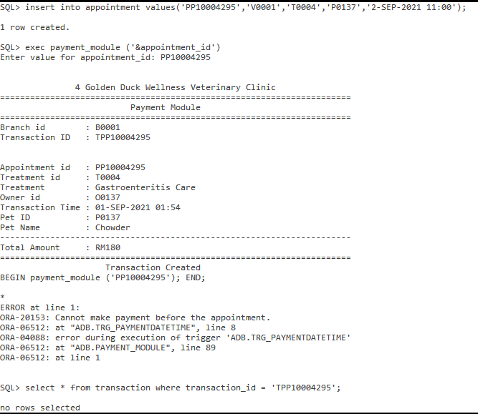

#### 

**4.4.5 Procedure 2: Add transaction detail**

**Purpose: The purpose of this procedure is to allow the staff or veterinarian to add transaction details such as medicine bought by the pet’s owner after creating transaction details. For example, adding medicine with id ‘M0001’ with quantity to a transaction. After adding transaction detail a trigger will be triggered to automatically update the total amount of the transaction. This procedure consists of validating whether the transaction id exists, the quantity must be more than zero, whether there is repeated medicine in the transaction.**

**Procedure code:**

SET SERVEROUTPUT ON FORMAT WRAPPED

alter session set nls_date_format = 'DD-MON-YYYY HH24:MI';

CREATE OR REPLACE PROCEDURE addTransactionDetail_module (in_transaction_id in TRANSACTION.transaction_id%TYPE, in_medic_id in TRANSACTIONDETAIL.transaction_id%TYPE, in_qty in TRANSACTIONDETAIL.line_qty%TYPE) IS

transactionCount NUMBER :=0;

medicCount NUMBER :=0;

v_treatmenttype TREATMENT.treatment_type%TYPE;

v_treatment_price TREATMENT.treatment_price%TYPE;

v_medic_price MEDICALSUPPLY.medic_price%TYPE;

v_medic_price2 MEDICALSUPPLY.medic_price%TYPE;

v_medic_name MEDICALSUPPLY.medic_name%TYPE;

v_medic_name2 MEDICALSUPPLY.medic_name%TYPE;

v_line_total TRANSACTIONDETAIL.line_total%TYPE;

v_transaction_id TRANSACTIONDETAIL.transaction_id%TYPE;

v_totalamount TRANSACTION.total_amount%TYPE;

v_transactiondate TRANSACTION.transaction_datetime%TYPE;

v_daydifferent number;

e_invalid_transactionid EXCEPTION;

PRAGMA EXCEPTION_INIT(e_invalid_transactionid, -20154);

e_repeated_medicid EXCEPTION;

PRAGMA EXCEPTION_INIT(e_repeated_medicid, -20155);

e_zero_qty EXCEPTION;

PRAGMA EXCEPTION_INIT(e_zero_qty, -20156);

e_dayexceed EXCEPTION;

PRAGMA EXCEPTION_INIT(e_dayexceed, -20157);

CURSOR detail_cursor IS

SELECT *

FROM transactiondetail

WHERE transaction_id = in_transaction_id;

BEGIN

DBMS_OUTPUT.PUT_LINE(chr(10));

DBMS_OUTPUT.PUT_LINE(LPAD('Transaction Detail',50, ' '));

DBMS_OUTPUT.PUT_LINE(LPAD('=',90,'='));

select count(transaction_id)

INTO transactionCount

FROM transaction

WHERE transaction_id = in_transaction_id;

IF transactionCount = 0 THEN

RAISE_APPLICATION_ERROR(-20154, 'Transaction ID not Found and Not Created yet !!!', true);

END IF;

SELECT SYSDATE - transaction_datetime, transaction_datetime INTO v_daydifferent,v_transactiondate

FROM DUAL, transaction

where transaction_id = in_transaction_id ;

IF v_daydifferent > 7 THEN

RAISE_APPLICATION_ERROR(-20157, 'Day Exceed', true);

END IF;

IF in_qty <= 0 THEN

RAISE_APPLICATION_ERROR(-20156, 'More than zero', true);

END IF;

select count(transaction_id)

INTO transactionCount

FROM transaction

WHERE transaction_id = in_transaction_id;

IF transactionCount = 0 THEN

RAISE_APPLICATION_ERROR(-20154, 'Transaction ID not Found and Not Created yet !!!', true);

END IF;

select count(medic_id)

INTO medicCount

FROM transactionDetail

WHERE medic_id = in_medic_id AND transaction_id = in_transaction_id;

IF medicCount >0 THEN

RAISE_APPLICATION_ERROR(-20155, 'The Medic for this transaction already existed !!!', true);

END IF;

select medic_price, medic_name

INTO v_medic_price, v_medic_name

FROM medicalsupply

WHERE medic_id = in_medic_id;

v_line_total := in_qty * v_medic_price;

select treatment_type, treatment_price into v_treatmenttype, v_treatment_price

from transaction T, appointment A, Treatment R

where T.transaction_id = in_transaction_id AND T.appointment_id = A.appointment_id AND A.treatment_id = R.treatment_id;

DBMS_OUTPUT.PUT_LINE(chr(10));

DBMS_OUTPUT.PUT_LINE(LPAD('4 Golden Duck Wellness Veterinary Clinic',65, ' '));

DBMS_OUTPUT.PUT_LINE(LPAD('=',90,'='));

DBMS_OUTPUT.PUT_LINE(LPAD('Payment Module',50, ' '));

DBMS_OUTPUT.PUT_LINE(LPAD('=',90,'='));

DBMS_OUTPUT.PUT_LINE(chr(10));

DBMS_OUTPUT.PUT_LINE(TO_CHAR(v_transactiondate));

DBMS_OUTPUT.PUT_LINE('Item'|| LPAD('Unit Price',53,' ') || LPAD('Quantity',15,' ')|| LPAD('Line Total(RM)',19,' '));

DBMS_OUTPUT.PUT_LINE(LPAD('=',90,'='));

DBMS_OUTPUT.PUT_LINE('Treatment : '|| RPAD(v_treatmenttype,35,' ') || LPAD(to_char(v_treatment_price, '9999.99'),'43',' '));

IF transactionCount >0 THEN

FOR detail_record IN detail_cursor LOOP

select medic_name, medic_price into v_medic_name2, v_medic_price2

from medicalsupply

where medic_id = detail_record.medic_id;

DBMS_OUTPUT.PUT_LINE(detail_record.medic_id||' : ' || RPAD(v_medic_name2,35,' ')||to_char(v_medic_price2, '9999.99')||LPAD(detail_record.line_qty,15,' ')||LPAD(to_char(detail_record.line_total, '9999.99'),20,' '));

END LOOP;

END IF;

DBMS_OUTPUT.PUT_LINE(in_medic_id || ' : ' || RPAD(v_medic_name,35,' ')|| to_char(v_medic_price, '9999.99')||LPAD(in_qty,15,' ')||LPAD(to_char(v_line_total, '9999.99'),20,' '));

DBMS_OUTPUT.PUT_LINE(LPAD('=',90,'='));

insert into transactiondetail values(in_transaction_id,in_medic_id,in_qty,v_line_total);

select total_amount into v_totalamount

from transaction where transaction_id = in_transaction_id;

DBMS_OUTPUT.PUT_LINE(chr(10));

DBMS_OUTPUT.PUT_LINE('Total Amount : '|| LPAD(to_char(v_totalamount, '9999.99'),'75',' '));

DBMS_OUTPUT.PUT_LINE(LPAD('=',90,'='));

EXCEPTION

WHEN e_invalid_transactionid THEN

DBMS_OUTPUT.PUT_LINE(LPAD('-',90,'-'));

DBMS_OUTPUT.PUT_LINE ('Transaction ID not Found and Not Created yet !!!');

DBMS_OUTPUT.PUT_LINE(LPAD('-',90,'-'));

WHEN e_repeated_medicid THEN

DBMS_OUTPUT.PUT_LINE(LPAD('-',90,'-'));

DBMS_OUTPUT.PUT_LINE ('The Medic type already exist if you wish edit run edit procedure');

DBMS_OUTPUT.PUT_LINE(LPAD('-',90,'-'));

WHEN e_zero_qty THEN

DBMS_OUTPUT.PUT_LINE(LPAD('-',90,'-'));

DBMS_OUTPUT.PUT_LINE ('The quantity must be more than zero');

DBMS_OUTPUT.PUT_LINE(LPAD('-',90,'-'));

WHEN e_dayexceed THEN

DBMS_OUTPUT.PUT_LINE(LPAD('-',90,'-'));

DBMS_OUTPUT.PUT_LINE ('Transaction that past 7 days cannot be edited');

DBMS_OUTPUT.PUT_LINE(LPAD('-',90,'-'));

END;

/

#### Sample Output: After adding the total amount will be updated

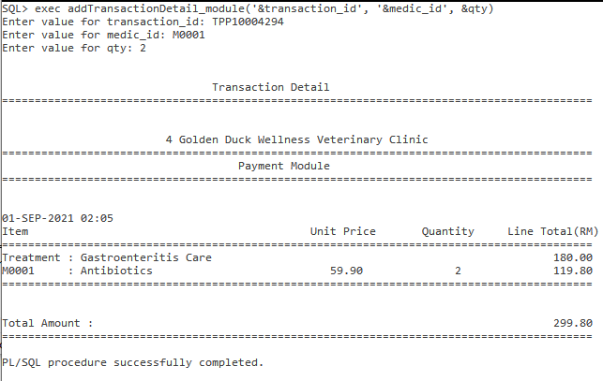

#### Exception output Output: When transaction id do not exist.

#### Exception output Output: When medic id entered it already exist in the transaction.

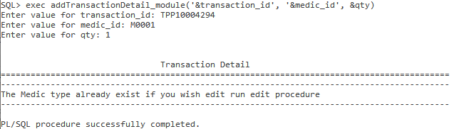

#### Exception output Output: When medic quantity less than 0.

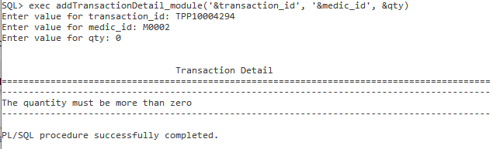

**4.4.6 Procedure 3: Edit or delete transaction detail**

**Purpose: The purpose of this procedure is to allow the staff or veterinarian to edit or delete a transaction detail if any mistake entry is made. For example, extra medicine charges for the pet’s owner, or require more quantity of a medicine. The procedure will validate that the quantity must more than or equal 0. If the quantity is 0 means delete that transaction detail. If the transaction is a past 7 days transaction, the transaction details are not allowed to be edited. If the transaction detail entered did not exist an error will be prompted and any edition or deletion will update the transaction total amount.**

**Procedure code:**

CREATE OR REPLACE PROCEDURE editTransactionDetail_module (in_transaction_id in TRANSACTION.transaction_id%TYPE, in_medic_id in TRANSACTIONDETAIL.medic_id%TYPE, in_qty in TRANSACTIONDETAIL.line_qty%TYPE) IS

transactionDetailCount NUMBER :=0;

medicCount NUMBER :=0;

v_treatmenttype TREATMENT.treatment_type%TYPE;

v_treatment_price TREATMENT.treatment_price%TYPE;

v_medic_price MEDICALSUPPLY.medic_price%TYPE;

v_medic_name MEDICALSUPPLY.medic_name%TYPE;

v_new_line_total TRANSACTIONDETAIL.line_total%TYPE;

v_line_total TRANSACTIONDETAIL.line_total%TYPE;

v_line_qty TRANSACTIONDETAIL.line_qty%TYPE;

v_transaction_id TRANSACTIONDETAIL.transaction_id%TYPE;

v_transactiondate TRANSACTION.transaction_datetime%TYPE;

v_daydifferent number;

v_samequantity number;

v_totalamount TRANSACTION.total_amount%TYPE;

e_invalid_transactiondetail EXCEPTION;

PRAGMA EXCEPTION_INIT(e_invalid_transactiondetail, -20158);

e_lesszero_qty EXCEPTION;

PRAGMA EXCEPTION_INIT(e_lesszero_qty, -20159);

e_day_exceed EXCEPTION;

PRAGMA EXCEPTION_INIT(e_day_exceed, -20160);

e_samequantity EXCEPTION;

PRAGMA EXCEPTION_INIT(e_samequantity, -20161);

CURSOR detail_cursor IS

SELECT *

FROM transactiondetail

WHERE transaction_id = in_transaction_id;

BEGIN

DBMS_OUTPUT.PUT_LINE(chr(10));

DBMS_OUTPUT.PUT_LINE(LPAD('Transaction Detail',50, ' '));

DBMS_OUTPUT.PUT_LINE(LPAD('=',90,'='));

select count(*)

INTO transactionDetailCount

FROM transactionDetail

WHERE transaction_id = in_transaction_id AND medic_id = in_medic_id ;

IF transactionDetailCount = 0 THEN

RAISE_APPLICATION_ERROR(-20158, 'Invalid Transaction Detail', true);

END IF;

IF in_qty < 0 THEN

RAISE_APPLICATION_ERROR(-20159, 'Cannot Negative', true);

END IF;

SELECT SYSDATE - transaction_datetime, transaction_datetime INTO v_daydifferent,v_transactiondate

FROM DUAL, transaction

where transaction_id = in_transaction_id ;

IF v_daydifferent > 7 THEN

RAISE_APPLICATION_ERROR(-20160, 'Day Exceed', true);

END IF;

select count(*)

INTO v_samequantity

FROM transactionDetail

WHERE transaction_id = in_transaction_id AND medic_id = in_medic_id AND line_qty = in_qty ;

IF v_samequantity > 0 THEN

RAISE_APPLICATION_ERROR(-20161, 'Same quantity', true);

END IF;

select line_qty, line_total

INTO v_line_qty, v_line_total

FROM transactionDetail

WHERE transaction_id = in_transaction_id AND medic_id = in_medic_id ;

select medic_price, medic_name

INTO v_medic_price, v_medic_name

FROM medicalsupply

WHERE medic_id = in_medic_id;

select treatment_type, treatment_price into v_treatmenttype, v_treatment_price

from transaction T, appointment A, Treatment R

where T.transaction_id = in_transaction_id AND T.appointment_id = A.appointment_id AND A.treatment_id = R.treatment_id;

DBMS_OUTPUT.PUT_LINE(chr(10));

DBMS_OUTPUT.PUT_LINE(LPAD('4 Golden Duck Wellness Veterinary Clinic',65, ' '));

DBMS_OUTPUT.PUT_LINE(LPAD('=',90,'='));

DBMS_OUTPUT.PUT_LINE(LPAD('Payment Module',50, ' '));

DBMS_OUTPUT.PUT_LINE(chr(10));

DBMS_OUTPUT.PUT_LINE(TO_CHAR(v_transactiondate));

DBMS_OUTPUT.PUT_LINE(LPAD('=',90,'='));

DBMS_OUTPUT.PUT_LINE('Item'|| LPAD('Unit Price',53,' ') || LPAD('Quantity',15,' ')|| LPAD('Line Total(RM)',19,' '));

DBMS_OUTPUT.PUT_LINE(LPAD('=',90,'='));

DBMS_OUTPUT.PUT_LINE('Treatment : '|| RPAD(v_treatmenttype,35,' ') || LPAD(to_char(v_treatment_price, '9999.99'),'43',' '));

FOR detail_record IN detail_cursor LOOP

IF detail_record.medic_id != in_medic_id THEN

select medic_name, medic_price into v_medic_name, v_medic_price

from medicalsupply

where medic_id = detail_record.medic_id;

DBMS_OUTPUT.PUT_LINE(detail_record.medic_id||' : ' || RPAD(v_medic_name,35,' ')||to_char(v_medic_price, '9999.99')||LPAD(detail_record.line_qty,15,' ')||LPAD(to_char(detail_record.line_total, '9999.99'),20,' '));

END IF;

END LOOP;

IF in_qty = 0 THEN

DELETE FROM transactiondetail

WHERE transaction_id = in_transaction_id AND medic_id = in_medic_id;

ELSE

select medic_name, medic_price into v_medic_name, v_medic_price

from medicalsupply

where medic_id = in_medic_id;

v_new_line_total := in_qty * v_medic_price;

UPDATE TRANSACTIONDETAIL

SET line_qty = in_qty, line_total = v_new_line_total

WHERE transaction_id = in_transaction_id AND medic_id = in_medic_id;

DBMS_OUTPUT.PUT_LINE(in_medic_id||' : ' ||RPAD(v_medic_name,35,' ')||to_char(v_medic_price, '9999.99')||LPAD(in_qty,15,' ')||LPAD(to_char(v_new_line_total, '9999.99'),20,' '));

END IF;

select total_amount into v_totalamount

from transaction where transaction_id = in_transaction_id;

DBMS_OUTPUT.PUT_LINE(LPAD('=',90,'='));

DBMS_OUTPUT.PUT_LINE(chr(10));

DBMS_OUTPUT.PUT_LINE('Total Amount : '|| LPAD(to_char(v_totalamount, '9999.99'),'75',' '));

DBMS_OUTPUT.PUT_LINE(LPAD('=',90,'='));

EXCEPTION

WHEN e_invalid_transactiondetail THEN

DBMS_OUTPUT.PUT_LINE(LPAD('-',90,'-'));

DBMS_OUTPUT.PUT_LINE ('Invalid Transaction Detail and not FOUND !!!');

DBMS_OUTPUT.PUT_LINE(LPAD('-',90,'-'));

WHEN e_lesszero_qty THEN

DBMS_OUTPUT.PUT_LINE(LPAD('-',90,'-'));

DBMS_OUTPUT.PUT_LINE ('Quantity Cannot Less Than 0 !!!');

DBMS_OUTPUT.PUT_LINE(LPAD('-',90,'-'));

WHEN e_day_exceed THEN

DBMS_OUTPUT.PUT_LINE(LPAD('-',90,'-'));

DBMS_OUTPUT.PUT_LINE ('Transaction more than 7 days can be modify');

DBMS_OUTPUT.PUT_LINE(LPAD('-',90,'-'));

WHEN e_samequantity THEN

DBMS_OUTPUT.PUT_LINE(LPAD('-',90,'-'));

DBMS_OUTPUT.PUT_LINE ('Same as previous quantity no changes needed');

DBMS_OUTPUT.PUT_LINE(LPAD('-',90,'-'));

END;

/

#### Sample Output: After editing existing transaction details, the total amount will be automatically updated.

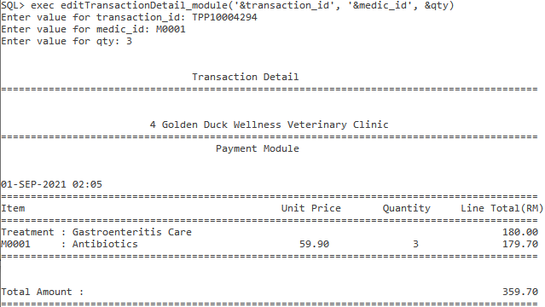

#### Sample Output: After deleting existing transaction details, the total amount will be automatically updated.

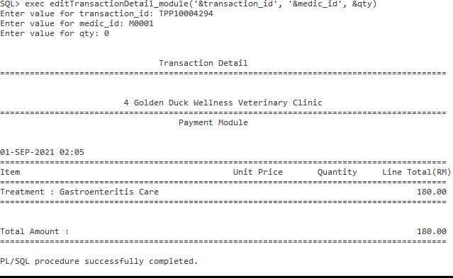

#### Exception Output: Entered transaction details that do not exist, an error message will be displayed.

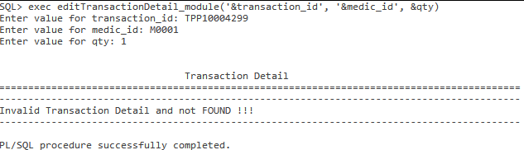

#### Exception Output: Past 7 days transaction cannot be edited.

#### 

#### Exception Output: Entered less than 0 , an error message will be displayed.

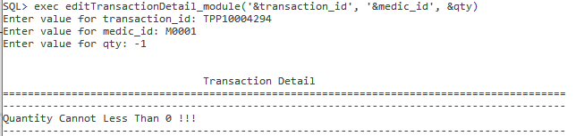

#### Exception Output: Past 7 days transactions are not allowed to be edited.

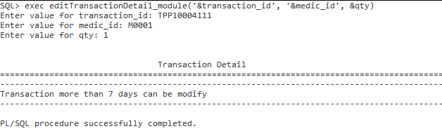

#### 

**4.4.7 Trigger 1: Validate Payment Date Time**

**Purpose: The purpose of this trigger is to validate payment date time. The pet’s owner is only able to make payment after the appointment. It is because the customer might cancel the appointment before the appointment date time. Thus, it only makes sense that the pet’s owner pays after the treatment for his or her pet has been done.**

**Trigger code:**

CREATE OR REPLACE TRIGGER trg_paymentDateTime

BEFORE INSERT ON Transaction

FOR EACH ROW

DECLARE

v_appointment_date APPOINTMENT.appointment_datetime%TYPE;

BEGIN

Select appointment_datetime into v_appointment_date

FROM appointment

Where appointment_id = :new.appointment_id;

IF :new.transaction_datetime<v_appointment_date THEN

RAISE_APPLICATION_ERROR(-20153, 'Cannot make payment before the appointment.' );

END IF;

END;

/

**Sample Output:**



**4.4.8 Trigger 2: Update medicine quantity and transaction total amount after editing transaction detail**

**Purpose: The veterinarian might enter the transaction details wrongly. For example, the veterinarian charges the pet’s owner 3 Skin Care Lotions but the pet’s owner only buys 2 instead of 3. This allows the veterinarian to edit the quantity that is bought by the pet's owner. Same goes to if the pet’s owner wishes to buy even after entering the transaction details. After editing, ths trigger will auto update the stock quantity and the total amount of the transaction. Before is use in this case because before editing the system needs to make sure the stock quantity is enough before selling to the pet’s owner.**

**Trigger code:**

CREATE OR REPLACE TRIGGER TRG_Update_EditTransaction

BEFORE UPDATE ON TransactionDetail

FOR EACH ROW

DECLARE

v_quantitydiff TRANSACTIONDETAIL.line_qty%TYPE;

v_newqty TRANSACTIONDETAIL.line_qty%TYPE;

v_newlinetotal TRANSACTIONDETAIL.line_total%TYPE;

v_medicprice MEDICALSUPPLY.medic_price%TYPE;

v_linetotal_dif TRANSACTIONDETAIL.line_total%TYPE;

BEGIN

Select medic_price into v_medicprice

from medicalsupply where medic_id = :old.medic_id;

v_newlinetotal := :new.line_total;

IF :new.line_qty > :old.line_qty THEN

Update medicalsupply

SET medic_qty = medic_qty - (:new.line_qty - :old.line_qty)

where medic_id = :old.medic_id;

v_linetotal_dif := v_newlinetotal - :old.line_total;

Update Transaction

SET total_amount = total_amount + v_linetotal_dif

where transaction_id = :old.transaction_id;

ELSE

Update medicalsupply

SET medic_qty = medic_qty + (:old.line_qty - :new.line_qty )

where medic_id = :old.medic_id;

v_linetotal_dif := :old.line_total - v_newlinetotal;

Update Transaction

SET total_amount = total_amount - v_linetotal_dif

where transaction_id = :old.transaction_id;

END IF;

END;/

**4.4.6 Trigger 3: Update the stock and transaction total amount after deleting transaction detail**

**Purpose: The purpose of this trigger is to Update the stock and transaction total amount after deleting transaction details. The veterinarian might accidentally charge the pet’s owner with medicine that the pet owner didn't purchase. Hence, after the pet’s owner or the veterinarian noticed the mistake. The veterinarian will delete that transaction detail. Thus this trigger will automatically the stock quantity and the total amount of the transaction.**

**Trigger code:**

CREATE OR REPLACE TRIGGER TRG_Update_DeleteTransaction

BEFORE DELETE ON TransactionDetail

FOR EACH ROW

BEGIN

Update Transaction

SET total_amount = total_amount - :old.line_total

where transaction_id = :old.transaction_id;

Update MedicalSupply

SET medic_qty = medic_qty + :old.line_qty

where medic_id = :old.medic_id;

END;

/

**4.4.7 Trigger 4: Update transaction total amount**

**Purpose: The purpose of this trigger is to keep adding the transaction amount after the pet’s owner keep buying new medicine for his or her pet after the treatment.**

**Trigger code:**

CREATE OR REPLACE TRIGGER TRG_Update_Total_Amount

After Insert ON TransactionDetail

FOR EACH ROW

BEGIN

Update Transaction

SET total_amount = total_amount + :new.line_total

where transaction_id = :new.transaction_id;

END;

/

**4.4.11 Report 1: Summary report of Veterinarian Performance in a month.**

**Purpose: The purpose of this report is to monitor the performance of a veterinarian in a month and how much revenue the veterinarian brings to the company in a specific month. The number of types of treatments that are handled by the veterinarian will also be shown.**

SQL statement:

CREATE OR REPLACE PROCEDURE RPT_Revenue_Vet(IN_vetid IN VETERINARIAN.vet_id%TYPE ,IN_year IN NUMBER, IN_month IN NUMBER) IS

v_vetcount NUMBER := 0;

v_treatmentcount NUMBER := 0;

v_vetID VETERINARIAN.vet_id%TYPE;

v_vetname VETERINARIAN.vet_name%TYPE;

v_vetcontact VETERINARIAN.vet_contact%TYPE;

v_branchid BRANCH.branch_id%TYPE;

v_branchS BRANCH.state%TYPE;

v_branchC BRANCH.city%TYPE;

v_branchP BRANCH.postcode%TYPE;

v_branchST BRANCH.streetname%TYPE;

v_sumQuantity NUMBER(10,2) := 0;

v_sumRevenue NUMBER(10,2) := 0;

v_month VARCHAR2(11);

v_maxYear NUMBER(4);

v_minYear NUMBER(4);

v_maxMonth NUMBER;

v_sysdate DATE;

e_invalid_vetid EXCEPTION;

PRAGMA EXCEPTION_INIT(e_invalid_vetid, -20162);

e_invalid_month EXCEPTION;

PRAGMA EXCEPTION_INIT(e_invalid_month, -20163);

e_invalid_year EXCEPTION;

PRAGMA EXCEPTION_INIT(e_invalid_year, -20164);

CURSOR Treatment_CURSOR IS

SELECT T.treatment_id, T.treatment_type, count(A.appointment_id) AS Number_of_Treatment,

t.treatment_price, (count(A.appointment_id)*T.treatment_price) AS

TotalAmount

FROM Appointment A, Treatment T, Veterinarian V

WHERE A.treatment_id = T.treatment_id AND V.vet_id = A.vet_id

AND EXTRACT(YEAR FROM appointment_datetime) = IN_year

AND EXTRACT(MONTH FROM appointment_datetime) = IN_month

AND A.vet_id = IN_vetid

GROUP BY T.treatment_id, T.treatment_type, T.treatment_price

ORDER BY TotalAmount ASC;

BEGIN

DBMS_OUTPUT.PUT_LINE(chr(10));

DBMS_OUTPUT.PUT_LINE(LPAD('4 Golden Duck Wellness Veterinary Clinic',65, ' '));

DBMS_OUTPUT.PUT_LINE(LPAD('=',90,'='));

DBMS_OUTPUT.PUT_LINE(chr(10));

DBMS_OUTPUT.PUT_LINE(LPAD('Vet Summary Report based on the revenue of each treatment',70, ' '));

DBMS_OUTPUT.PUT_LINE(LPAD('=',90,'='));

Select count(V.vet_id) INTO v_vetcount from veterinarian V Where V.vet_id = IN_vetid;

IF v_vetcount = 0 THEN

RAISE_APPLICATION_ERROR(-20162, 'Invalid Vet ID', true);

END IF;

IF IN_MONTH < 1 OR IN_MONTH > 12 THEN

RAISE_APPLICATION_ERROR(-20163, 'Invalid Month', true);

END IF;

Select V.vet_id, V.vet_name,V.vet_contact,B.branch_id, B.state, B.city, B.Postcode,B.streetname,

Extract(Year FROM Max(A.appointment_datetime)),Extract(Year FROM Min(A.appointment_datetime))

INTO v_vetID, v_vetname, v_vetcontact, v_branchid, v_branchS, v_branchC, v_branchP,v_branchST,

v_maxyear, v_minyear

From veterinarian V, branch B, Appointment A

Where A.vet_id = V.vet_id AND V.branch_id = B.branch_id AND V.vet_id = IN_vetid

group by V.vet_id, V.vet_name,V.vet_contact,B.branch_id, B.state, B.city, B.Postcode,B.streetname;

IF IN_YEAR < v_minyear OR IN_YEAR > v_maxyear THEN

RAISE_APPLICATION_ERROR(-20164, 'Invalid Year', true);

END IF;

Select sysdate into v_sysdate from dual;

DBMS_OUTPUT.PUT_LINE('Report Generated on : ' || v_sysdate);

DBMS_OUTPUT.PUT_LINE(chr(10));

DBMS_OUTPUT.PUT_LINE('Veterinarian ID : ' || v_vetID);

DBMS_OUTPUT.PUT_LINE('Veterinarian Name : ' || v_vetName);

DBMS_OUTPUT.PUT_LINE('Veterinarian Contact : ' || v_vetContact);

DBMS_OUTPUT.PUT_LINE(chr(10));

DBMS_OUTPUT.PUT_LINE('Branch ID : ' || v_branchid);

DBMS_OUTPUT.PUT_LINE('Branch State : ' || v_branchS);

DBMS_OUTPUT.PUT_LINE('Branch City : ' || v_branchC);

DBMS_OUTPUT.PUT_LINE('Branch Postcode : ' || v_branchP);

DBMS_OUTPUT.PUT_LINE('Branch Street : ' || v_branchS);

DBMS_OUTPUT.PUT_LINE(chr(10));

DBMS_OUTPUT.PUT_LINE(LPAD('=',90,'='));

SELECT TO_CHAR(TO_DATE(IN_MONTH, 'MM'), 'MONTH') INTO v_month FROM DUAL;

DBMS_OUTPUT.PUT_LINE(LPAD('Year ' || IN_YEAR || ' '|| v_month,55,' '));

DBMS_OUTPUT.PUT_LINE(chr(10));

DBMS_OUTPUT.PUT_LINE(LPAD('=',90,'='));

DBMS_OUTPUT.PUT_LINE(RPAD('Treatment ID',15,' ')|| ' | ' || RPAD('Treatment Type',25,' ')|| ' | ' ||LPAD('No',2,' ')|| ' | ' ||LPAD('Treatment Price (RM)',20,' ')|| ' | ' ||LPAD('Total (RM)',15,' '));

DBMS_OUTPUT.PUT_LINE(LPAD('=',90,'='));

FOR treatment_record IN Treatment_CURSOR LOOP

DBMS_OUTPUT.PUT_LINE(RPAD(treatment_record.treatment_id, 15, ' ')|| ' | ' || RPAD(treatment_record.treatment_type,25,' ')|| ' | ' || LPAD(treatment_record.Number_of_Treatment,2,' ')

|| ' | ' || LPAD(TO_CHAR(treatment_record.treatment_price, 999.99),20,' ')|| ' | ' || LPAD(to_char(treatment_record.TotalAmount, '999999.99'),15,' '));

v_sumQuantity := v_sumQuantity + treatment_record.Number_of_Treatment;

v_sumRevenue := v_sumRevenue + treatment_record.TotalAmount;

v_treatmentcount := v_treatmentcount + 1;

END LOOP;

IF v_treatmentcount = 0 THEN

DBMS_OUTPUT.PUT_LINE(chr(10));

DBMS_OUTPUT.PUT_LINE(LPAD('No treatment handled this month !!!',60,' '));

END IF;

DBMS_OUTPUT.PUT_LINE(LPAD('=',90,'='));

DBMS_OUTPUT.PUT_LINE('Total Treatment : '|| v_sumQuantity);

DBMS_OUTPUT.PUT_LINE('Total Treatment Revenue : RM'|| to_char(v_sumRevenue,99999.99));

DBMS_OUTPUT.PUT_LINE(LPAD('=',90,'='));

EXCEPTION

WHEN e_invalid_vetid THEN

DBMS_OUTPUT.PUT_LINE(LPAD('-',90,'-'));

DBMS_OUTPUT.PUT_LINE ('Vet ID Does Not Exist !!!');

DBMS_OUTPUT.PUT_LINE(LPAD('-',90,'-'));

WHEN e_invalid_month THEN

DBMS_OUTPUT.PUT_LINE(LPAD('-',90,'-'));

DBMS_OUTPUT.PUT_LINE ('Invalid Month must be within (1-12)');

DBMS_OUTPUT.PUT_LINE(LPAD('-',90,'-'));

WHEN e_invalid_year THEN

DBMS_OUTPUT.PUT_LINE(LPAD('-',90,'-'));

DBMS_OUTPUT.PUT_LINE ('Invalid Year or No Treatment by '|| v_vetid || ' : ' || v_vetname || ' in this year');

DBMS_OUTPUT.PUT_LINE(LPAD('-',90,'-'));

END;

/

alter session set nls_date_format = 'DD-MON-YYYY';

ACCEPT vetid CHAR FORMAT 'A5' PROMPT 'Enter the vet id (V0001) : '

ACCEPT year NUMBER FORMAT 9999 PROMPT 'Enter the year (Eg:2020) : '

ACCEPT month NUMBER FORMAT 99 PROMPT 'Enter the month (1-12) : '

exec RPT_Revenue_Vet(upper('&vetid'),&year,&month);

**Sample Output:**

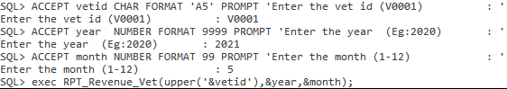

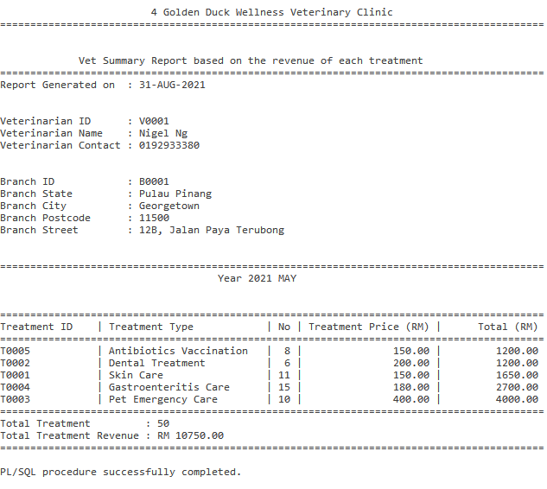

Exception Output : Invalid veterinarian ID

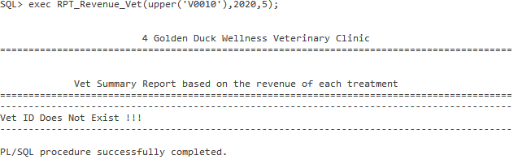

Exception Output : Invalid Month

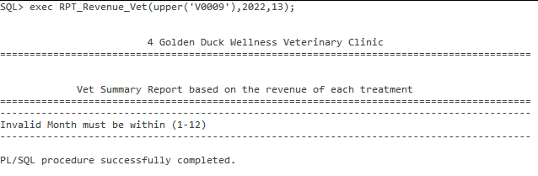

Exception Output : Invalid year or no treatment for the veterinarian in that month and year

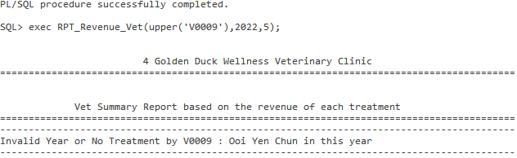

**4.4.9 Report 2: On demand report of days that performed poorly for a specific with a date range**

**Purpose: The purpose of this report is to analyze days that performed poorly within a date range. For example, Branch “B0001” from 1-MAY-2021 to 31-MAY-2021 which days that the brunch has revenue lower than RM 2000. Then a list of days with all the transactions will be displayed. At the end of the report will show which day has the revenue that is less than RM 2000. For example, within the date range two days that have lower revenue are on revenue. This allows the branch head to know which specific day has lower revenue and is required to improve it.**

SQL statement:

CREATE OR REPLACE PROCEDURE RPT_Less_Revenue(IN_branchID IN Transaction.branch_id%TYPE ,IN_StartDate in DATE, IN_EndDate in DATE, IN_MinAmount in Number) IS

CURSOR less_transaction_CURSOR IS

select trunc(transaction_datetime) as TransactionDate,to_char(transaction_datetime, 'DAY') AS Day,

count(transaction_id) AS TotalTransaction,

sum(total_amount) AS Total_Amount, ((sum(total_amount))/(count(transaction_id))) AS AverageT

from transaction

where transaction_datetime between IN_StartDate AND IN_EndDate AND branch_id = IN_branchID

Having sum(total_amount) < IN_MinAmount

group by trunc(transaction_datetime), to_char(transaction_datetime, 'DAY')

order by 1;

CURSOR transactiondetail_CURSOR (v_transaction_datetime DATE) IS

select T.transaction_id , T.transaction_datetime, TT.treatment_id, TT.treatment_type, TT.treatment_price,

TD.medic_id, M.medic_name, TD.line_qty,M.medic_price, TD.line_total

from transaction T, appointment A, treatment TT, transactiondetail TD, medicalsupply M

where T.appointment_id = A.appointment_id AND A.treatment_id = TT.treatment_id AND

TD.transaction_id = T.transaction_id AND TD.medic_id = M.medic_id AND

trunc(T.transaction_datetime) = v_transaction_datetime AND T.branch_id = IN_branchID

order by 1;

CURSOR less_day_CURSOR IS

select to_char(DateTime, 'DAY') AS Day, count(*) AS TotalDay

from (select trunc(transaction_datetime) AS DateTime, sum(total_amount) as Total_amount

from Transaction

Where transaction_datetime Between '01-MAY-2021' AND '31-MAY-2021' AND branch_id = 'B0001'

group by trunc(transaction_datetime)

having sum(total_amount) < 2000)

where Total_amount < 3000

group by to_char(DateTime, 'DAY')

order by 2;

v_totalCount NUMBER := 0;

v_detailCount NUMBER := 0;

v_transactionid TRANSACTION.transaction_id%type := 'TPP00000000';

v_rowCount NUMBER := 0;

v_sysdate DATE;

v_datecount NUMBER :=0;

v_branchcount NUMBER :=0;

e_invalid_branch EXCEPTION;

PRAGMA EXCEPTION_INIT(e_invalid_branch, -20165);

BEGIN

DBMS_OUTPUT.PUT_LINE(chr(10));

DBMS_OUTPUT.PUT_LINE(LPAD('4 Golden Duck Wellness Veterinary Clinic',95, ' '));

DBMS_OUTPUT.PUT_LINE(LPAD('=',150,'='));

DBMS_OUTPUT.PUT_LINE(chr(10));

DBMS_OUTPUT.PUT_LINE(LPAD('On Demand Report', 85, ' '));

DBMS_OUTPUT.PUT_LINE(LPAD('Days that have less revenue RM'||to_char(IN_MinAmount,999999.99),95, ' '));

DBMS_OUTPUT.PUT_LINE(LPAD('FROM '|| IN_StartDate ||' to '|| IN_EndDate,90, ' '));

Select sysdate into v_sysdate from dual;

DBMS_OUTPUT.PUT_LINE('Report Generated on : ' || v_sysdate);

DBMS_OUTPUT.PUT_LINE(LPAD('=',150,'='));

Select count(*) into v_branchcount from branch where branch_id = IN_branchID;

IF v_branchcount = 0 THEN

RAISE_APPLICATION_ERROR(-20165, 'Invalid Branch ID', true);

END IF;

FOR less_transaction_record IN less_transaction_CURSOR LOOP

DBMS_OUTPUT.PUT_LINE(RPAD('DATE : ' || less_transaction_record.TransactionDate,23, ' ')||

LPAD('| DAY : ' || less_transaction_record.Day,20, ' ') ||

LPAD('| No Transaction :' || to_char(less_transaction_record.TotalTransaction,99),25,' ') ||

LPAD('| Total Amount RM '|| to_char(less_transaction_record.Total_Amount,9999.99),30,' ')||

LPAD('| Average Amount RM '|| to_char(less_transaction_record.AverageT,999.99),30,' '));

DBMS_OUTPUT.PUT_LINE(LPAD('=',150,'='));

FOR transactiondetail_record IN transactiondetail_CURSOR (less_transaction_record.TransactionDate) LOOP

IF v_transactionid != transactiondetail_record.transaction_id THEN

DBMS_OUTPUT.PUT_LINE(chr(10));

v_transactionid := transactiondetail_record.transaction_id;

DBMS_OUTPUT.PUT_LINE(LPAD('-',150,'-'));

DBMS_OUTPUT.PUT_LINE(RPAD('Transaction ID',15, ' ')|| ' | ' ||RPAD('Treatment ID',12, ' ')|| ' | ' ||

LPAD('Treatment Type',25, ' ')|| ' | ' ||LPAD('Treatment Price',15, ' ')|| ' | ' ||

LPAD('Medicine ID',12, ' ')|| ' | ' || LPAD('Medicine Name',17, ' ')|| ' | ' ||

LPAD('QTY',3, ' ')|| ' | ' ||LPAD('Medicine Price',15, ' ')|| ' | ' ||LPAD('Total (RM)',10, ' '));

DBMS_OUTPUT.PUT_LINE(LPAD('-',150,'-'));

DBMS_OUTPUT.PUT_LINE(RPAD(transactiondetail_record.Transaction_id,15, ' ')||' | ' || RPAD(transactiondetail_record.Treatment_id,12, ' ')||' | ' ||

LPAD(transactiondetail_record.treatment_type,25, ' ')||' | ' ||LPAD(to_char(transactiondetail_record.treatment_price, 999.99),15, ' ')||' | '||

LPAD(transactiondetail_record.medic_id,12, ' ')||' | ' || LPAD(transactiondetail_record.medic_name,17, ' ')||' | ' ||

LPAD(to_char(transactiondetail_record.line_qty,99),3, ' ') ||' | ' || LPAD(to_char(transactiondetail_record.medic_price, 999.99),15, ' ') ||' | ' ||

LPAD(to_char(transactiondetail_record.line_total,9999.99),10, ' '));

ELSE

DBMS_OUTPUT.PUT_LINE(LPAD(transactiondetail_record.medic_id,91, ' ')|| ' | ' || LPAD(transactiondetail_record.medic_name,17, ' ')|| ' | ' ||

LPAD(to_char(transactiondetail_record.line_qty,99),3, ' ')||' | '|| LPAD(to_char(transactiondetail_record.medic_price, 999.99),15, ' ')|| ' | ' ||

LPAD(to_char(transactiondetail_record.line_total,9999.99),10, ' '));

END IF;

v_rowCount := v_detailcount + 1;

END LOOP;

v_totalcount := v_totalcount +1;

DBMS_OUTPUT.PUT_LINE(chr(10)||chr(10));

DBMS_OUTPUT.PUT_LINE(LPAD('=',150,'='));

END LOOP;

IF v_rowCount = 0 THEN

DBMS_OUTPUT.PUT_LINE(chr(10));

DBMS_OUTPUT.PUT_LINE(LPAD('No sales than less RM '|| to_char(IN_MinAmount,99999.99) ||'than during this period',70, ' '));

DBMS_OUTPUT.PUT_LINE(chr(10));

ELSE

DBMS_OUTPUT.PUT_LINE(chr(10));

DBMS_OUTPUT.PUT_LINE(LPAD('=',50,'='));

DBMS_OUTPUT.PUT_LINE(RPAD('Count of days from MONDAY to SUNDAY',50,' ')|| '|');

DBMS_OUTPUT.PUT_LINE(LPAD('=',50,'='));

DBMS_OUTPUT.PUT_LINE(RPAD('Day',20,' ')||' | ' ||RPAD('Number',27,' ') || '|');

DBMS_OUTPUT.PUT_LINE(LPAD('-',50,'-'));

FOR dayCount_record in less_day_CURSOR LOOP

DBMS_OUTPUT.PUT_LINE(RPAD(dayCount_record.Day,20, ' ')|| ' | ' ||RPAD(dayCount_record.TotalDay,27, ' ')|| '|');

v_dateCount := v_dateCount + dayCount_record.TotalDay;

END LOOP;

DBMS_OUTPUT.PUT_LINE(LPAD('=',50,'='));

DBMS_OUTPUT.PUT_LINE('Total ' || v_dateCount || ' days Revenue Less Than RM' || to_char(IN_MinAmount,99999.99));

DBMS_OUTPUT.PUT_LINE(LPAD('=',50,'='));

END IF;

EXCEPTION

WHEN e_invalid_branch THEN

DBMS_OUTPUT.PUT_LINE(LPAD('-',150,'-'));

DBMS_OUTPUT.PUT_LINE ('Branch ID Does Not Exist !!!');

DBMS_OUTPUT.PUT_LINE(LPAD('-',150,'-'));

END;

/

**Exception Output: Out of clinic operated year.**

**Sample Output:**



Sample Output :

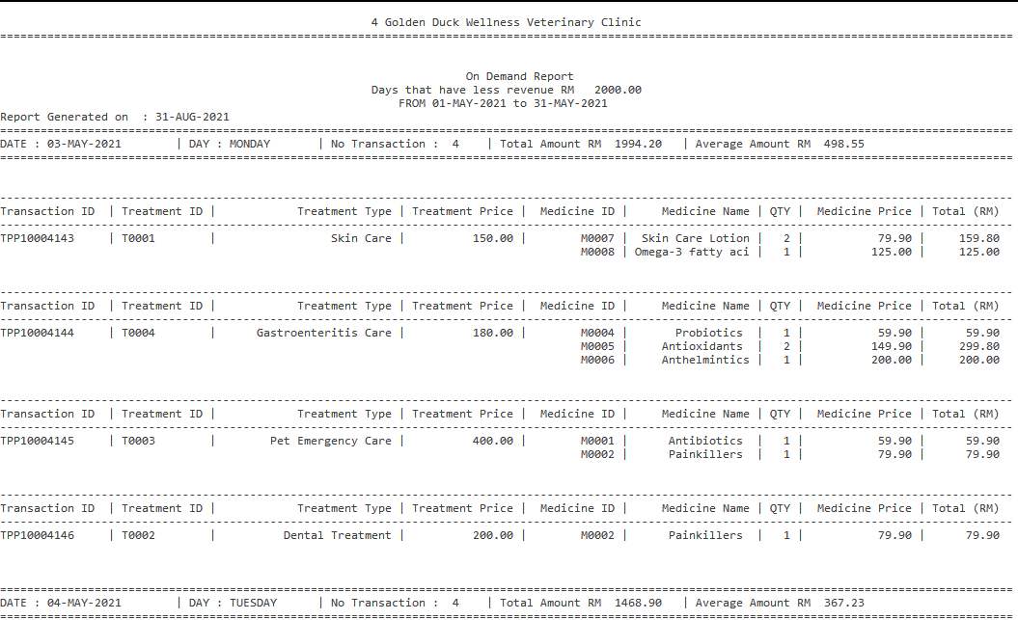

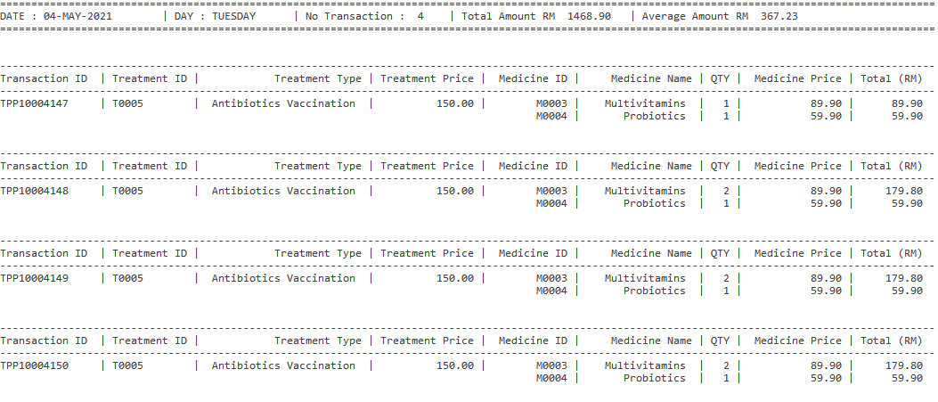

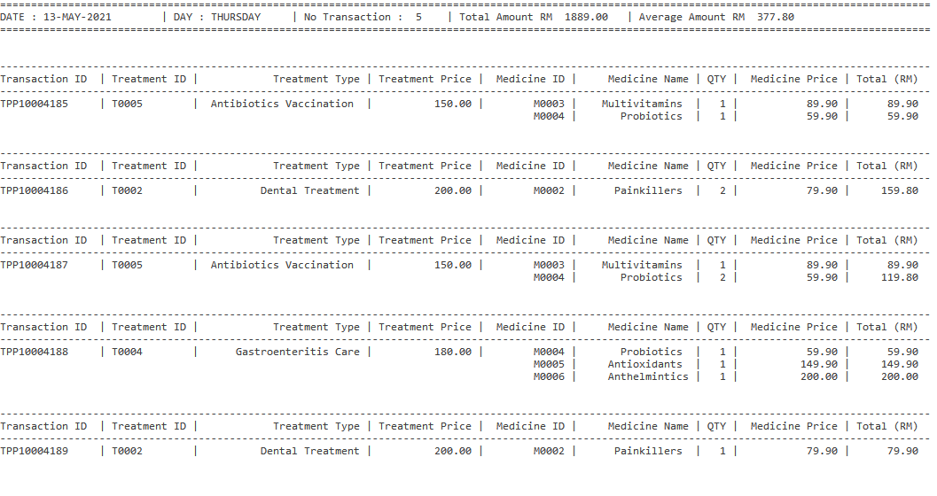

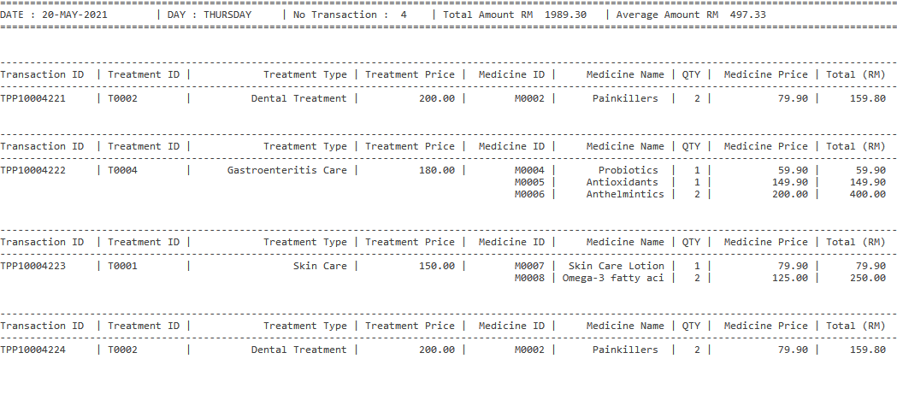

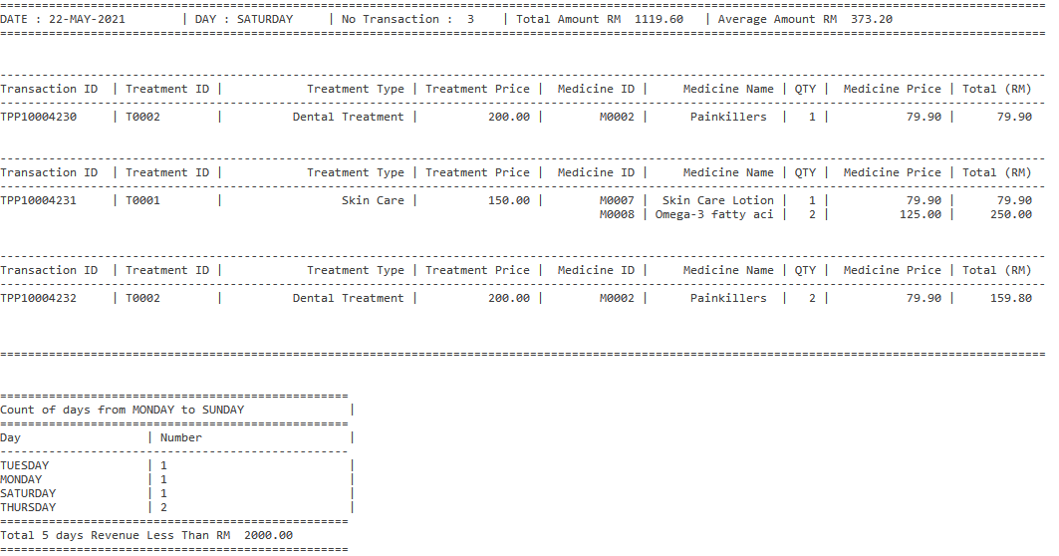

**Exception Output: Invalid Branch ID**

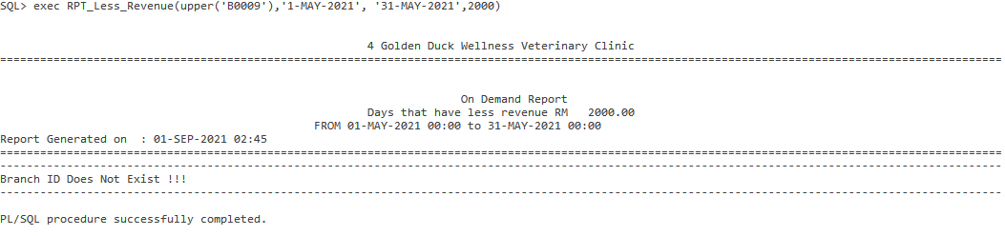

**4.4.10 Report 3: Detail report of each Branch’s Performance in a specific year**

**Purpose: The purpose of this report is to show total revenue, revenue of each treatment and revenue of each medecine of a branch. Details such as treatment done, medicine sold by each branch will also be shown, contribution of each treatment and medicine to the branch revenue will also be shown . The contribution of each branch to the total revenue of the specific year will be shown in percentage.**

SQL statement:

CREATE OR REPLACE PROCEDURE RPT_Branch_Performance(in_YEAR IN NUMBER) IS

CURSOR branch_overall_revenue_CURSOR IS

select B.branch_id , B.state, B.city, B.postcode, B.streetname,

count(T.transaction_id) AS TotalTransaction,

sum(T.total_amount) AS Total_Amount

from transaction T, Branch B

where T.branch_id = B.branch_id AND Extract(YEAR from transaction_datetime) = 2020

group by B.branch_id , B.state, B.city, B.postcode, B.streetname

order by 1;

CURSOR branch_treatment_revenue_CURSOR (v_branchID BRANCH.branch_id%TYPE) IS

select B.branch_id , TT.treatment_id, TT.treatment_type, TT.treatment_price,

count(T.transaction_id) as TotalTreatment,

(count(T.transaction_id)*treatment_price) AS TotalTreatmentRevenue

from transaction T, Branch B, appointment A, treatment TT

where T.branch_id = B.branch_id AND T.appointment_id = A.appointment_id AND

A.treatment_id = TT.treatment_id AND

Extract(YEAR from transaction_datetime) = in_YEAR AND

T.branch_id = v_branchID

group by B.branch_id, TT.treatment_id, TT.treatment_type, TT.treatment_price

order by 1,2;

CURSOR branch_medic_revenue_CURSOR (v_branchID BRANCH.branch_id%TYPE) IS

select T.branch_id , M.medic_id, M.medic_name, M.medic_price,

sum(TD.line_qty) as TotalMedic,

sum(TD.line_total) AS TotalMedicRevenue

from transaction T, transactiondetail TD, medicalsupply M

where T.transaction_id = TD.transaction_id AND TD.medic_id = M.medic_id AND

Extract(YEAR from T.transaction_datetime) = in_YEAR AND

T.branch_id = v_branchID

group by T.branch_id, M.medic_id, M.medic_name, M.medic_price

order by 1,2;

v_branchTotalTreatmentRevenue NUMBER := 0;

v_branchTotalMedicRevenue NUMBER := 0;

v_all_totalamount NUMBER;

v_all_totalTreatment NUMBER :=0;

v_all_totalMedical NUMBER :=0;

v_transactionid TRANSACTION.transaction_id%type := 'TPP00000000';

v_rowCount NUMBER := 0;

v_sysdate DATE;

v_branchcount NUMBER :=0;

v_allRevenue NUMBER :=0;

v_minYear NUMBER;

v_maxYear NUMBER;

e_invalid_year EXCEPTION;

PRAGMA EXCEPTION_INIT(e_invalid_year, -20166);

BEGIN

DBMS_OUTPUT.PUT_LINE(chr(10));

DBMS_OUTPUT.PUT_LINE(LPAD('4 Golden Duck Wellness Veterinary Clinic',80, ' '));

DBMS_OUTPUT.PUT_LINE(LPAD('=',115,'='));

DBMS_OUTPUT.PUT_LINE(chr(10));

DBMS_OUTPUT.PUT_LINE(LPAD('Detail Report', 63, ' '));

DBMS_OUTPUT.PUT_LINE(LPAD('Each Branch Performance Report',72, ' '));

DBMS_OUTPUT.PUT_LINE(LPAD(IN_YEAR,58, ' '));

Select sysdate into v_sysdate from dual;

DBMS_OUTPUT.PUT_LINE('Report Generated on : ' || v_sysdate);

Select Extract(YEAR FROM Min(transaction_datetime)), Extract(YEAR FROM Max(transaction_datetime))

into v_minYear, v_maxYear

From transaction;

IF in_YEAR < v_minYear or in_Year > v_maxYear THEN

RAISE_APPLICATION_ERROR(-20166, 'Invalid Year', true);

END IF;

FOR branch_record IN branch_overall_revenue_CURSOR LOOP

DBMS_OUTPUT.PUT_LINE(LPAD('=',115,'='));

DBMS_OUTPUT.PUT_LINE('Branch ID :' || branch_record.branch_id);

DBMS_OUTPUT.PUT_LINE('State :' || branch_record.state);

DBMS_OUTPUT.PUT_LINE('City :' || branch_record.city);

DBMS_OUTPUT.PUT_LINE('Postcode :' || branch_record.postcode);

DBMS_OUTPUT.PUT_LINE('Street Name :' || branch_record.streetname);

DBMS_OUTPUT.PUT_LINE(LPAD('-',115,'-'));

DBMS_OUTPUT.PUT_LINE(LPAD('Revenue for each treatment',75,' '));

DBMS_OUTPUT.PUT_LINE(LPAD('-',115,'-'));

DBMS_OUTPUT.PUT_LINE(RPAD('Treatment ID', 12 ,' ')|| ' | ' || RPAD('Treatment Type', 20 ,' ')|| ' | ' ||

LPAD('Treatment Price (RM)', 20 ,' ')|| ' | ' ||

LPAD('No Treatment', 12 ,' ')|| ' | ' ||

LPAD('Treatment Revenue (RM)', 25 ,' ')|| ' | ' ||

LPAD('Percent%',10,' '));

DBMS_OUTPUT.PUT_LINE(LPAD('-',115,'-'));

FOR treatment_record1 IN branch_treatment_revenue_CURSOR (branch_record.branch_id) LOOP

v_branchTotalTreatmentRevenue := v_branchTotalTreatmentRevenue + treatment_record1.TotalTreatmentRevenue;

END LOOP;

FOR treatment_record IN branch_treatment_revenue_CURSOR (branch_record.branch_id) LOOP

DBMS_OUTPUT.PUT_LINE(RPAD(treatment_record.treatment_id, 12 ,' ')|| ' | ' ||

RPAD(treatment_record.treatment_type, 20 ,' ')|| ' | ' ||

LPAD(to_char(treatment_record.treatment_price, 999.99), 20 ,' ')|| ' | ' ||

LPAD(treatment_record.TotalTreatment, 12 ,' ')|| ' | ' ||

LPAD(to_char(treatment_record.TotalTreatmentRevenue, 999999.99), 25 ,' ')|| ' | ' ||

LPAD(round((treatment_record.TotalTreatmentRevenue/v_branchTotalTreatmentRevenue*100),2),10,' '));

END LOOP;

DBMS_OUTPUT.PUT_LINE(LPAD('-',115,'-'));

DBMS_OUTPUT.PUT_LINE('Total (RM)'||LPAD(to_char(v_branchTotalTreatmentRevenue,99999999.99),91,' '));

DBMS_OUTPUT.PUT_LINE(LPAD('-',115,'-'));

DBMS_OUTPUT.PUT_LINE(LPAD('Revenue for each Medicine',75,' '));

DBMS_OUTPUT.PUT_LINE(LPAD('-',115,'-'));

DBMS_OUTPUT.PUT_LINE(RPAD('Medicine ID', 12 ,' ')|| ' | ' || RPAD('Medicine Name', 20 ,' ')|| ' | ' ||

LPAD('Medicine Price (RM)', 20 ,' ')|| ' | ' ||

LPAD('QTY Sold', 12 ,' ')|| ' | ' ||

LPAD('Medicine Revenue (RM)', 25 ,' ')|| ' | ' ||

LPAD('Percent%',10,' '));

DBMS_OUTPUT.PUT_LINE(LPAD('-',115,'-'));

FOR medic_record1 IN branch_medic_revenue_CURSOR (branch_record.branch_id) LOOP

v_branchTotalMedicRevenue := v_branchTotalMedicRevenue + medic_record1.TotalMedicRevenue;

END LOOP;

FOR medic_record IN branch_medic_revenue_CURSOR (branch_record.branch_id) LOOP

DBMS_OUTPUT.PUT_LINE(RPAD(medic_record.medic_id, 12 ,' ')|| ' | ' ||

RPAD(medic_record.medic_name, 20 ,' ')|| ' | ' ||

LPAD(to_char(medic_record.medic_price, 999.99), 20 ,' ')|| ' | ' ||

LPAD(medic_record.TotalMedic, 12 ,' ')|| ' | ' ||

LPAD(to_char(medic_record.TotalMedicRevenue, 999999.99), 25 ,' ')|| ' | ' ||

LPAD(round((medic_record.TotalMedicRevenue/v_branchTotalMedicRevenue*100),2),10,' '));

END LOOP;

DBMS_OUTPUT.PUT_LINE(LPAD('-',115,'-'));

DBMS_OUTPUT.PUT_LINE('Total (RM)'||LPAD(to_char(v_branchTotalMedicRevenue,99999999.99),91,' '));

v_branchTotalTreatmentRevenue:= 0;

v_branchTotalMedicRevenue:= 0;

DBMS_OUTPUT.PUT_LINE(LPAD('-',115,'-'));

DBMS_OUTPUT.PUT_LINE(chr(10));

END LOOP;

DBMS_OUTPUT.PUT_LINE(LPAD('-',115,'-'));

DBMS_OUTPUT.PUT_LINE(LPAD('Contribution of each branch in ',70,' ' )|| IN_YEAR);

DBMS_OUTPUT.PUT_LINE(LPAD('-',115,'-'));

DBMS_OUTPUT.PUT_LINE(RPAD('Branch ID ', 10, ' ') ||' | ' || LPAD('Treatment Revenue (RM)',25,' ') || ' | ' ||

LPAD('Medicine Revenue (RM)',25,' ') ||' | ' || LPAD('Branch Total Revenue (RM)',25,' ') ||' | ' || LPAD('Contribution%',17,' '));

DBMS_OUTPUT.PUT_LINE(LPAD('-',115,'-'));

Select sum(total_amount) into v_all_totalamount from transaction where Extract(YEAR from transaction_datetime) = IN_year;

FOR branch_record IN branch_overall_revenue_CURSOR LOOP

v_branchTotalTreatmentRevenue:= 0;

v_branchTotalMedicRevenue:= 0;

FOR treatment_record1 IN branch_treatment_revenue_CURSOR (branch_record.branch_id) LOOP

v_branchTotalTreatmentRevenue := v_branchTotalTreatmentRevenue + treatment_record1.TotalTreatmentRevenue;

END LOOP;

FOR medic_record1 IN branch_medic_revenue_CURSOR (branch_record.branch_id) LOOP

v_branchTotalMedicRevenue := v_branchTotalMedicRevenue + medic_record1.TotalMedicRevenue;

END LOOP;

DBMS_OUTPUT.PUT_LINE(RPAD(branch_record.branch_id, 10, ' ') ||' | ' ||

LPAD(to_char(v_branchTotalTreatmentRevenue,999999.99),25,' ') || ' | ' ||

LPAD(to_char(v_branchTotalMedicRevenue, 999999.99),25, ' ') ||' | ' ||

LPAD(to_char(branch_record.Total_Amount, 999999.99),25,' ') ||' | ' ||

LPAD(round((branch_record.Total_Amount/v_all_totalamount*100),2),17,' '));

v_all_totalTreatment := v_all_totalTreatment + v_branchTotalTreatmentRevenue;

v_all_totalMedical := v_all_totalMedical + v_branchTotalMedicRevenue;

END LOOP;

DBMS_OUTPUT.PUT_LINE(LPAD('-',115,'-'));

DBMS_OUTPUT.PUT_LINE('Total (RM) |'|| LPAD(to_char(v_all_totalTreatment,9999999.99),26,' ') ||' | ' ||

LPAD(to_char(v_all_totalMedical,9999999.99),25,' ')||' | ' ||

LPAD(to_char( v_all_totalamount,9999999.99),25,' ')||' | ' );

DBMS_OUTPUT.PUT_LINE(LPAD('-',115,'-'));

EXCEPTION

WHEN e_invalid_year THEN

DBMS_OUTPUT.PUT_LINE(LPAD('-',115,'-'));

DBMS_OUTPUT.PUT_LINE ('The year you have entered is invalid or within the range of operated year !!!');

DBMS_OUTPUT.PUT_LINE(LPAD('-',115,'-'));

END ;

/

exec RPT_Branch_Performance(&year)

**Sample Output :**

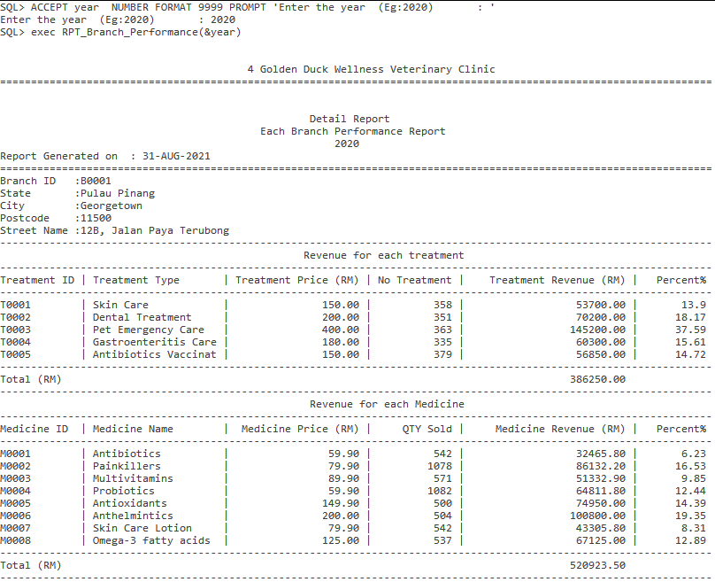

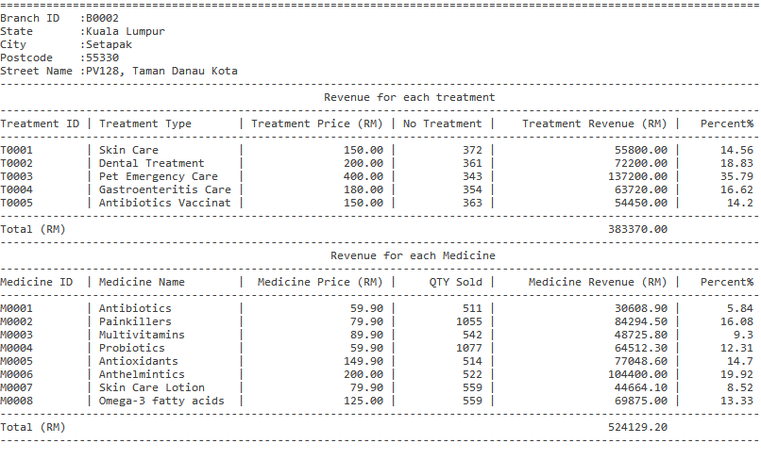

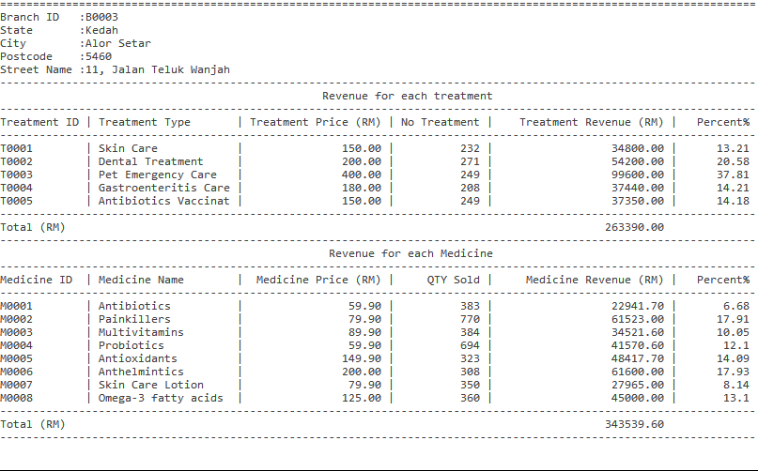

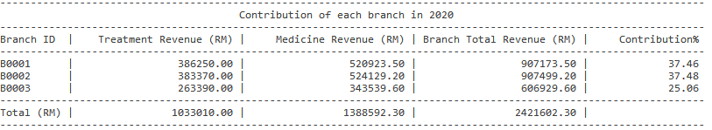

**Exception Output : Invalid year and out of clinic operation year**

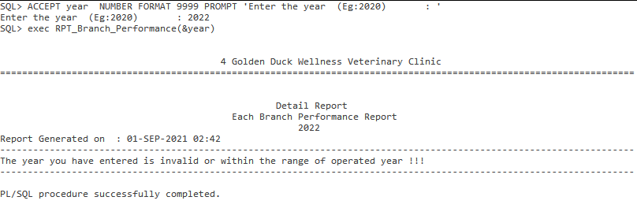

### Chapter 5 Extra Effort Highlights

**5.1 (Tan Yi Hong)**

**5.1.1 Views**

**View 1: The purpose of this view is to display the top pet type that received treatment in each branch**

CREATE OR REPLACE VIEW topPetTreatment AS

SELECT t.branch_id, pt.type_name, COUNT(t.appointment_id) AS NoOfTreatment, SUM(t.total_amount) AS TransactionAmount

FROM appointment a, veterinarian v, pet p, petType pt, transaction t

WHERE t.appointment_id=a.appointment_id AND a.vet_id=v.vet_id AND a.pet_id=p.pet_id

AND p.type_id=pt.type_id AND t.appointment_id=a.appointment_id

GROUP BY t.branch_id, pt.type_name

ORDER BY t.branch_id, SUM(t.total_amount) DESC;

**Sample output :**

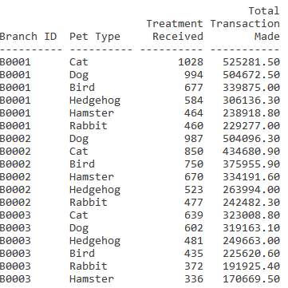

**View 2: The purpose of this view is to display the amount of appointments made during morning times of each branch in last year**

CREATE OR REPLACE VIEW morningApp AS

SELECT t.branch_id, COUNT(t.transaction_id) AS MORNING

FROM appointment a, transaction t

WHERE t.appointment_id = a.appointment_id AND

EXTRACT(HOUR FROM CAST(a.appointment_datetime AS TIMESTAMP)) BETWEEN 10 AND 12

AND EXTRACT(YEAR FROM a.appointment_datetime) = EXTRACT(YEAR FROM SYSDATE)-1

GROUP BY t.branch_id

ORDER BY t.branch_id;

**Sample output :**

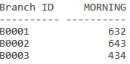

**View 3: The purpose of this view is to display the amount of appointments made during afternoon times of each branch in last year**

CREATE OR REPLACE VIEW afternoonApp AS

SELECT t.branch_id, COUNT(t.transaction_id) AS AFTERNOON

FROM appointment a, transaction t

WHERE t.appointment_id = a.appointment_id AND

EXTRACT(HOUR FROM CAST(a.appointment_datetime AS TIMESTAMP)) BETWEEN 13 AND 15

AND EXTRACT(YEAR FROM a.appointment_datetime) = EXTRACT(YEAR FROM SYSDATE)-1

GROUP BY t.branch_id

ORDER BY t.branch_id;

**Sample output :**

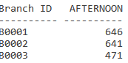

**View 4: The purpose of this view is to display the amount of appointments made during evening times of each branch in last year**

CREATE OR REPLACE VIEW eveningApp AS

SELECT t.branch_id, COUNT(t.transaction_id) AS EVENING

FROM appointment a, transaction t

WHERE t.appointment_id = a.appointment_id AND

EXTRACT(HOUR FROM CAST(a.appointment_datetime AS TIMESTAMP)) BETWEEN 16 AND 18

AND EXTRACT(YEAR FROM a.appointment_datetime) = EXTRACT(YEAR FROM SYSDATE)-1

GROUP BY t.branch_id

ORDER BY t.branch_id;

**Sample output :**

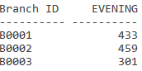

**View 5: This purpose of this view is to calculate the sales of each branch in the year 2020 first half**

CREATE OR REPLACE VIEW Sales2020_1stHalf AS

SELECT branch_id, SUM(total_amount) AS Sales2020_1stHalf

FROM transaction

WHERE EXTRACT(YEAR FROM transaction_dateTime) = 2020 AND EXTRACT(MONTH FROM transaction_dateTime) <= 6

GROUP BY branch_id

ORDER BY branch_id, SUM(total_amount) DESC;

**Sample output :**

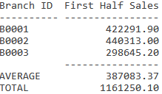

**View 6: This purpose of this view is to calculate the sales of each branch in the year 2020 second half**

CREATE OR REPLACE VIEW Sales2020_2ndHalf AS

SELECT branch_id, SUM(total_amount) AS Sales2020_2ndHalf

FROM transaction

WHERE EXTRACT(YEAR FROM transaction_dateTime) = 2020 AND EXTRACT(MONTH FROM transaction_dateTime) > 6

GROUP BY branch_id

ORDER BY branch_id, SUM(total_amount) DESC;

**Sample output :**

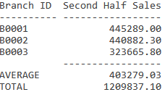

**5.1.2 User Defined Exceptions**

**Exception 1: This exception is defined in the procedure add appointment and it will be raised when treatment ID enter by user is not found or invalid**

e_invalid_treatment EXCEPTION;

PRAGMA EXCEPTION_INIT(e_invalid_treatment, -20050);

RAISE_APPLICATION_ERROR(-20050, 'Invalid Treatment ID.');

**Exception 2: This exception is defined in the procedure add appointment and it will be raised when pet ID enter by user is not found or invalid**

e_invalid_pet EXCEPTION;

PRAGMA EXCEPTION_INIT(e_invalid_pet, -20051);

RAISE_APPLICATION_ERROR(-20051, 'Invalid Pet ID.');

**Exception 3: This exception is defined in the summary, detail, and on demand report. It will be raised when the record of report generate by user was not found**

e_norecord EXCEPTION;

PRAGMA EXCEPTION_INIT(e_norecord,-20060);

RAISE_APPLICATION_ERROR(-20060,'No record found');

**Exception 4: This exception is defined in trigger appointment date time and it will be raised when the appointment insert is before now.**

RAISE_APPLICATION_ERROR(-20052, 'Cannot insert the date time before now.' );

**Exception 5: This exception is defined in trigger appointment date time and it will be raised when the appointment insert is not within business hours.**

RAISE_APPLICATION_ERROR(-20053, 'Date time must be within business hour.' );

**Exception 6: This exception is defined in trigger delete appointment and it will be raised when the appointment is recorded in transaction and unable to delete**

RAISE_APPLICATION_ERROR(-20055,'Appointment delete unsuccessful');

**5.1.3 Sequences**

**Sequence 1: This sequence will automatically generate the appointment ID for the Kuala Lumpur branch. It will be used when inserting a new appointment in the KL branch and adding 1 after the next new appointment.**

CREATE SEQUENCE app_seq_KL

MINVALUE 10000001

MAXVALUE 99999999

START WITH 10000001

INCREMENT BY 1;

**Sequence 2: This sequence will automatically generate the appointment ID for the Pulau Pinang branch. It will be used when inserting a new appointment in the PG branch and adding 1 after the next new appointment.**

CREATE SEQUENCE app_seq_PG

MINVALUE 10000001

MAXVALUE 99999999

START WITH 10000001

INCREMENT BY 1;

**Sequence 3: This sequence will automatically generate the appointment ID for the Kedah branch. It will be used when inserting a new appointment in the KD branch and adding 1 after the next new appointment.**

CREATE SEQUENCE app_seq_KD

MINVALUE 10000001

MAXVALUE 99999999

START WITH 10000001

INCREMENT BY 1;

**5.1.4 Triggers**

**Trigger 1: This trigger is use to validate the age of the veterinarian that should be above 22 years old when a new veterinarian is inserted into the database**

CREATE OR REPLACE TRIGGER trgVetAge

BEFORE INSERT OR UPDATE ON Veterinarian

FOR EACH ROW

BEGIN

IF((ROUND((SYSDATE-:new.vet_dob)/365)) < 22) THEN

RAISE_APPLICATION_ERROR(-20002, 'Veterinarian must be at least 22 years old.' );

END IF;

END;

/

**5.2 (Tan Teoh Xin Ee)**

**5.2.1 Views**

**View 1: The purpose of this view is to store the information of medicine details from different branches. For example, the medicine name, qty and amount.**

create or replace view medicalUsed As

select t.branch_id, d.medic_id, m.medic_name, sum(d.line_qty) as quantity, sum(d.line_total) as amount

from transaction t, branch b, transactiondetail d, medicalsupply m

where b.branch_id = t.branch_id

and t.transaction_id = d.transaction_id

and d.medic_id = m.medic_id

group by t.branch_id, d.medic_id,m.medic_name

order by t.branch_id,sum(d.line_qty) DESC;

**Sample Output:**

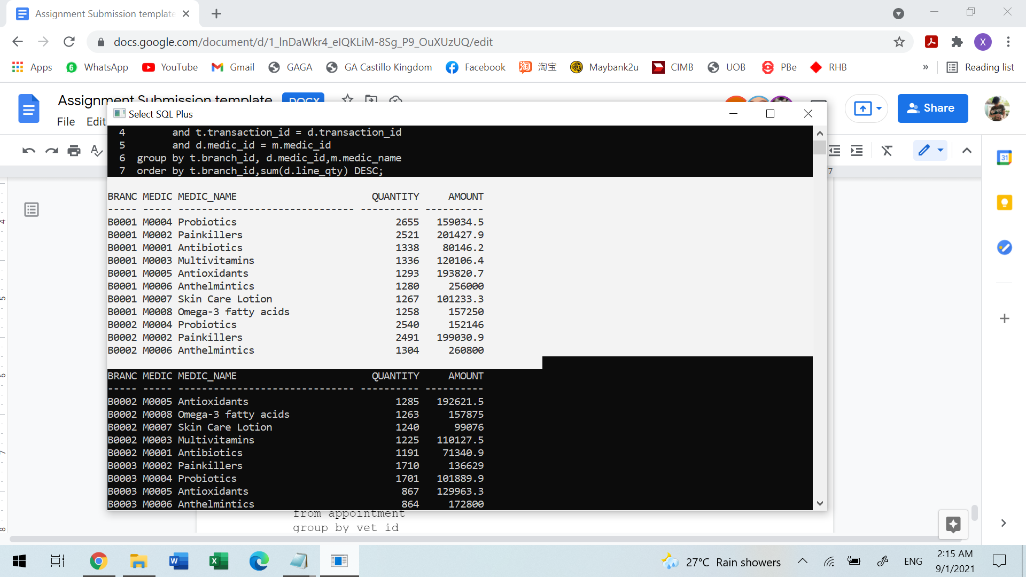

**View 2: The purpose of this view is to store the numbers of appointments received by every veterinarian.**

create or replace view appointNum As

select count(appointment_id) as NoOfapp, vet_id

from appointment

group by vet_id

order by count(appointment_id) desc;

**Sample Output:**

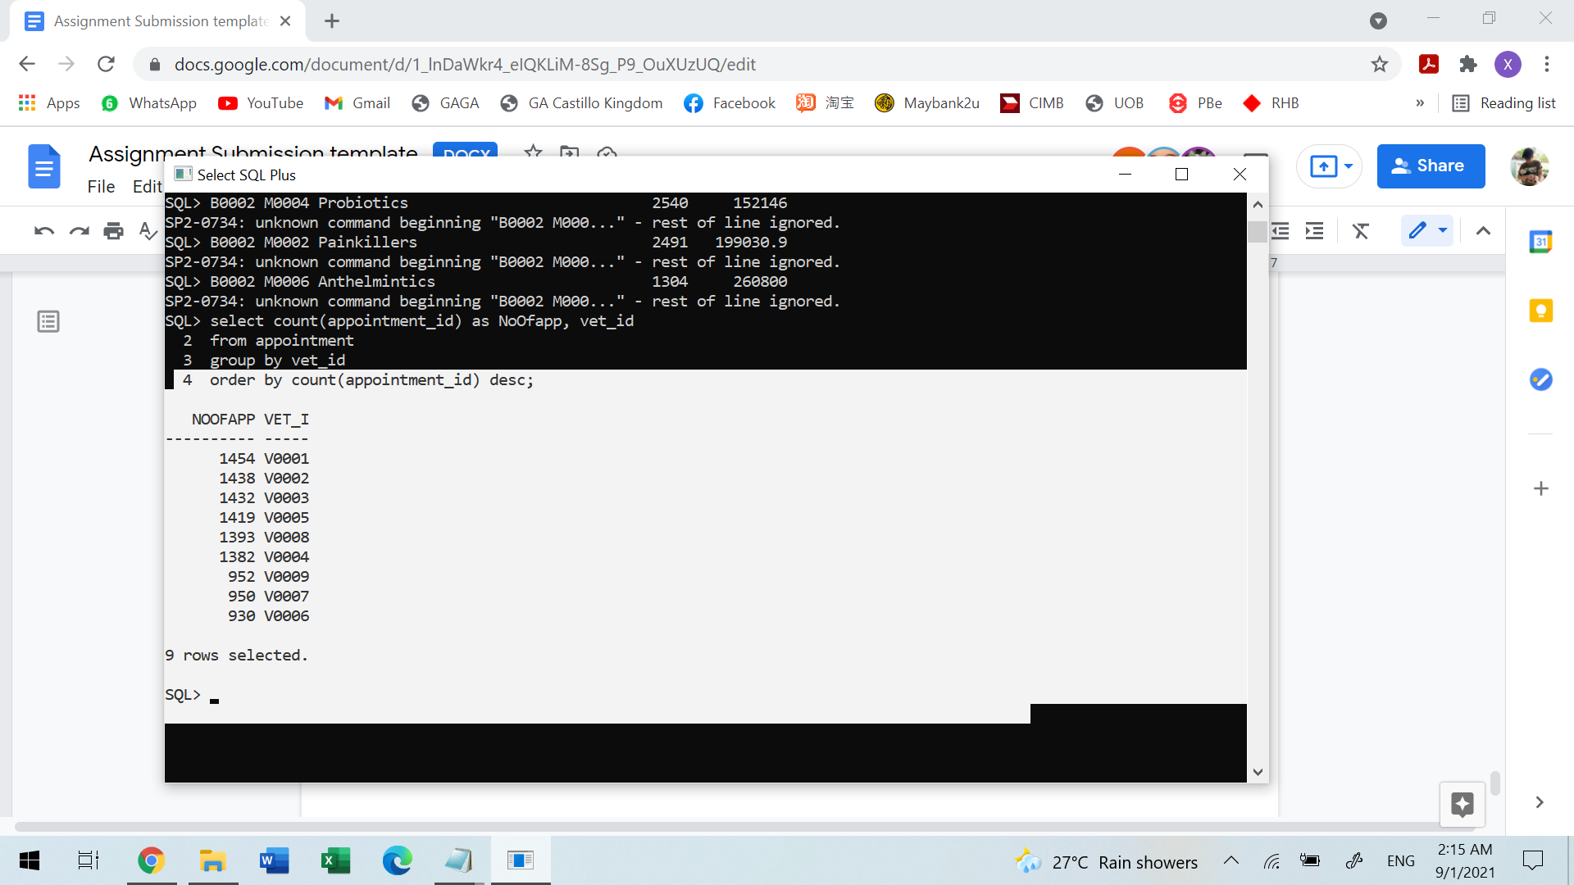

**View 3: The purpose of this view is to store late sent stock information from the supplier such as purchase date, receive date and the duration from purchase date until receive date. The stock normally will be sent within 6 days.**

create or replace view difdate as

select purchase_id, supplier_id, purchase_date, receive_date,(receive_date-purchase_date) as duration

from purchaseTransaction

where receive_date-purchase_date>6

group by purchase_id,supplier_id, purchase_date, receive_date

order by supplier_id;

**Sample Output:**

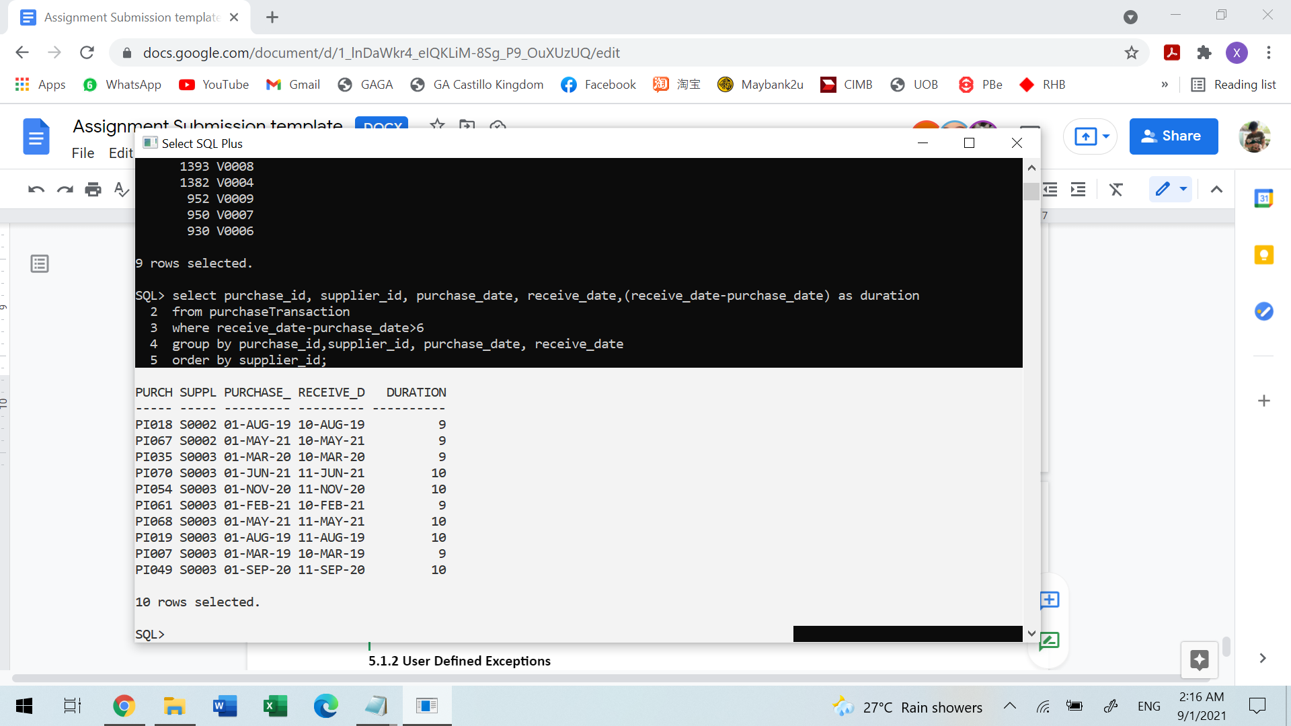

**5.2.2 User Defined Exceptions**

**The purpose of this exception is to prompt the user that ‘Invalid supplier code.’, if he/she key in the wrong supplier id.**

EXCE_SUPPLIERCODE EXCEPTION;

PRAGMA EXCEPTION_INIT(EXCE_SUPPLIERCODE, -20310);

**5.2.3 Sequence**

**The purpose of this sequence is to generate numbers for medic_id, which will be needed in the medic add procedure.**

CREATE SEQUENCE MEDICID

MINVALUE 8

MAXVALUE 9999

START WITH 8

INCREMENT BY 1;

**5.2.4 Trigger**

**The purpose of this trigger is to delete the amount of purchase items from the amount of purchase transaction, if the purchase item was deleted.**

CREATE OR REPLACE TRIGGER trgDelPurchaseItem

After Delete ON PurchaseItem

FOR EACH ROW

BEGIN

Update PurchaseTransaction

SET purchase_amount = purchase_amount - (:new.purchase_qty * :new.purchase_price)

where purchase_id = :new.purchase_id;

END;

/

**5.3 (Tan Wei Siong)**

**5.3.1 User Defined Exceptions**

**Exception 1: This exception is defined in the trigger check appointment date time to check whether the selected time for the veterinarian is book or not. If the time has been booked, the exception will raise and output the suggested time for the user.**

Date_Time_Booked EXCEPTION;

PRAGMA exception_init(Date_Time_Booked, -20200 );

**Exception 2: This exception is defined in the procedure pet register to check whether the provided owner information exists or not. It will raise when the owner information is not found.**

No_owner_found EXCEPTION;

PRAGMA exception_init(No_owner_found,-20201);

**Exception 3: This exception is defined in the on-demand report of the pet treatment detail. The exception will raise when the user enters the invalid pet id into the system. It will message the user that the pet is not found.**

NO_PET_FOUND EXCEPTION;

PRAGMA EXCEPTION_INIT(NO_PET_FOUND, -20202);

**Exception 4: This exception is defined in the trigger check owner age. The exception will raise when the registered user age is below 18.**

RAISE_APPLICATION_ERROR(-20004, 'Pet Owner must be at least 18 years old.' );

**5.3.2 Sequence**

**Sequence 1: This sequence is used to auto generate the pet owner id. The sequence number will increase 1 when there is a new pet owner registered.**

CREATE SEQUENCE owner_seq

START WITH 501

INCREMENT BY 1;

**Sequence 2: This sequence is used to auto generate the pet id. The sequence number will increase 1 when there is a new pet registered.**

CREATE SEQUENCE pet_seq

START WITH 1001

INCREMENT BY 1;

**5.3.3 Procedure**

**5.3.3.1 Procedure 1: Pet Owner Registration**

**Purpose: The purpose of this procedure is to let the staff register the pet owner in an easier way. The staff online need to input the owner information into this procedure and the owner will be added into the database.**

**Procedure code:**

CREATE OR REPLACE Procedure Prc_register_owner(in_owner_Name IN VARCHAR2, in_owner_Contact IN VARCHAR2,

in_owner_dob IN Date, in_gender IN CHAR, in_state IN VARCHAR2,

in_city IN VARCHAR2, in_postcode IN VARCHAR2,

in_streetName IN VARCHAR2) AS

v_owner_seq VARCHAR2(4);

v_petOwner_id PetOwner.owner_id%TYPE;

BEGIN

SELECT to_char(lpad(owner_seq.nextval,'4','0')) INTO v_owner_seq from dual;

v_petOwner_id := ('O'||v_owner_seq);

Insert into petOwner values(v_petOwner_id, in_owner_Name , in_owner_Contact, in_owner_dob,

in_gender, in_state, in_city, in_postcode, in_streetName);

dbms_output.put_line('Owner is registered. ID is ' || v_petOwner_id);

END;

/

**Sample Output:**

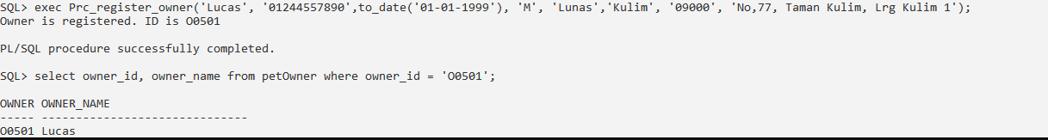

**5.3.4 Trigger**

**Trigger 1: The purpose of this trigger is to auto update the purchase amount when there is a new purchase item inserted into the purchase item table.**

CREATE OR REPLACE TRIGGER trgPurchaseItem

After Insert ON PurchaseItem

FOR EACH ROW

BEGIN

Update PurchaseTransaction

SET purchase_amount = purchase_amount + (:new.purchase_qty * :new.purchase_price)

where purchase_id = :new.purchase_id;

END;

/

**5.4 (Nigel Lee Jian Hsee)**

**5.4.1 Views**

**View 1: The purpose of this view is to store the treatment revenue in the year of 2021 of each branch.**

CREATE OR REPLACE VIEW FullRevenueGroupByTreatment2021 AS

select T.branch_id,TT.treatment_id, TT.treatment_type, sum(T.total_amount) as Total_Amount

from transaction T, appointment A, treatment TT

where A.appointment_id = T.appointment_id AND A.treatment_id = TT.treatment_id AND EXTRACT(YEAR FROM T.transaction_datetime) = '2021'

group by T.branch_id,TT.treatment_id, TT.treatment_type

order by branch_id;

**Sample Output:**

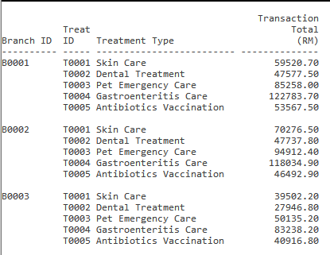

**View 1: The purpose of this view is to store the medicine revenue of each treatment in the year of 2021 of each branch. For example, total medicine revenue that earned after a dental treatment.**

CREATE OR REPLACE VIEW MedicRevenueGroupByTreatment2021 AS

select T.branch_id,TT.treatment_id, TT.treatment_type, sum(TD.line_total) AS Medic_Revenue, sum(TD.line_qty) AS Sold_Quantity, (sum(TD.line_total)/sum(TD.line_qty)) AS Revenue_Per_Quantity

from transactiondetail TD, transaction T, appointment A, treatment TT

where TD.transaction_id = T.transaction_id AND A.appointment_id = T.appointment_id AND A.treatment_id = TT.treatment_id AND EXTRACT(YEAR FROM T.transaction_datetime) = '2021'

group by T.branch_id,TT.treatment_id, TT.treatment_type

order by branch_id;

**Sample Output:**

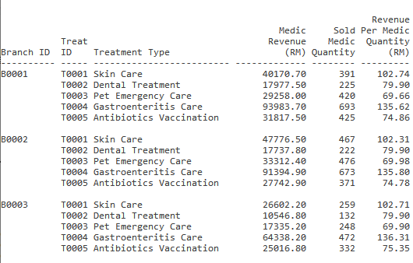

**5.4.2 User Defined Exceptions**

**Exception 1: This exception is defined in the procedure add and create transaction to check whether the entered appointment exists. If not an error message will be displayed.**

e_invalid_appointmentid EXCEPTION;

PRAGMA EXCEPTION_INIT(e_invalid_appointmentid, -20150);

**Exception 2: This exception is defined in the procedure add and create transaction to check whether the entered appointment id transaction is already created . If yes an error message will be displayed.**

e_repeated_transaction EXCEPTION;

PRAGMA EXCEPTION_INIT(e_repeated_transaction, -20151);

**Exception 3: This exception is defined in the adding transaction detail procedure. The exception will raise when the user adds a medicine that already exists in a created transaction. If yes an error message will be prompted.**

e_repeated_medicid EXCEPTION;

PRAGMA EXCEPTION_INIT(e_repeated_medicid, -20155);

**Exception 4: This exception is defined in the adding transaction detail procedure. The exception will raise when the medic quantity entered is less than or equal zero.**

e_zero_qty EXCEPTION;

PRAGMA EXCEPTION_INIT(e_zero_qty, -20156);

**Exception 5: This exception is defined in the edit transaction detail procedure. The exception will raise when the transaction is an old transaction that has already passed 7 days.**

e_dayexceed EXCEPTION;

PRAGMA EXCEPTION_INIT(e_dayexceed, -20157)

**Exception 5: This exception is defined in the edit transaction detail procedure. The exception will raise when the user enters a transaction detail that does not exist.**

e_invalid_transactiondetail EXCEPTION;

PRAGMA EXCEPTION_INIT(e_invalid_transactiondetail, -20158);

**Exception 6: This exception is defined in the edit transaction detail procedure. The exception will raise when the quantity is less than zero.**

e_lesszero_qty EXCEPTION;

PRAGMA EXCEPTION_INIT(e_lesszero_qty, -20159);

**Exception 7: This exception is defined in the edit transaction detail procedure. The exception will raise when the medicine quantity entered is the same as the old quantity and remind the user that the quantity is the same and will not change.**

e_samequantity EXCEPTION;

PRAGMA EXCEPTION_INIT(e_samequantity, -20161);

**Exception 8: This exception is defined in the vet monthly performance summary report. The exception will raise when the entered vet id is invalid.**

e_invalid_vetid EXCEPTION;

PRAGMA EXCEPTION_INIT(e_invalid_vetid, -20162);

**Exception 9: This exception is defined in the vet monthly performance summary report. The exception will raise when the entered month is invalid.**

e_invalid_month EXCEPTION;

PRAGMA EXCEPTION_INIT(e_invalid_month, -20163);

**Exception 10: This exception is defined in the branch performance yearly detail report and in the vet monthly performance summary report. The exception will raise when the year is invalid.**

e_invalid_year EXCEPTION;

PRAGMA EXCEPTION_INIT(e_invalid_year, -20164);

**Exception 11: This exception is defined in the branch poor performance on demand report. The exception will raise when the entered branch id is invalid.**

e_invalid_branch EXCEPTION;

PRAGMA EXCEPTION_INIT(e_invalid_branch, -20165);

**Exception 12: This exception is defined in the branch performance yearly detail report. The exception will raise when the entered year is inavlid and out of range.**

e_invalid_year EXCEPTION;

PRAGMA EXCEPTION_INIT(e_invalid_year, -20166);

**5.4.3 Trigger**

**Trigger 1: The purpose of this trigger is to validate pet age by checking the date of birth. Which means when the date of birth is after the system, an error will be raised to prompt the user. The pet age must be more than 1.**

CREATE OR REPLACE TRIGGER trgPetAge

BEFORE INSERT OR UPDATE ON Pet

FOR EACH ROW

BEGIN

IF((ROUND((SYSDATE-:new.pet_dob)/365)) < 0) THEN

RAISE_APPLICATION_ERROR(-20003, 'Pet must be at least more than 0 years old.' );

END IF;

END;

/